Issue:

1. Pay Later fails at SI batch job
2. In IBAM>CBE>BSNeBiz Transaction Enquiry>Details, field Host Error Reason do not show ICBS error code

Finding:  
SI batch job do not log Host Error Reason

Solution:  
Fix SI batch job to log Host Error Reason

Test case 1: Does not set SI Charges

1. Access CDB>Payment & Transfer>BSN/Other Account Transfer
2. Create transfer with Transfer mode 'Transfer Later'
3. Request developer to change 'Transfer Later' to today and run SI batch job
4. Access IBAM>CBE>BSNeBiz Transaction Enquiry>Details
5. Expected result, transfer status is successful

Test case 2: Set SI Charges that is not registered at ICBS

1. Access IBAM>BBE>Content>Service Info
2. Select Transfer services and set SI charges
3. Access CDB>Payment & Transfer>BSN/Other Account Transfer
4. Create transfer with Transfer mode 'Transfer Later'
5. Request developer to change 'Transfer Later' to today and run SI batch job
6. Access IBAM>CBE>BSNeBiz Transaction Enquiry>Details
7. Expected result, transfer status is failed and field Host Error Reason has ICBS error code

# Test case 1: Does not set SI Charges

1. Access CDB>Payment & Transfer>BSN/Other Account Transfer
2. Create transfer with Transfer mode 'Transfer Later'
3. Request developer to change 'Transfer Later' to today and run SI batch job
4. Access IBAM>CBE>BSNeBiz Transaction Enquiry>Details
5. Expected result, transfer status is successful

## Own Account Transfer

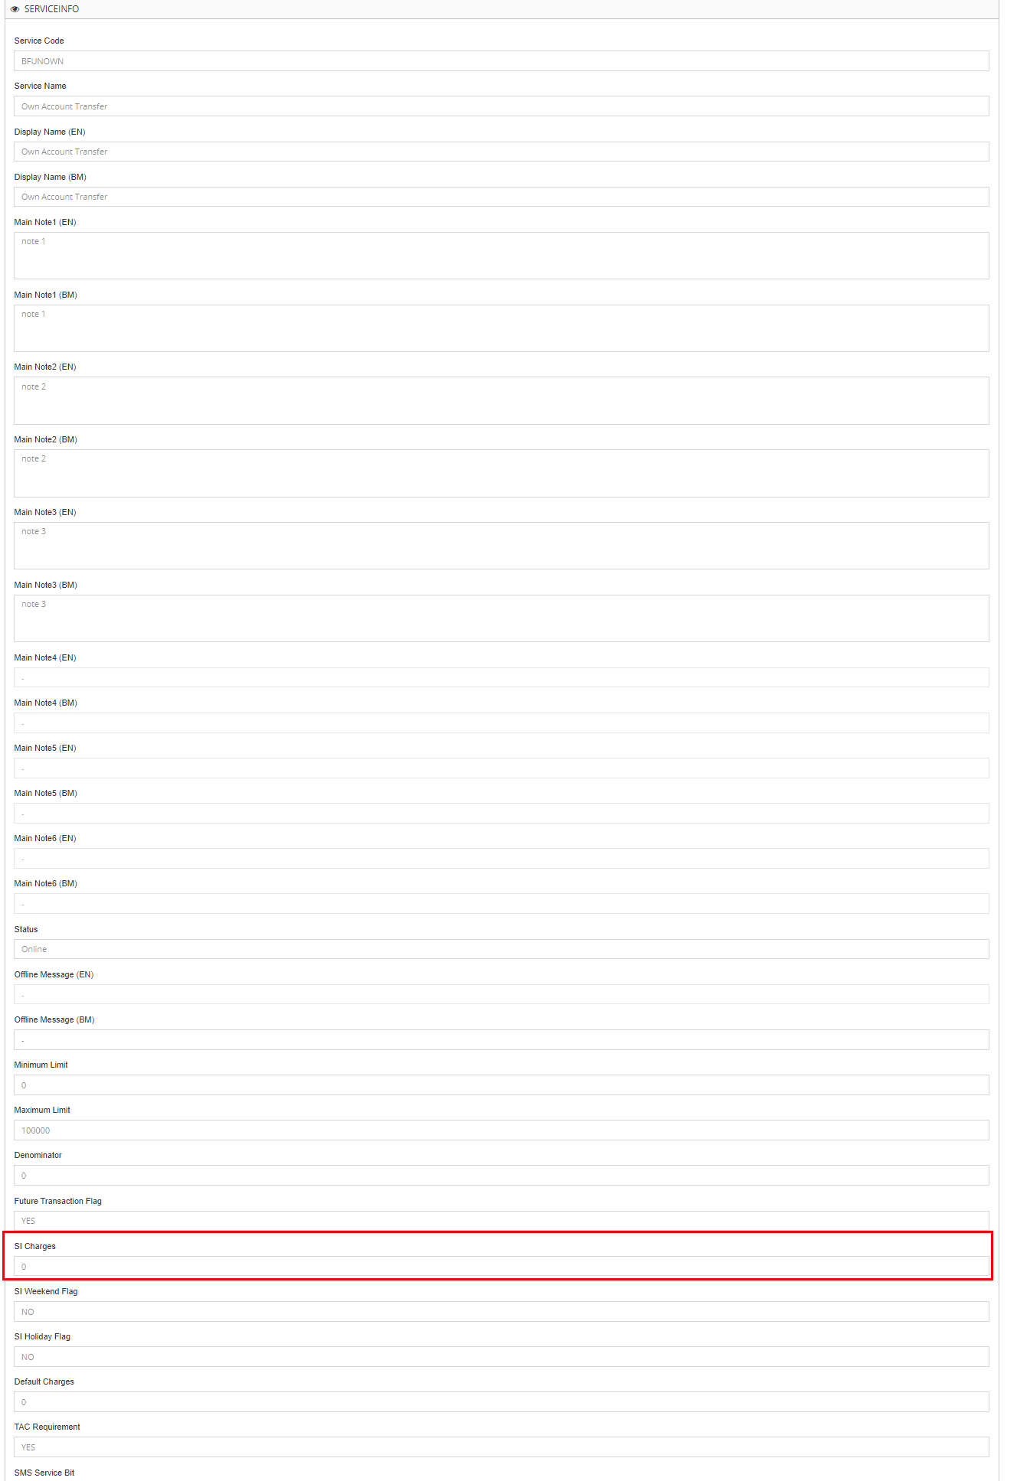

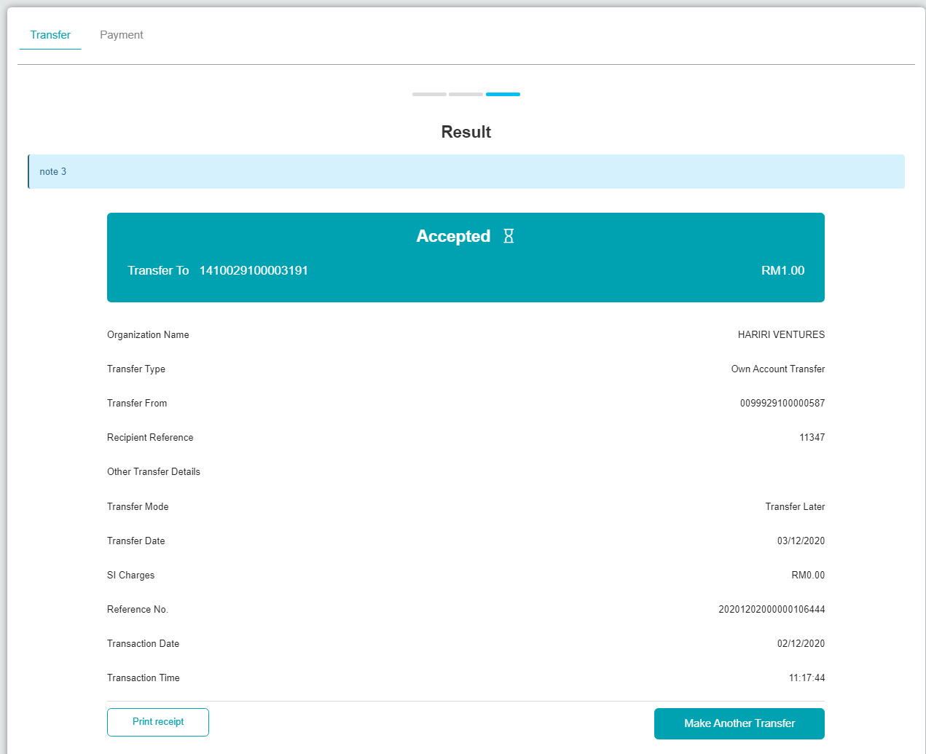

Request developer to change 'Transfer Later' to today and run SI batch job

BSNeBiz History:  


SI Enquiry:



BSNeBiz Transaction Enquiry:



## 3rd Party Transfer

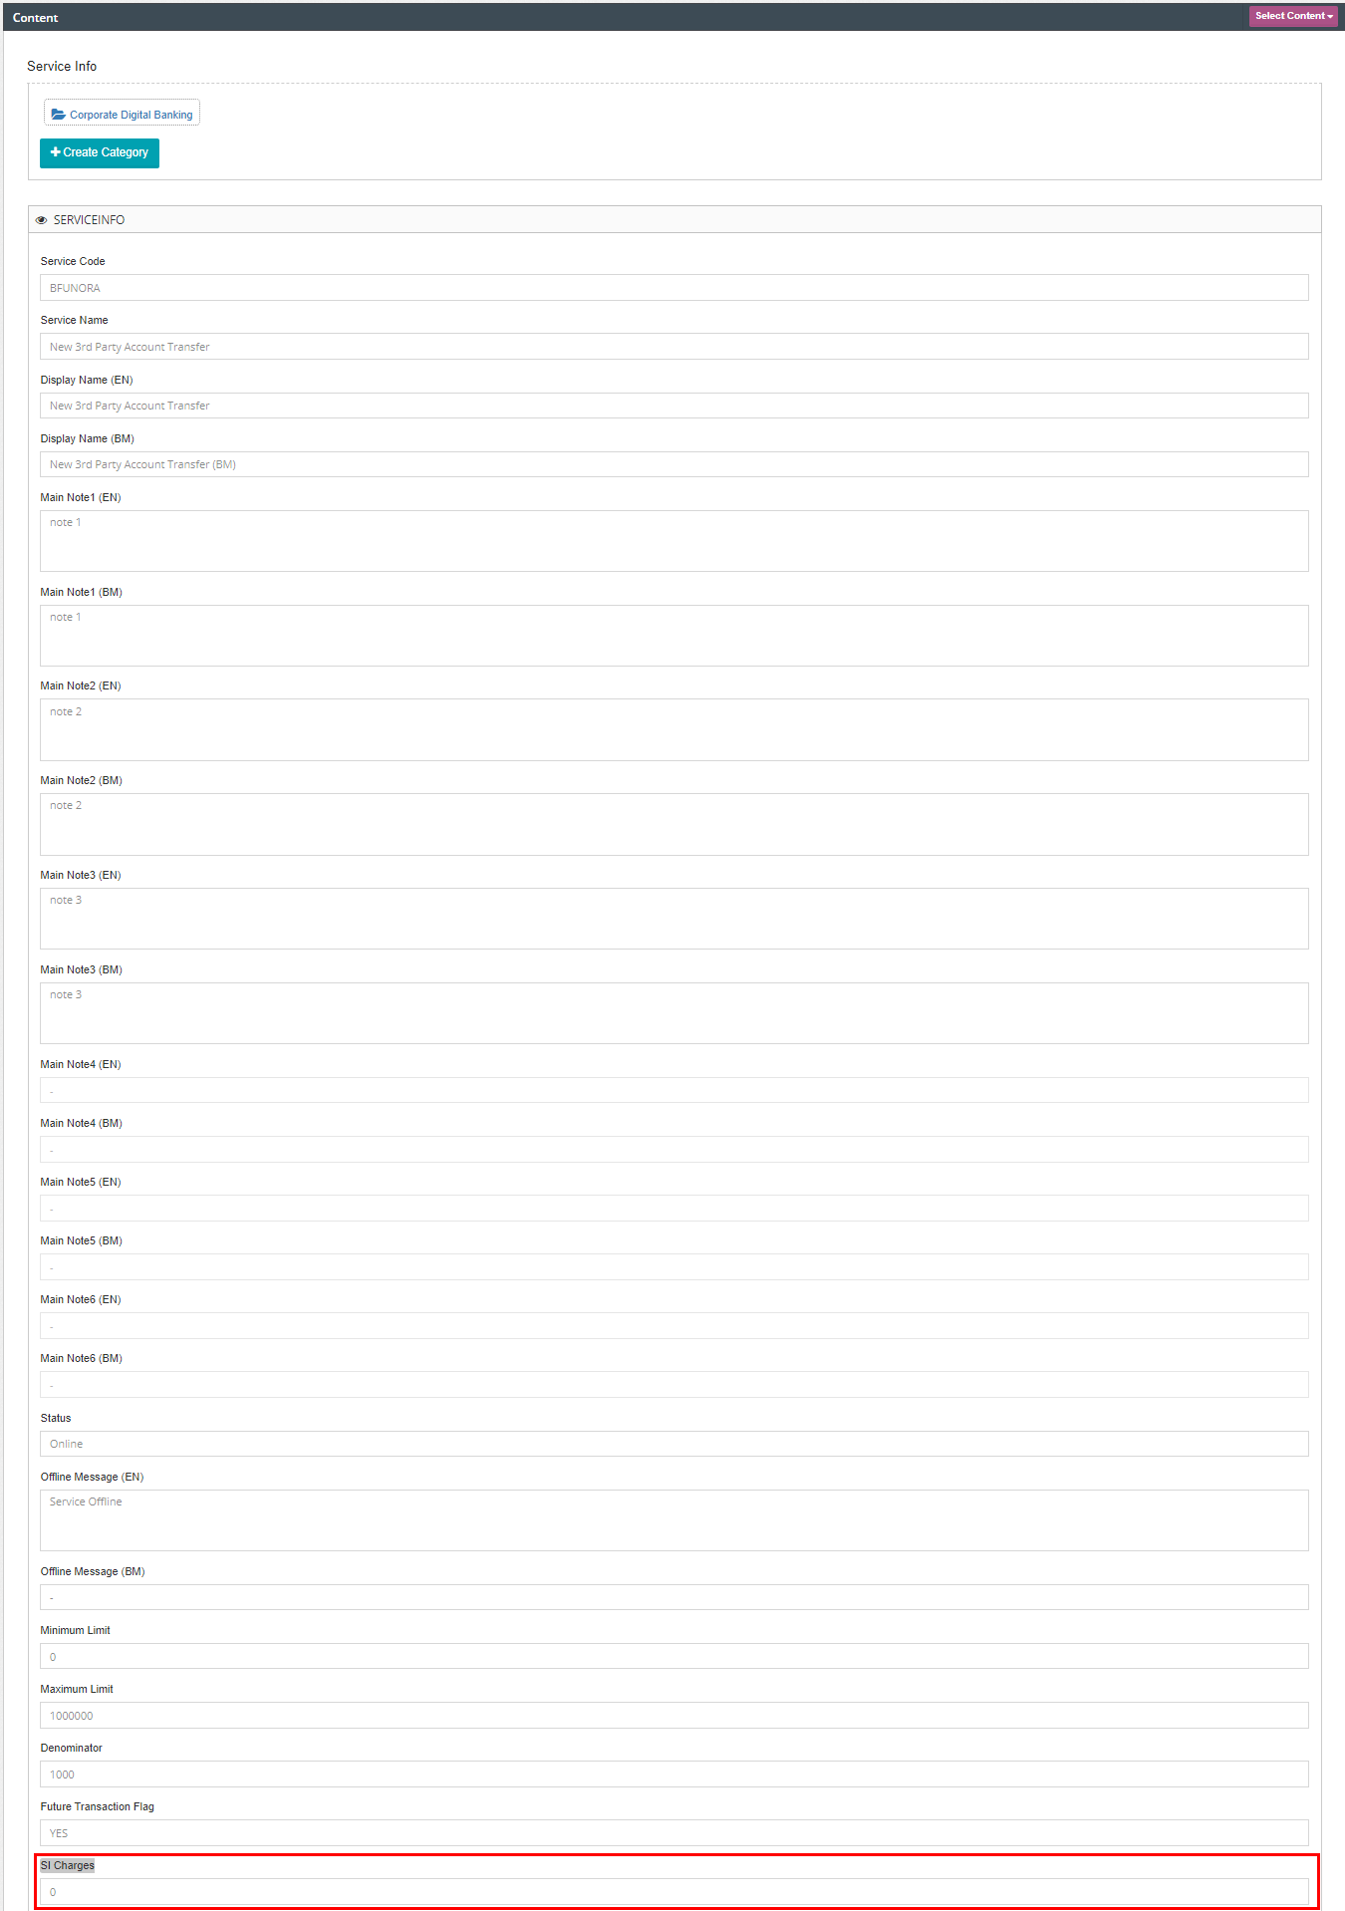

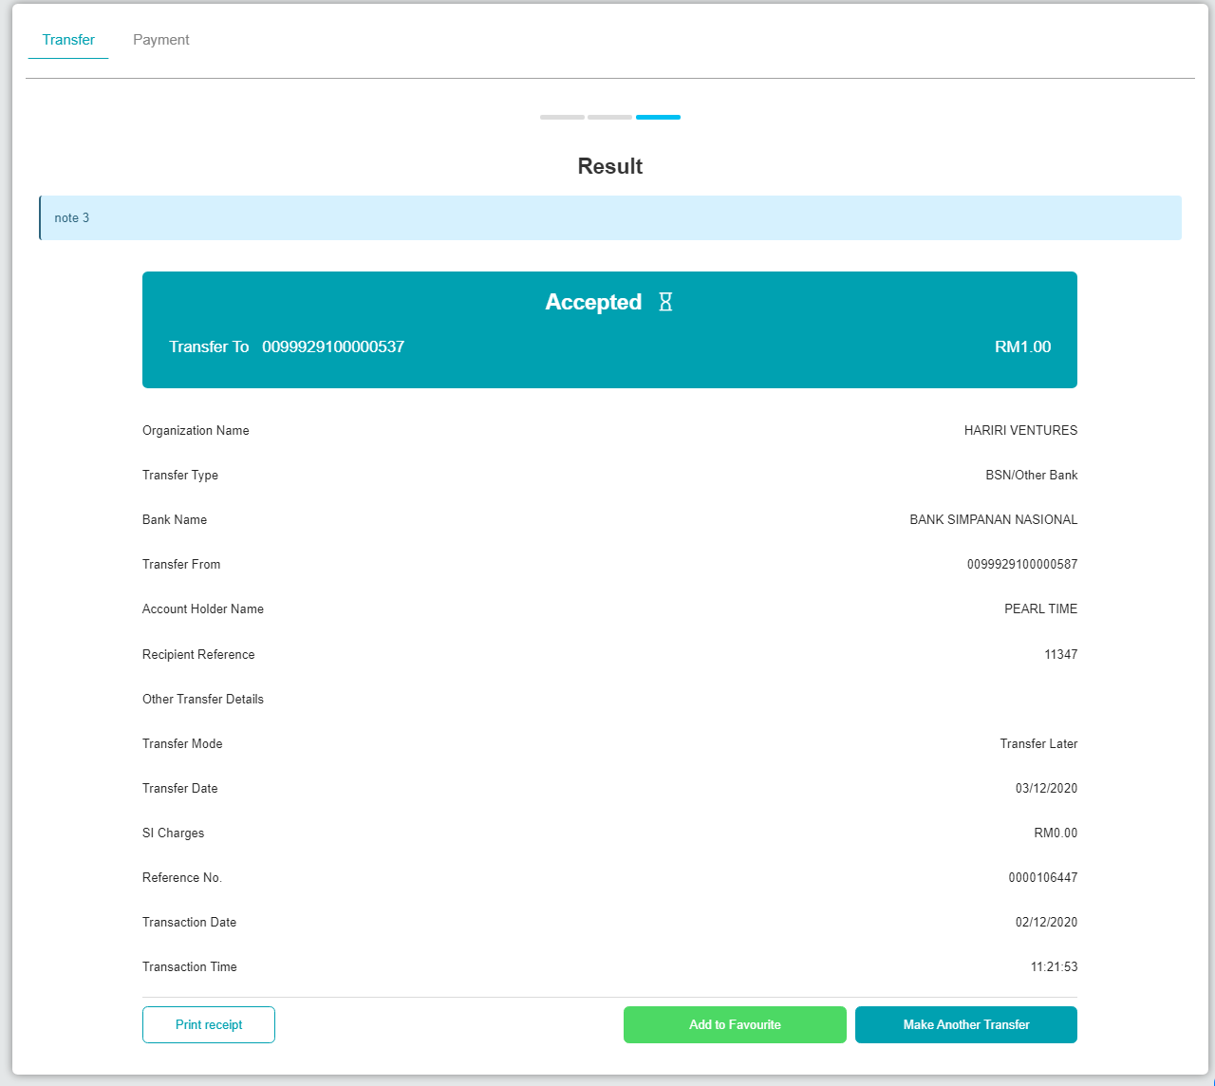

Request developer to change 'Transfer Later' to today and run SI batch job

BSNeBiz History:  


SI Enquiry:



BSNeBiz Transaction Enquiry:



## Interbank Transfer

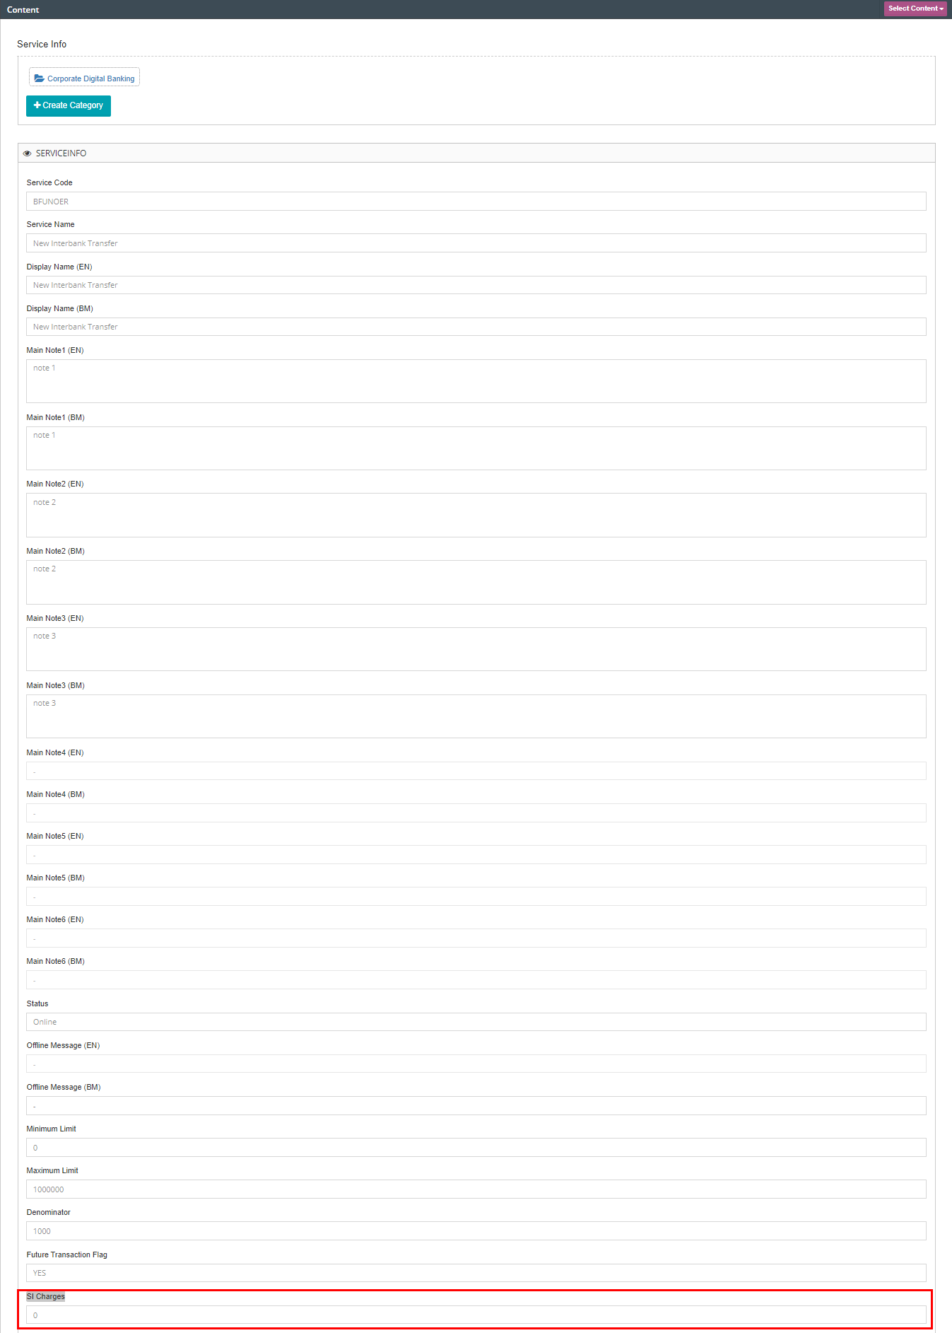

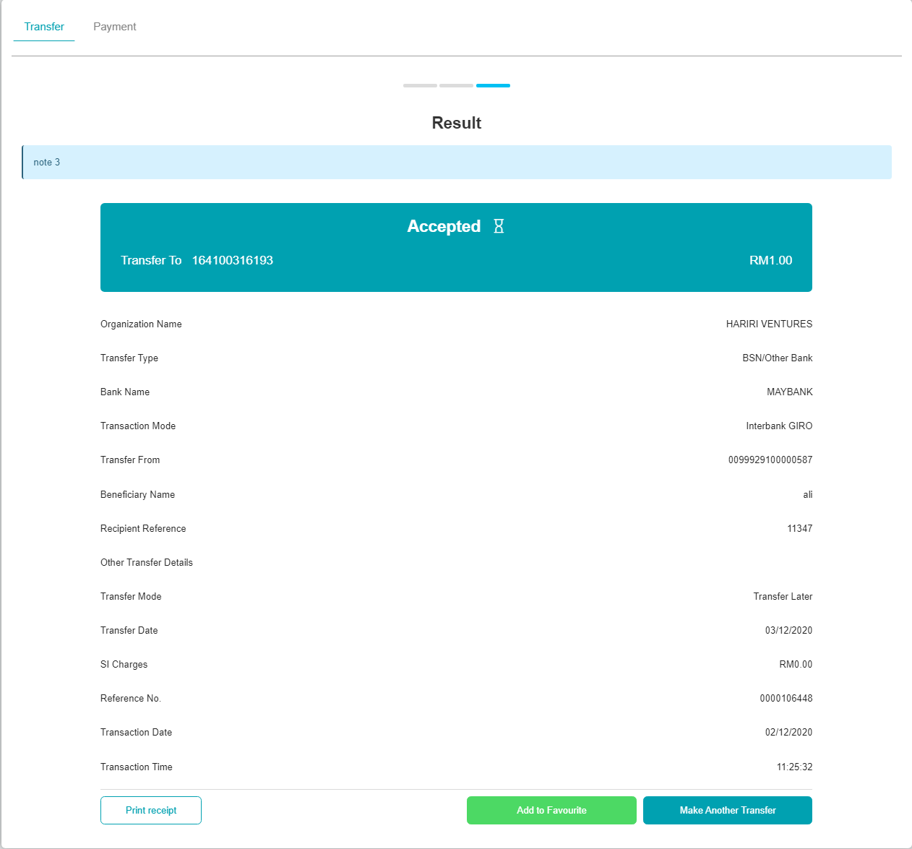

Request developer to change 'Transfer Later' to today and run SI batch job

BSNeBiz History:  


SI Enquiry:



BSNeBiz Transaction Enquiry:



## Bill Payment

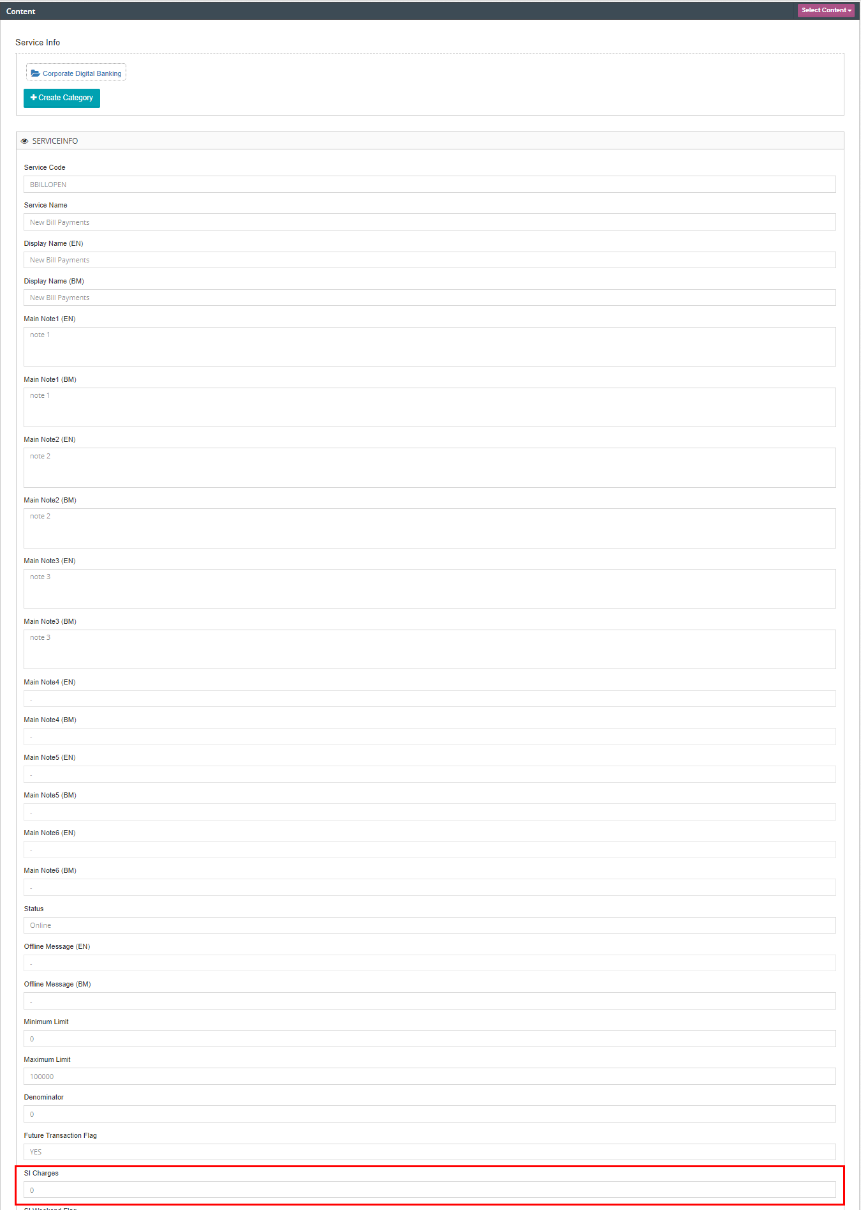

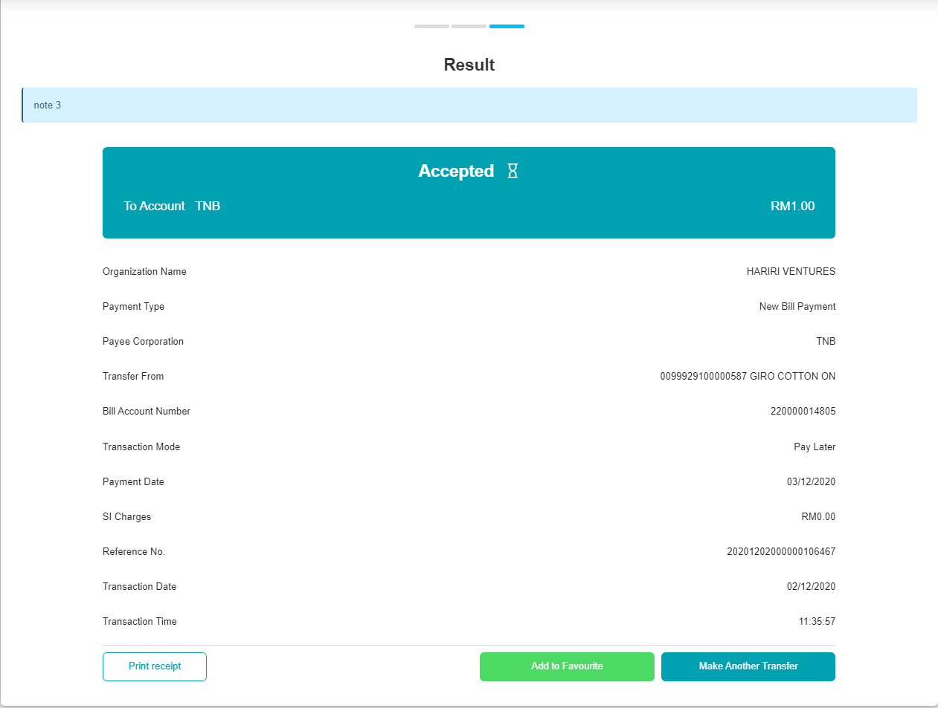

Request developer to change 'Transfer Later' to today and run SI batch job

BSNeBiz History:  


SI Enquiry:



BSNeBiz Transaction Enquiry:



## JomPAY

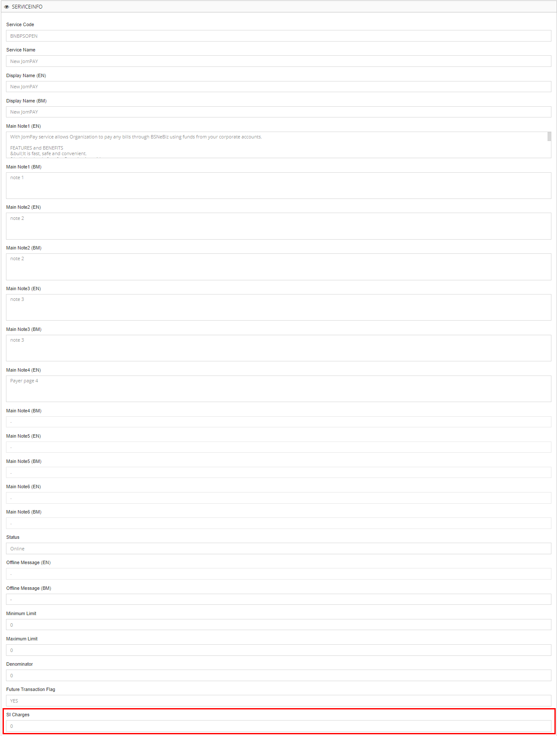

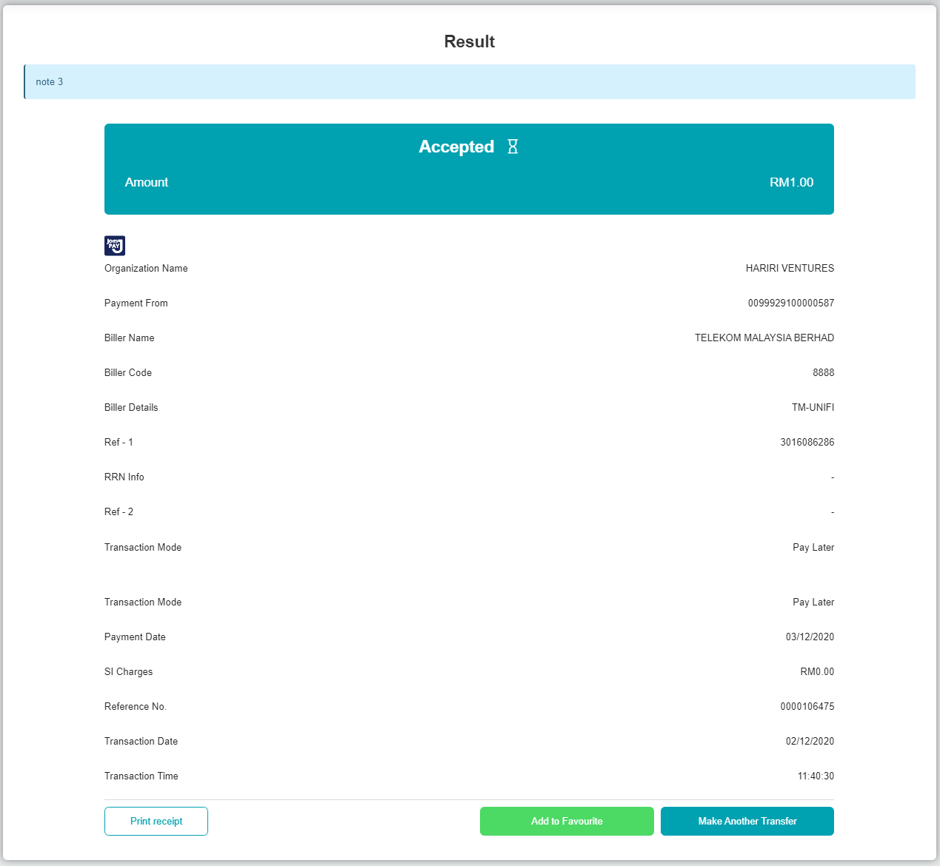

Request developer to change 'Transfer Later' to today and run SI batch job

BSNeBiz History:  


SI Enquiry:



BSNeBiz Transaction Enquiry:



# Test case 2: Set SI Charges that is not registered at ICBS

1. Access CDB>Payment & Transfer>BSN/Other Account Transfer
2. Create transfer with Transfer mode 'Transfer Later'
3. Request developer to change 'Transfer Later' to today and run SI batch job
4. Access IBAM>CBE>BSNeBiz Transaction Enquiry>Details
5. Expected result, transfer status is successful

## Own Account Transfer

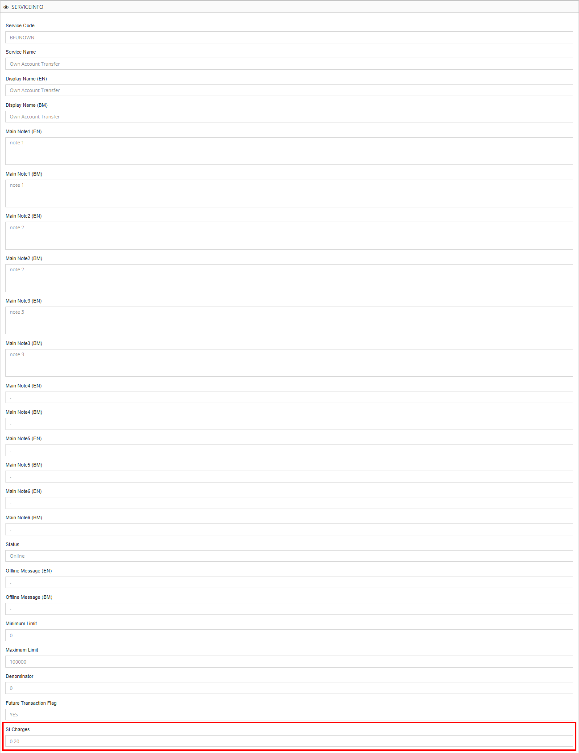

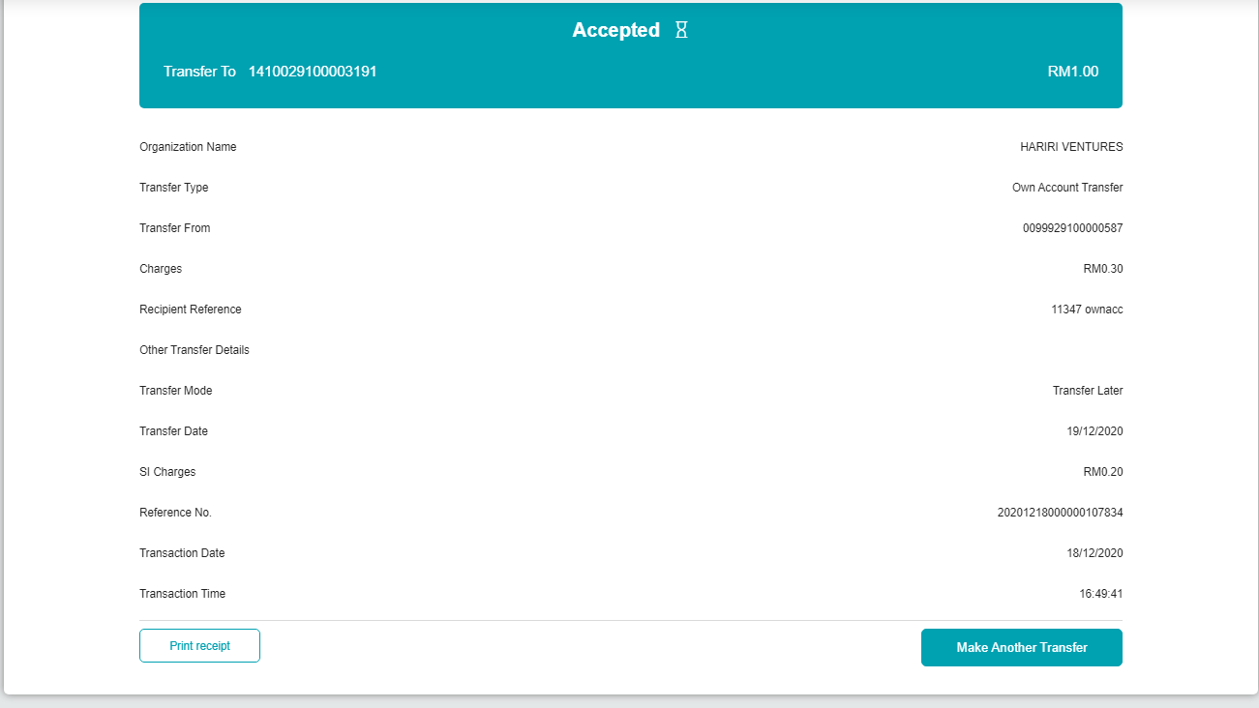

Request developer to change 'Transfer Later' to today and run SI batch job

BSNeBiz History:  


SI History:



BSNeBiz Transaction Enquiry:

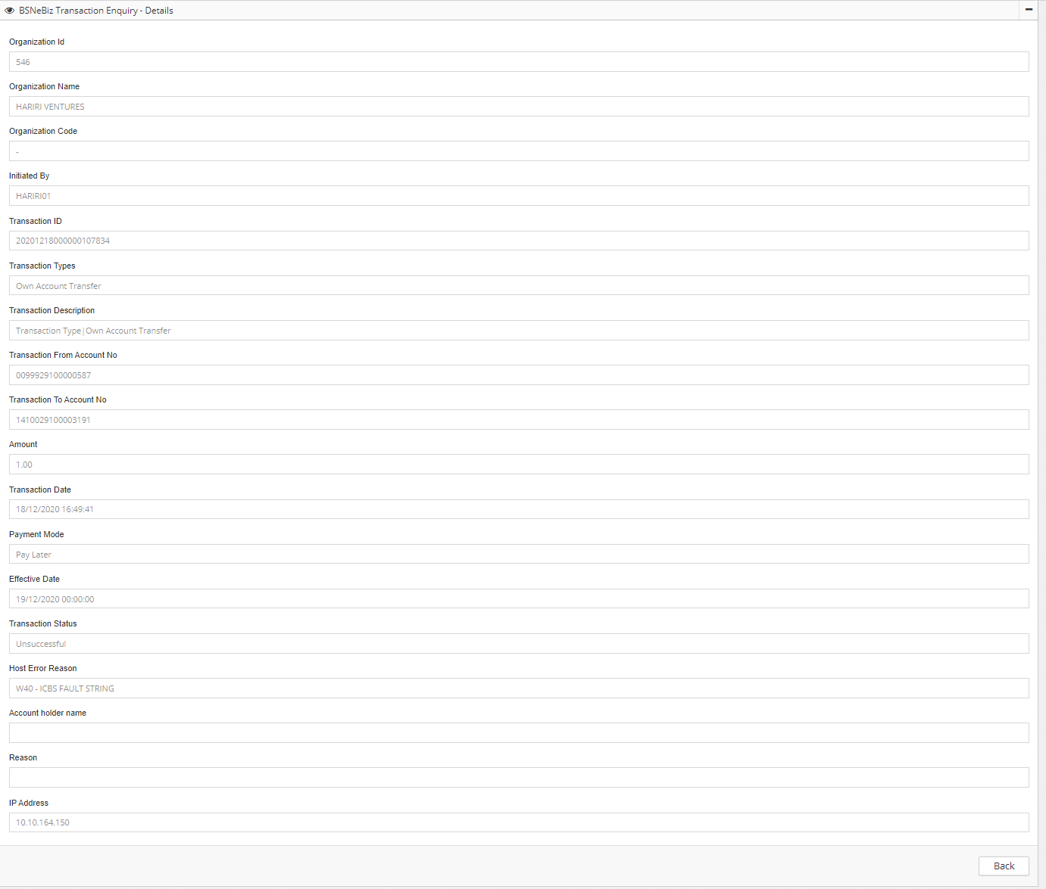

## 3rd Party Transfer

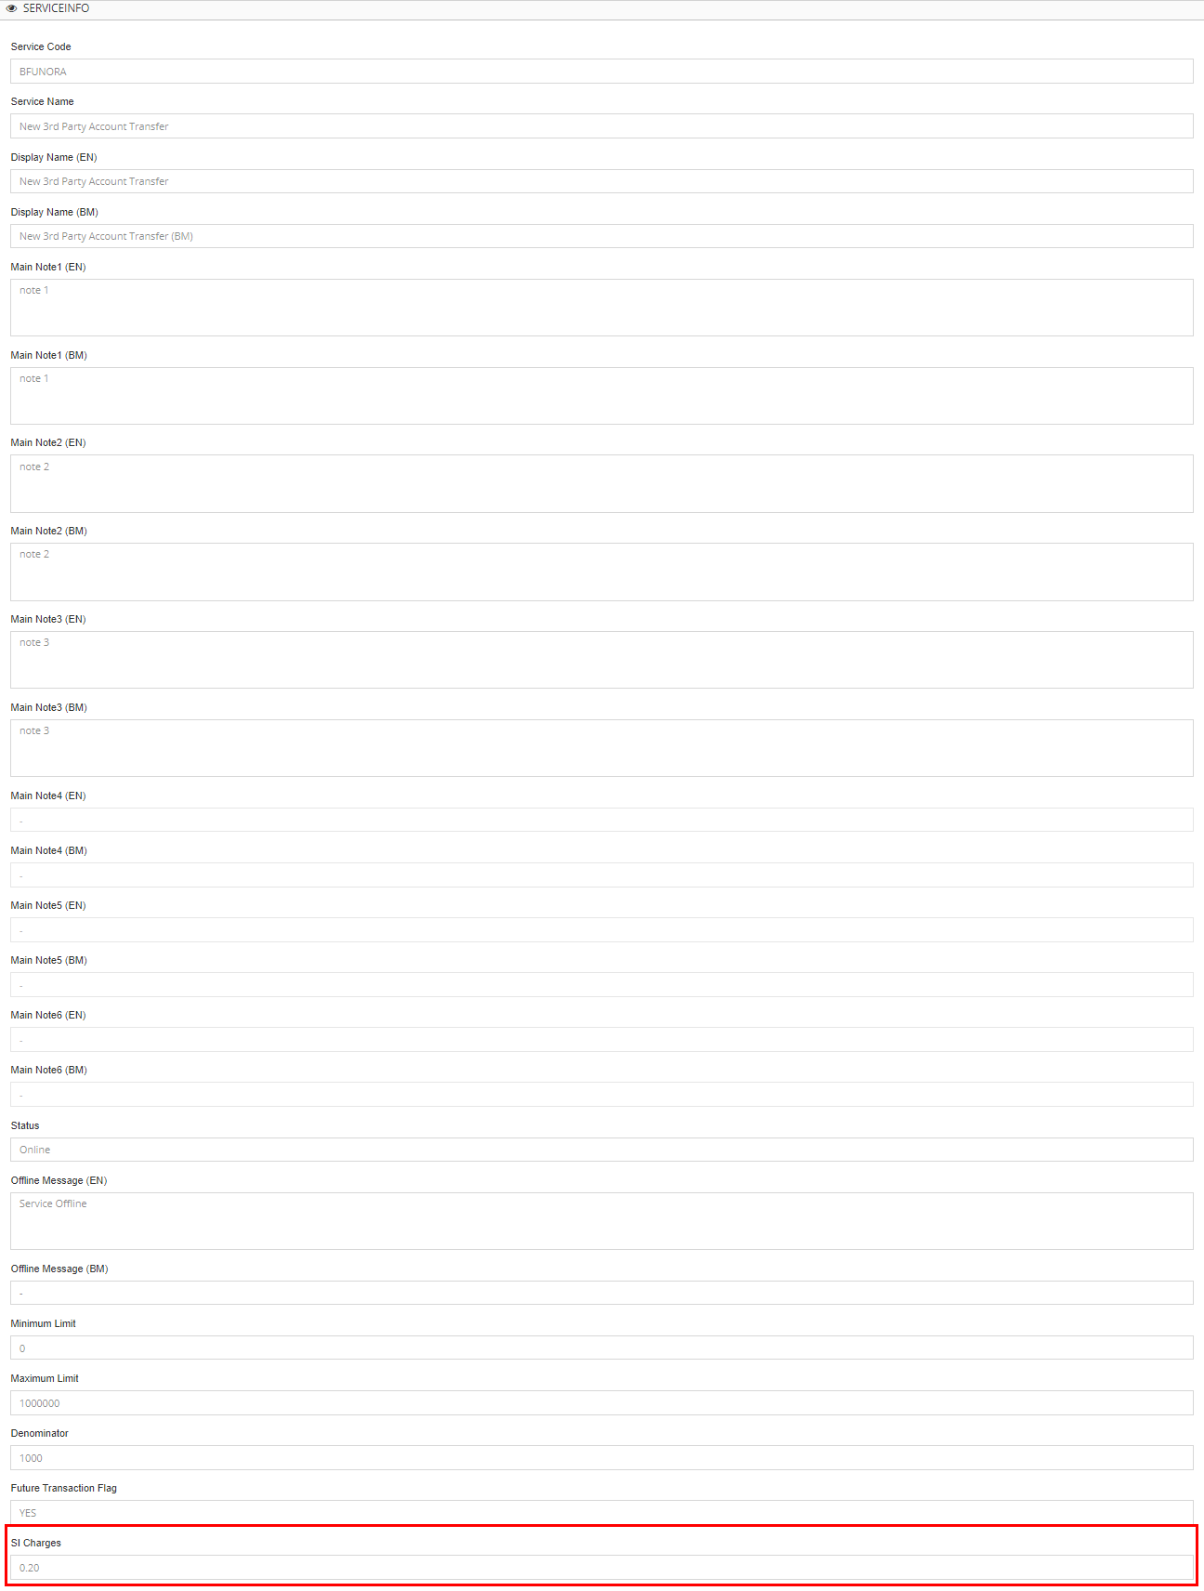

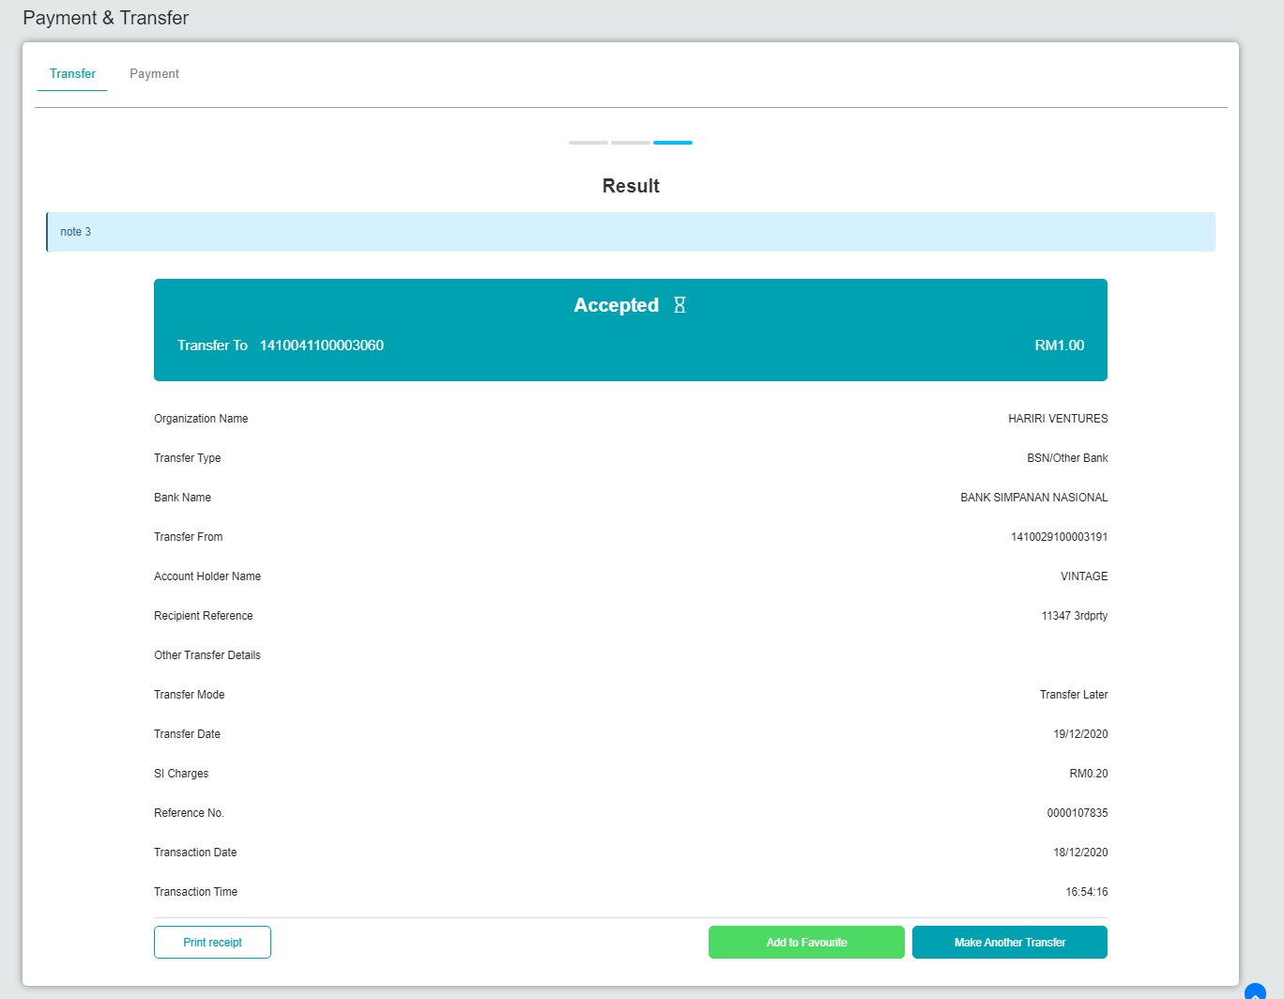

Request developer to change 'Transfer Later' to today and run SI batch job

BSNeBiz History:  


SI History:



BSNeBiz Transaction Enquiry:

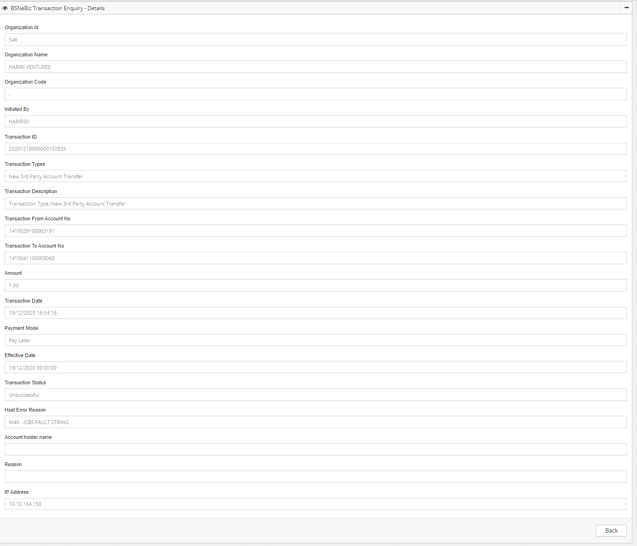

## Interbank Transfer

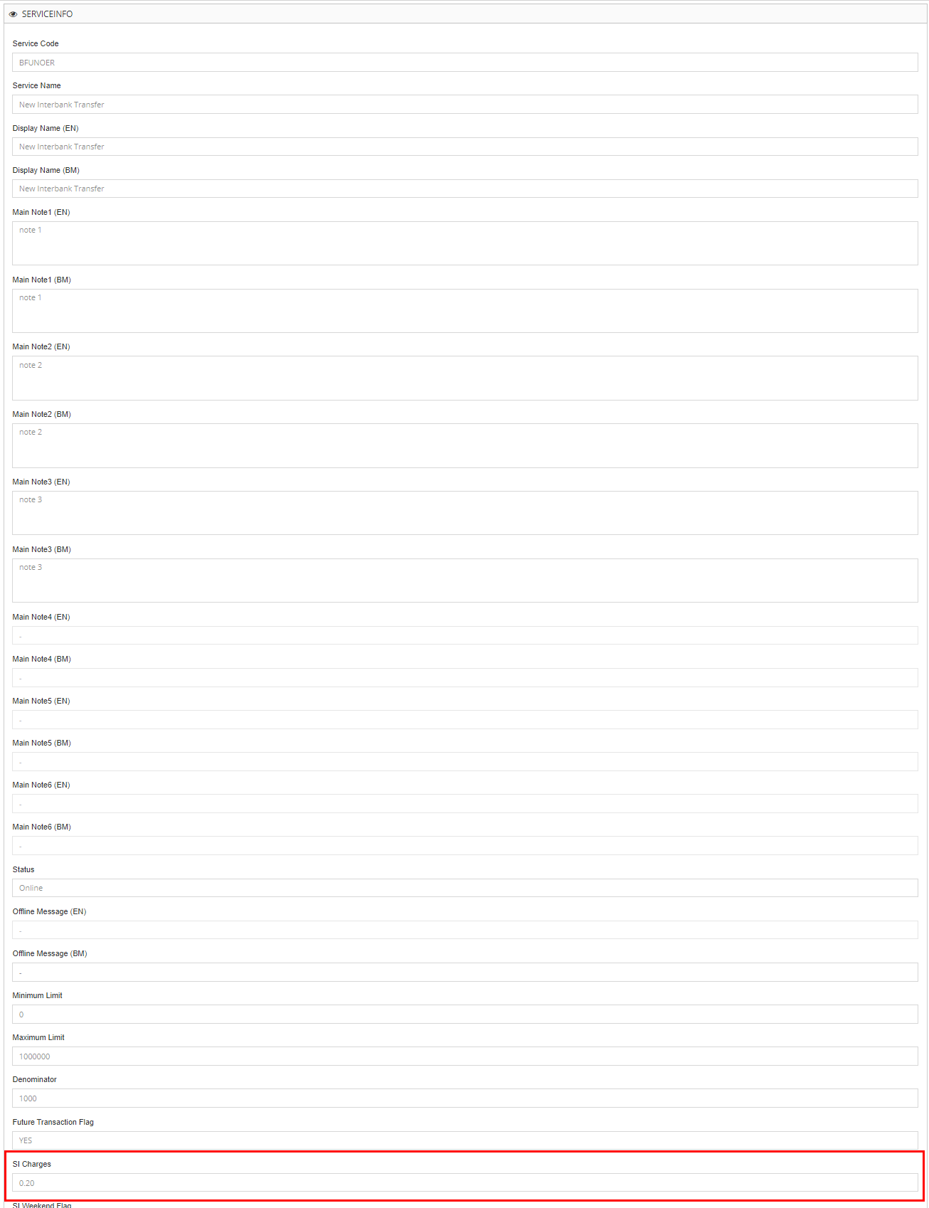

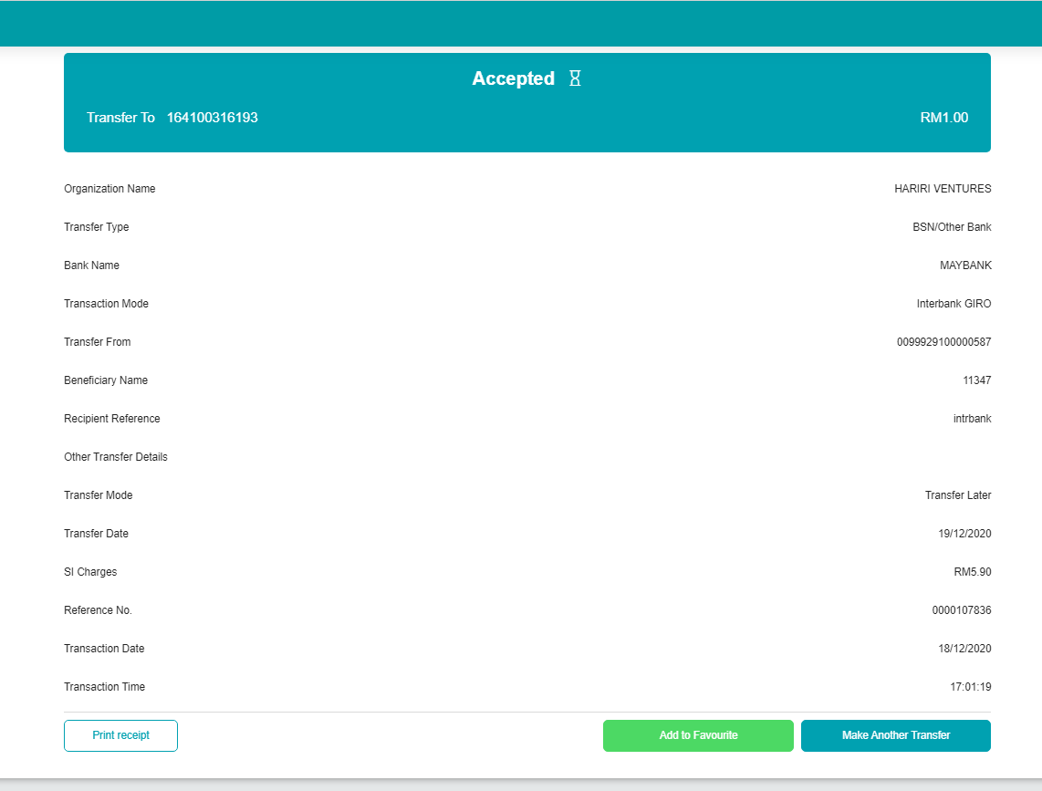

Request developer to change 'Transfer Later' to today and run SI batch job

BSNeBiz History:  


SI History:



BSNeBiz Transaction Enquiry:

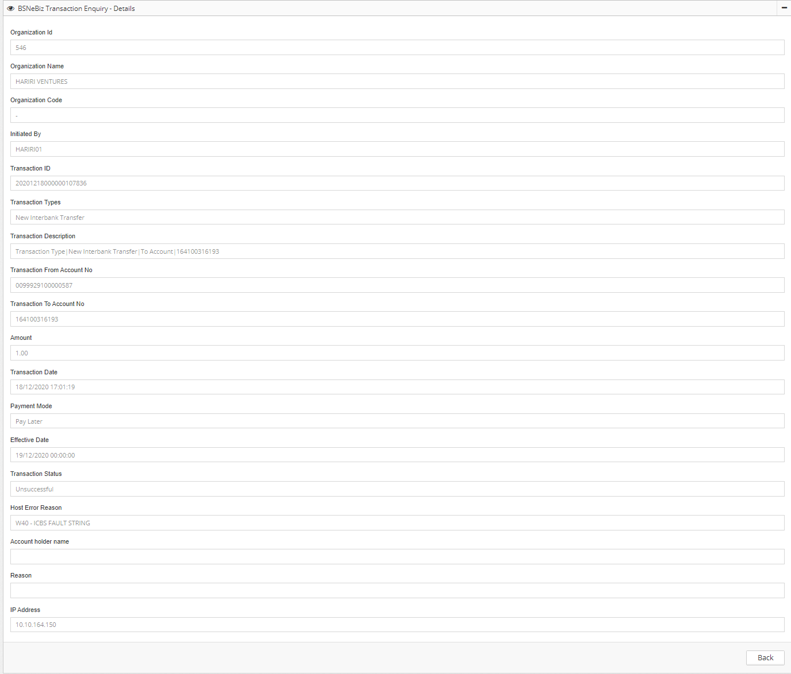

## Bill Payment

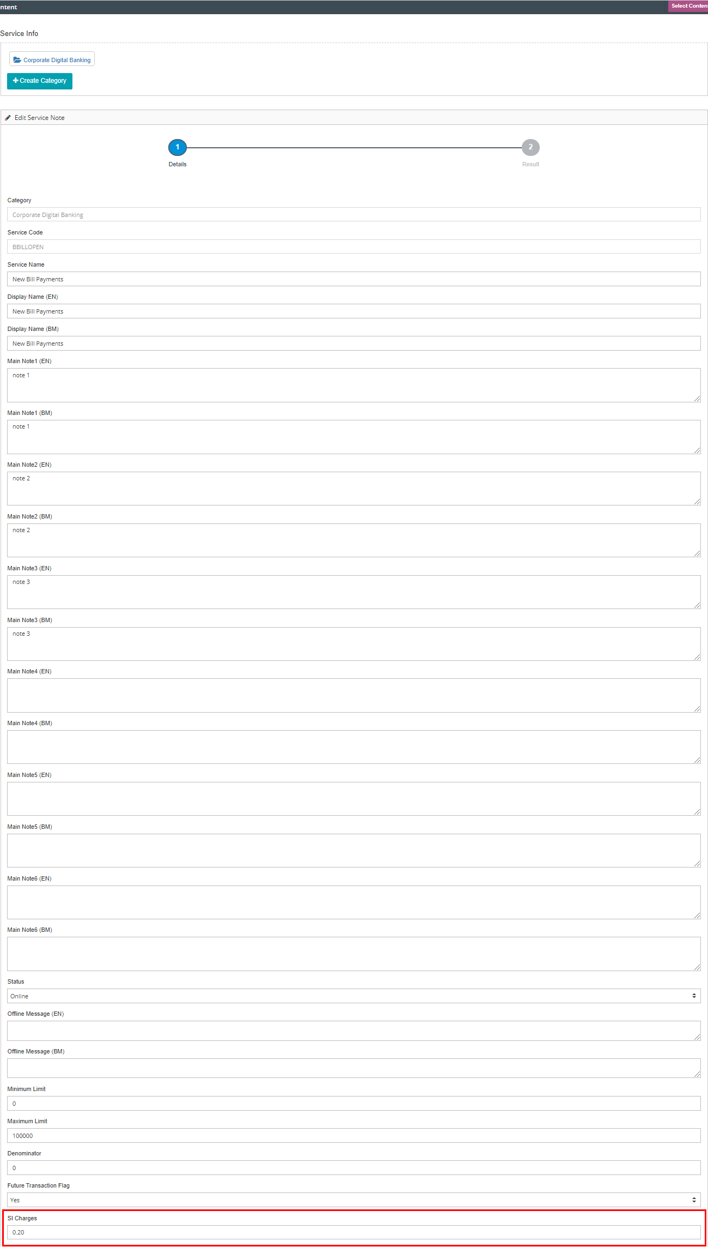

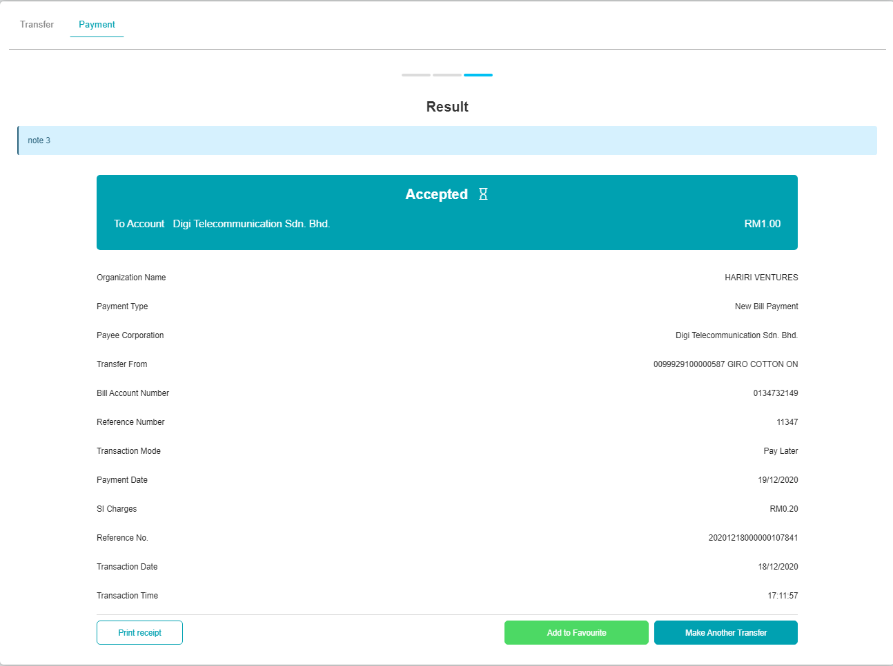

Request developer to change 'Transfer Later' to today and run SI batch job

BSNeBiz History:  


SI History:



BSNeBiz Transaction Enquiry:

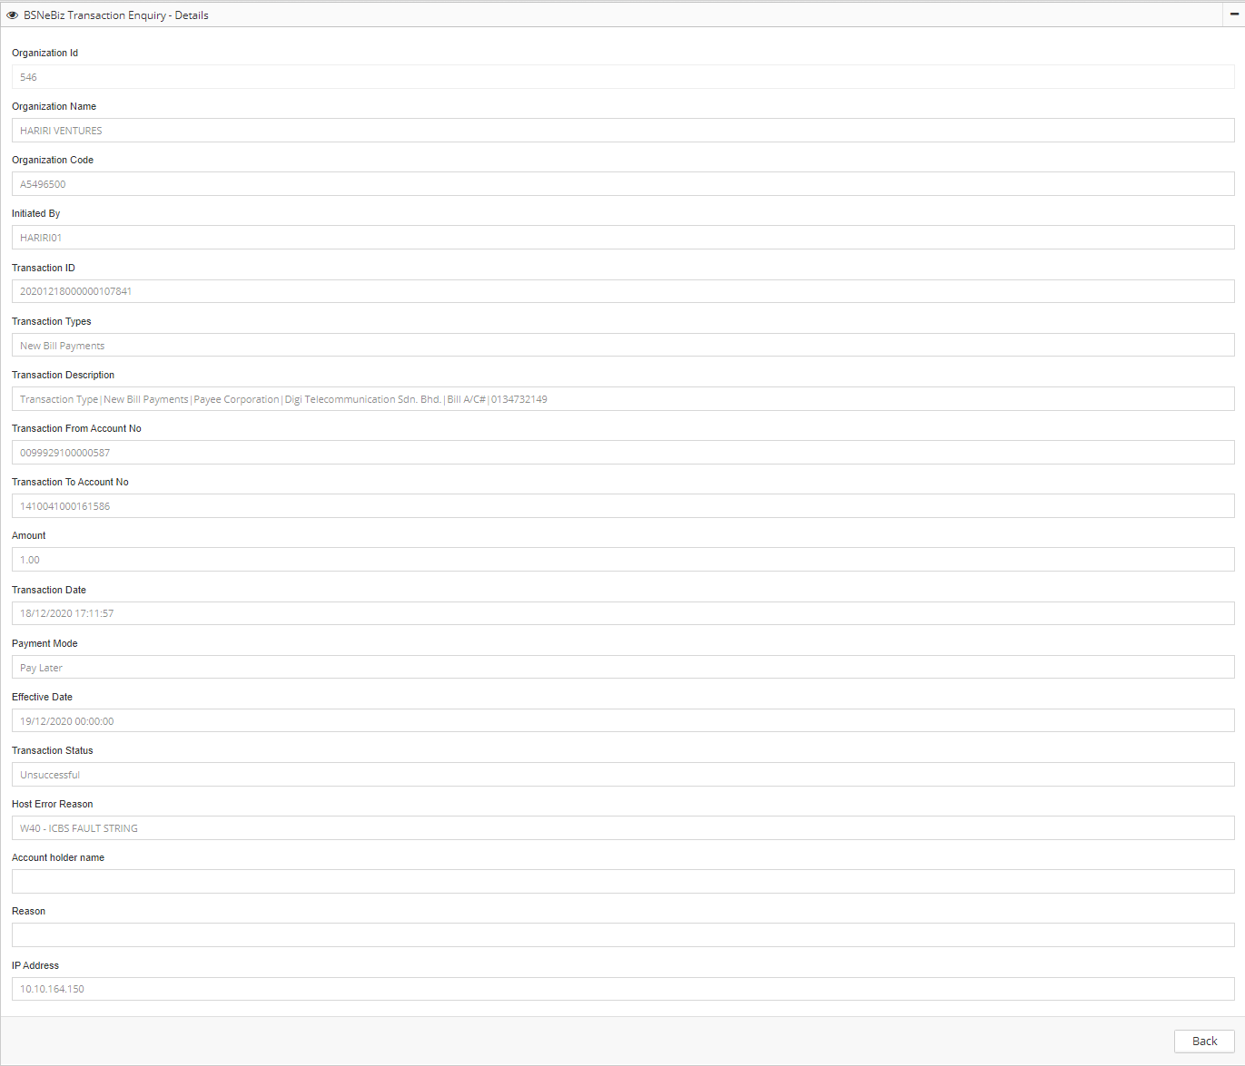

## JomPAY

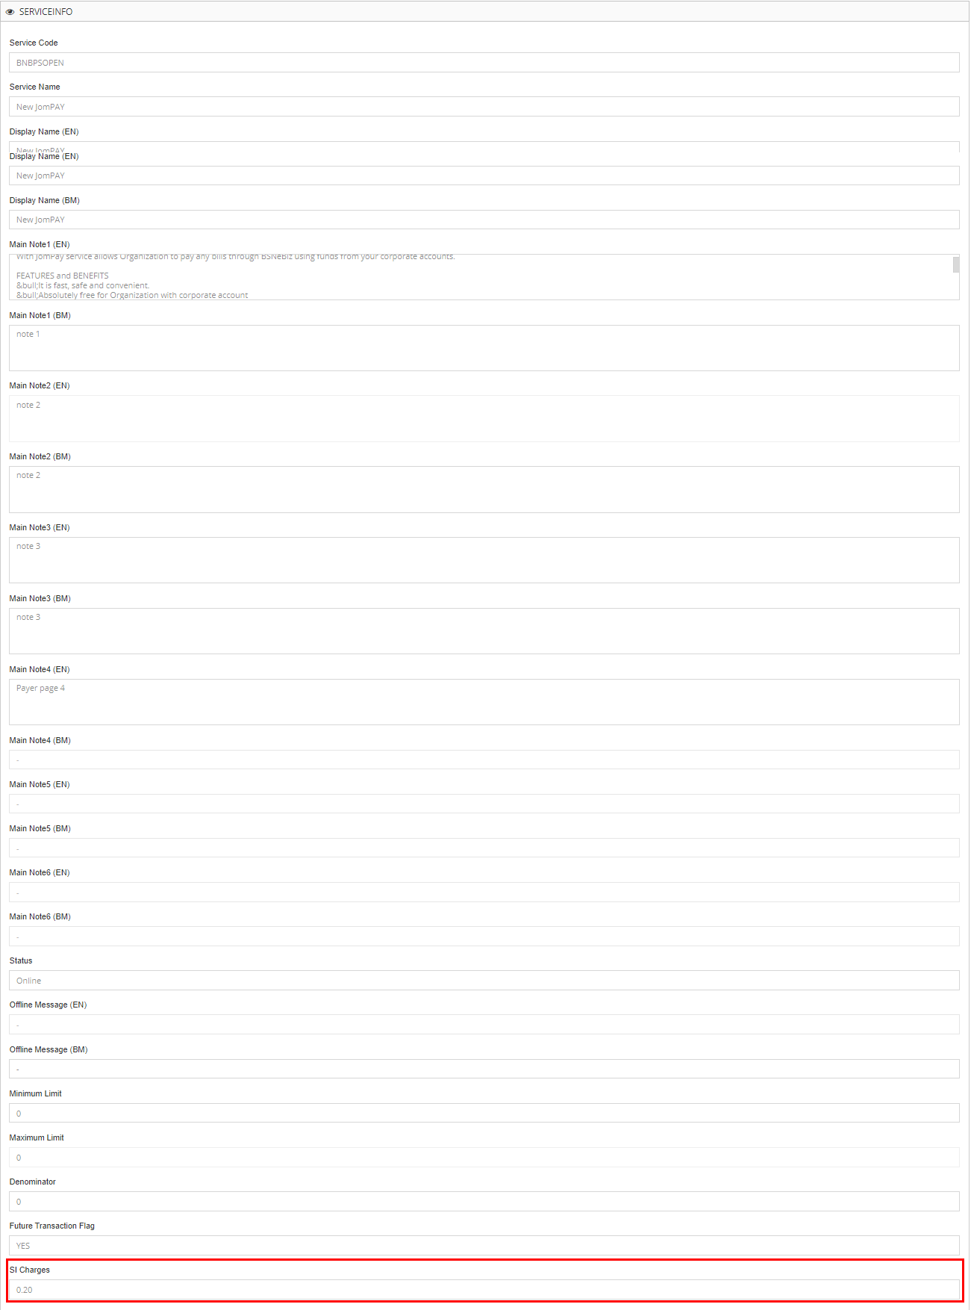

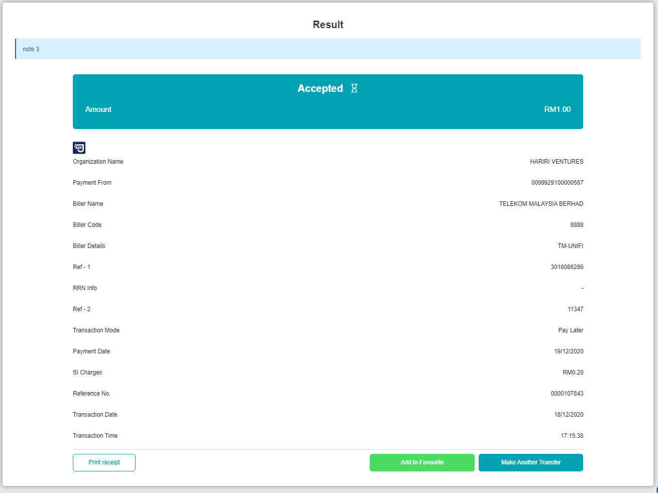

Request developer to change 'Transfer Later' to today and run SI batch job

BSNeBiz History:  


SI Enquiry:



BSNeBiz Transaction Enquiry:

