Issue:  
IBAM authorization cannot approve Edit Organization CA user

Finding:  
IBAM authorization did not check null for CA Allowed services

Solution:  
Add null checking to IBAM authorization

Test case:

1. Access IBAM as maker
2. Access CBE > Org Setup > User Maintenance > Create User
3. Create new CA user
4. Access IBAM > Authorization > Pending > CBE > Pending Create User
5. Expected result, can access Pending Details page
6. Access IBAM as checker
7. Access IBAM > Authorization > Approval > CBE > Pending Create User
8. Expected result, can access Approval Details page and approve
9. Access IBAM as maker
10. Access CBE > Org Setup > User Maintenance > Create User
11. Create new CA user

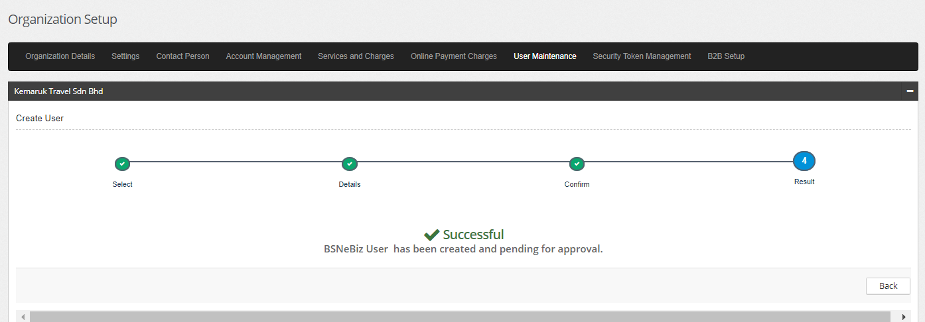

1. Access IBAM > Authorization > Pending > CBE > Pending Create User
2. Expected result, can access Pending Details page

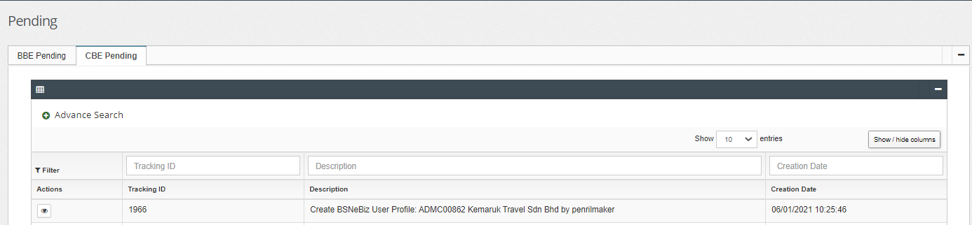

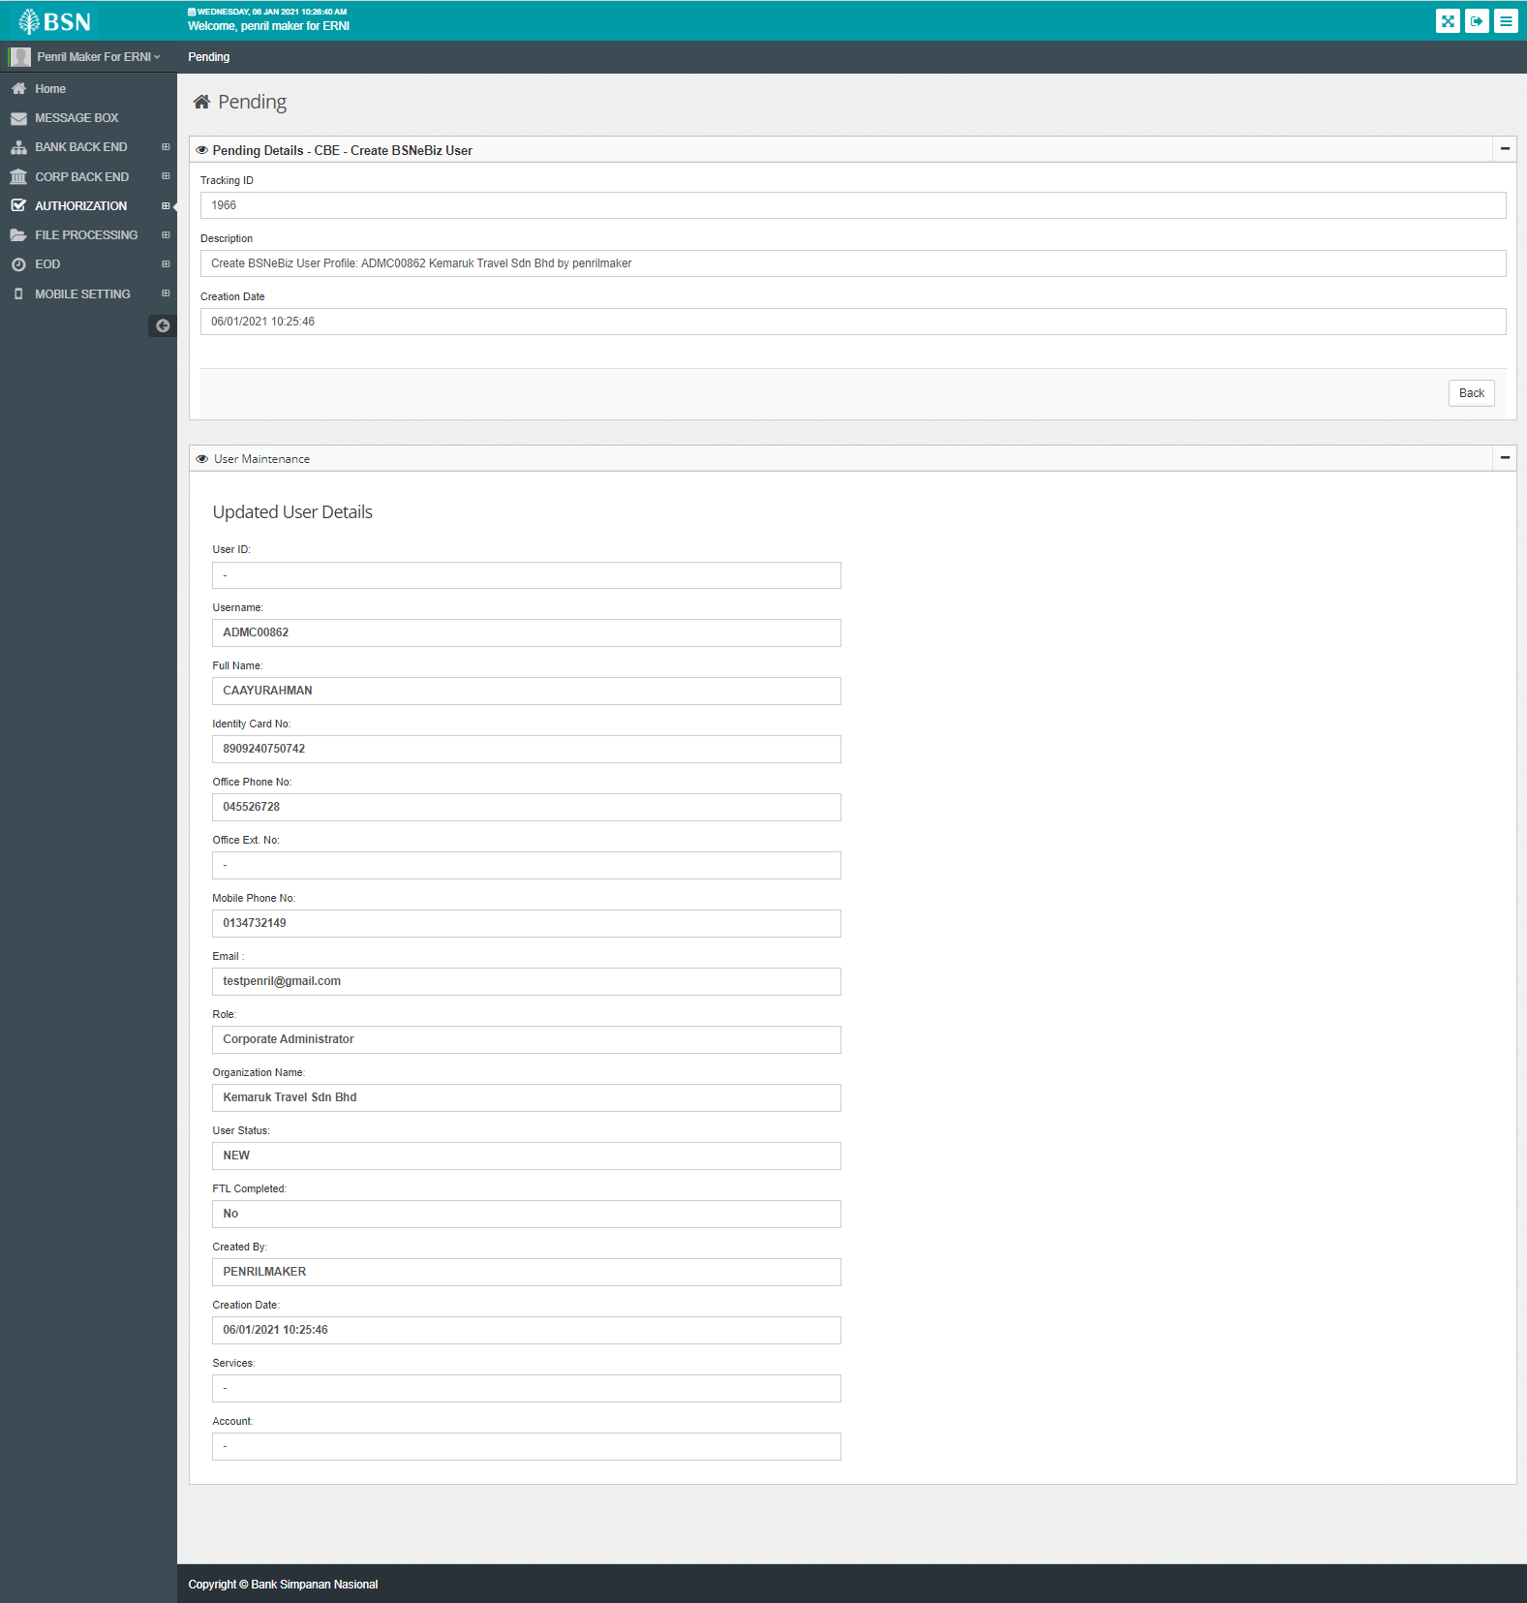

1. Access IBAM as checker
2. Access IBAM > Authorization > Approval > CBE > Pending Create User

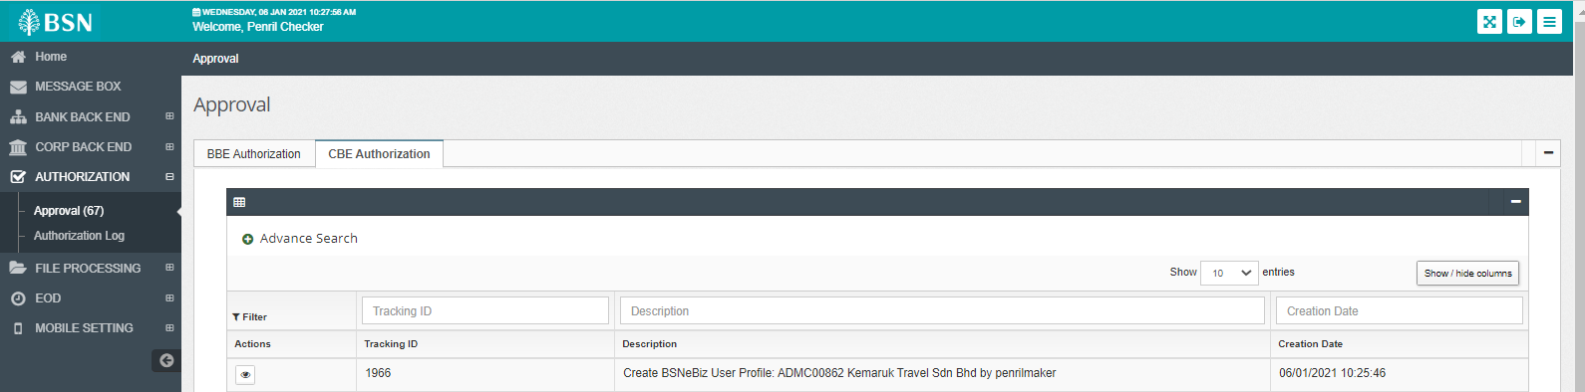

1. Expected result, can access Approval Details page and approve

