1. Forgot Password

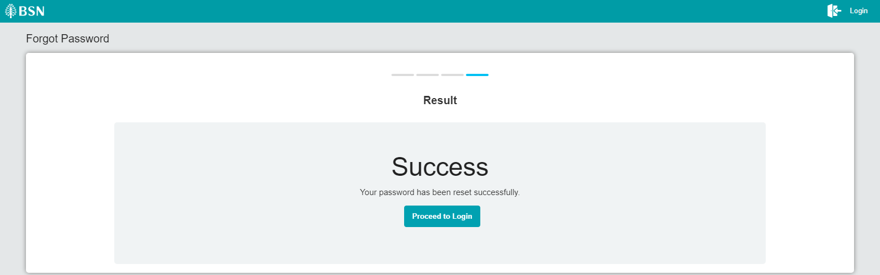

1. Force Change Password

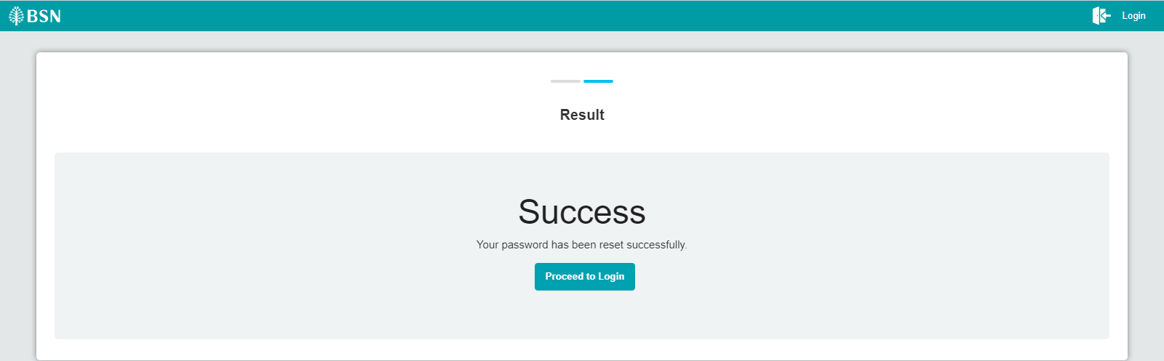

1. FTL

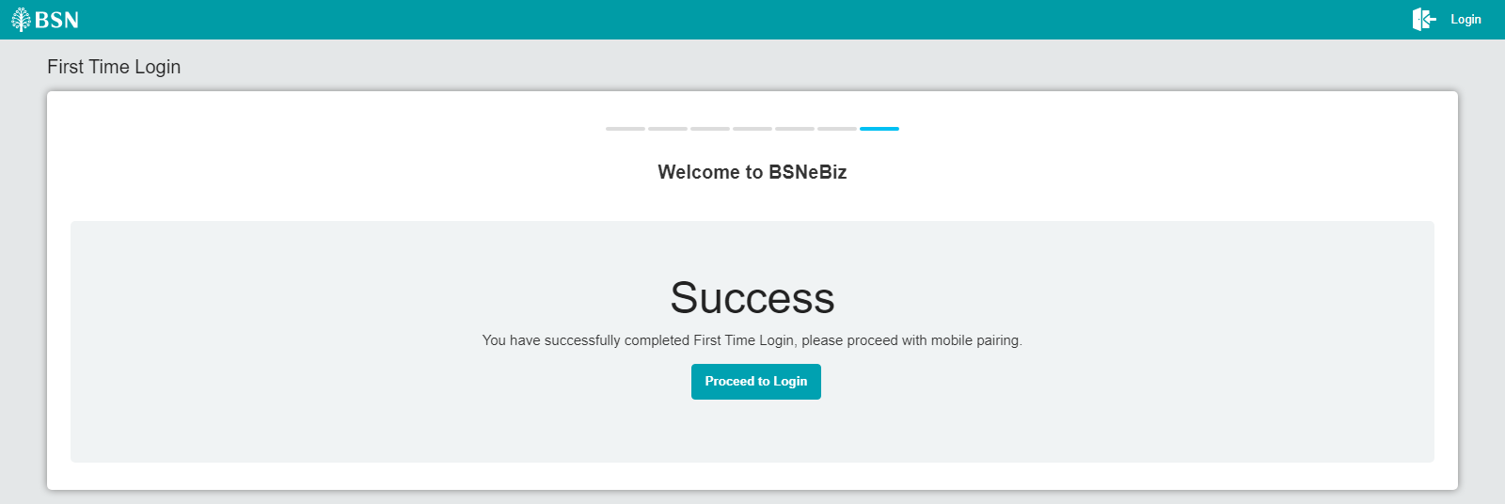

1. Activate Token

