Secured Mailbox Test

Test ID | FCFT/IBAM014
Test Name | Secure Mailbox Test – Inbox & Replied Message.
Description | Check the Inbox & Replied Message Functionality, such as:  - List all the inbox message from the RIB  - Reply the email  - List all the replied email  - Print the email
Test Steps | - View the list of inbox message  - Send multiple message to archive  - Check the list pagination functionality  - Verify the message by subject and the content  - Print the message  - Reply the message  - Verify the ‘replied message’  - Archive the message  - Verify the archived message
Verification Details | Test Field  View the list of inbox message Step 1 Click on the Secured Mailbox, access on the Inbox  Results on RIB Does the message sent by RIB User appear in this list? <field>  Check the list pagination functionality Step 1 Click on the Secured Mailbox, access on the Inbox. Click on the next page (1, 2, Next Page hyperlink).  Result on IBAM <field>  Verify the message by subject and the content Step 1 View the message content by clicking on the subject title (select the last message sent from RIB).  Result on IBAM Does the message content and subject are match with the one sent from RIB? <field>  Print the message Step 1 View this message and click on ‘print’ button.  Result on IBAM How is the look and format of the printed message? Is the message printed correctly? <field>  Reply the message Step 1 After viewing above email, test the reply functionality by clicking ‘reply’ button.  Subject The subject is appended with ‘RE:’ format.  Result on IBAM Does the ‘RE:’ format appears? <field>  Message The original message will be included like sample below: 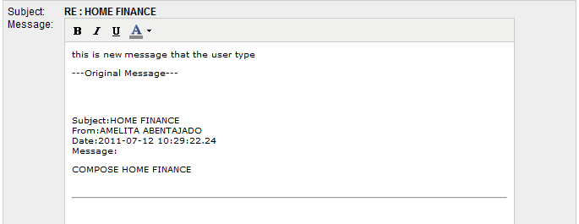  Result on IBAM Does the ‘original message’ appear? <field>  Step 2 Type the message, and click Reply button. Now login to RIB, and see the message inbox.  Result on RIB Does the ‘message’ appear in RIB? <field>  Replied Message Step 1 Select the message just now sent to RIB. Verify the subject and the content of the message in IBAM  Result on IBAM Does the ‘subject and message content’ appear correctly in ‘Replied Message’? <field>

