1. In BRS_SMS_Notification doc didn’t listed the Grant Total Record, Grant Total Successful Record, Grand Total Ussuccessful Record, and Grant Total Unssuccessful Record, and Grant Total Charges Amount but in SMS Issuance Report it have.

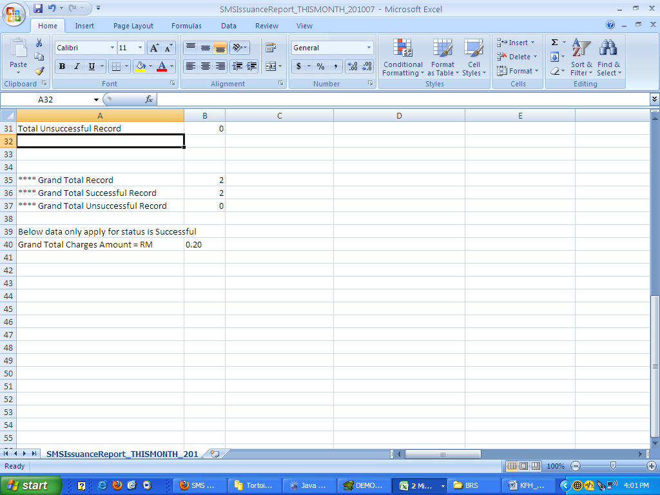

In BRS Doest have.