Test steps:

1. Select 2 existing orgCode for testing
2. Access Staging batch server
3. Access /batch/BSN/BatchJobsSIT/setting.properties
4. Set orgCodeBlankDataFile=A5636500 or any orgCode for testing
5. Access /batch/BSN/BatchFilesSIT/ICBSReports/Data/
6. Case A: Create the following files
   1. A5636500_31012021.TXT > with mockup content
   2. A5640500_31012021.TXT > with mockup content
7. Expected result, both files are processed and available in IBAM Data & report
8. Case B: Create the following files
   1. A5636500_31012021.TXT > without content
   2. A5640500_31012021.TXT > without content

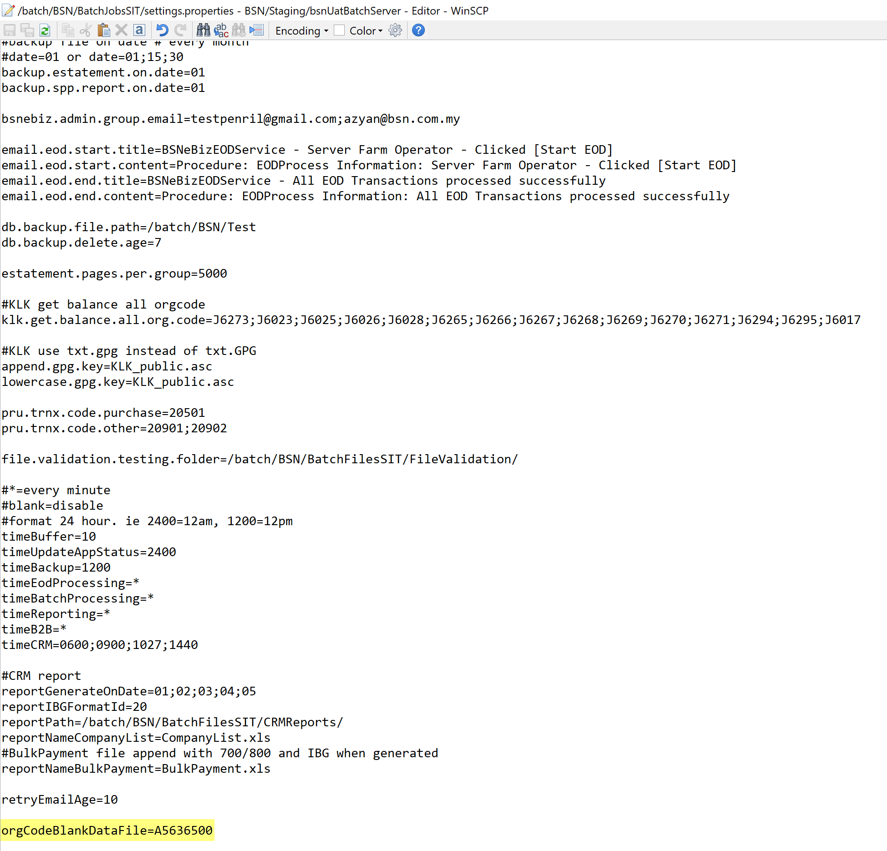

Create file with content

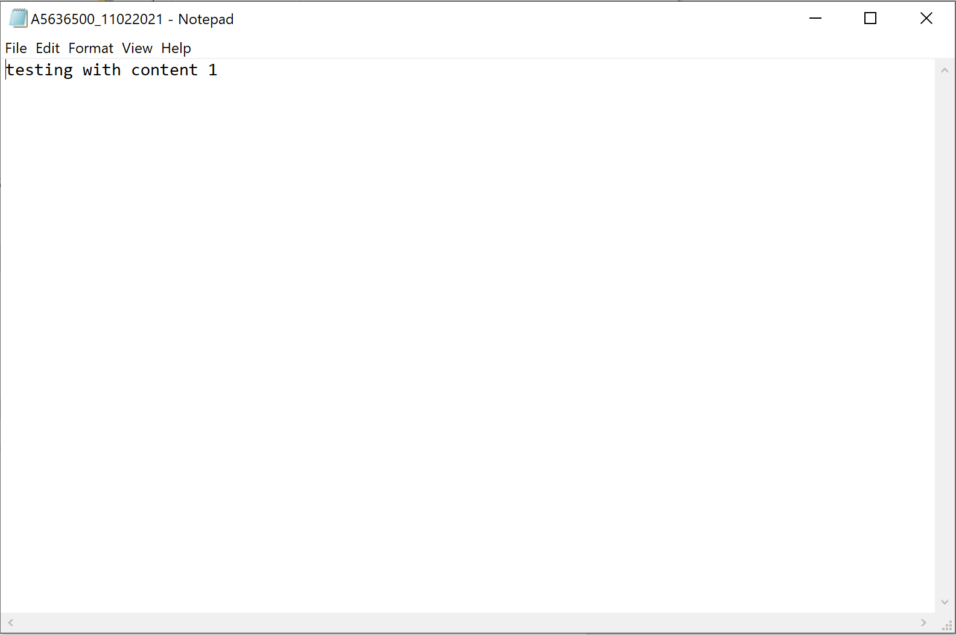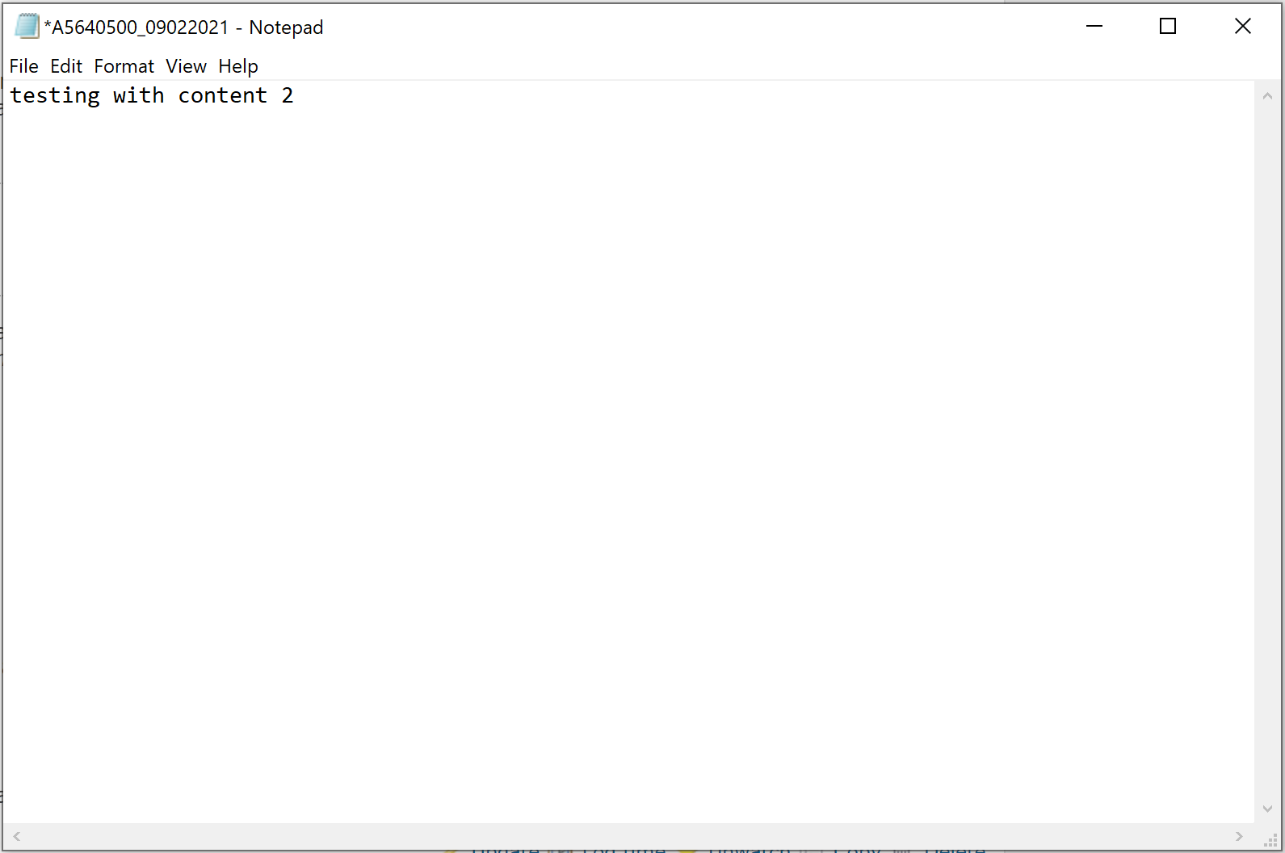

Insert created data to /batch/BSN/BatchFilesSIT/ICBSReports/Data/

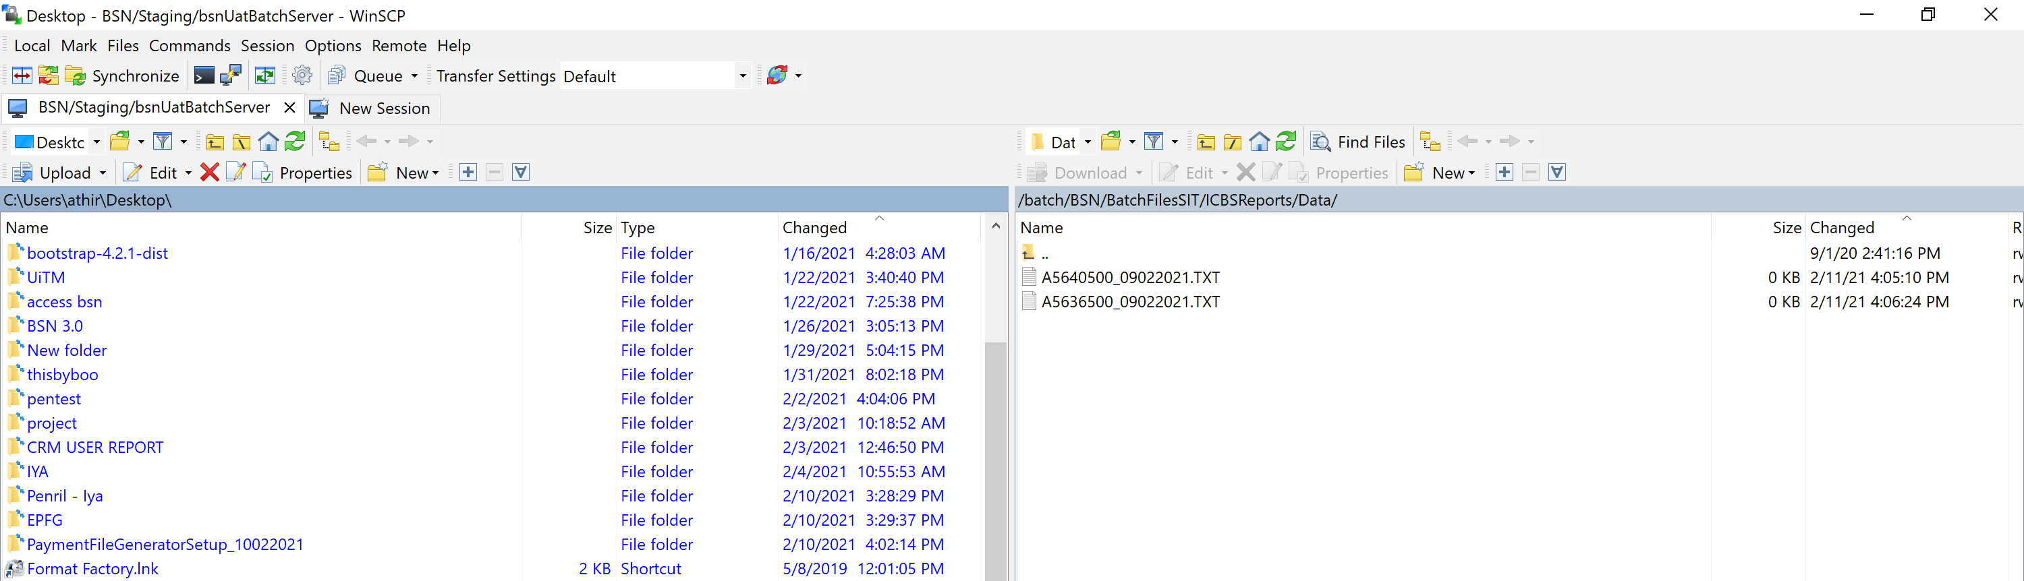

Both report available on IBAM

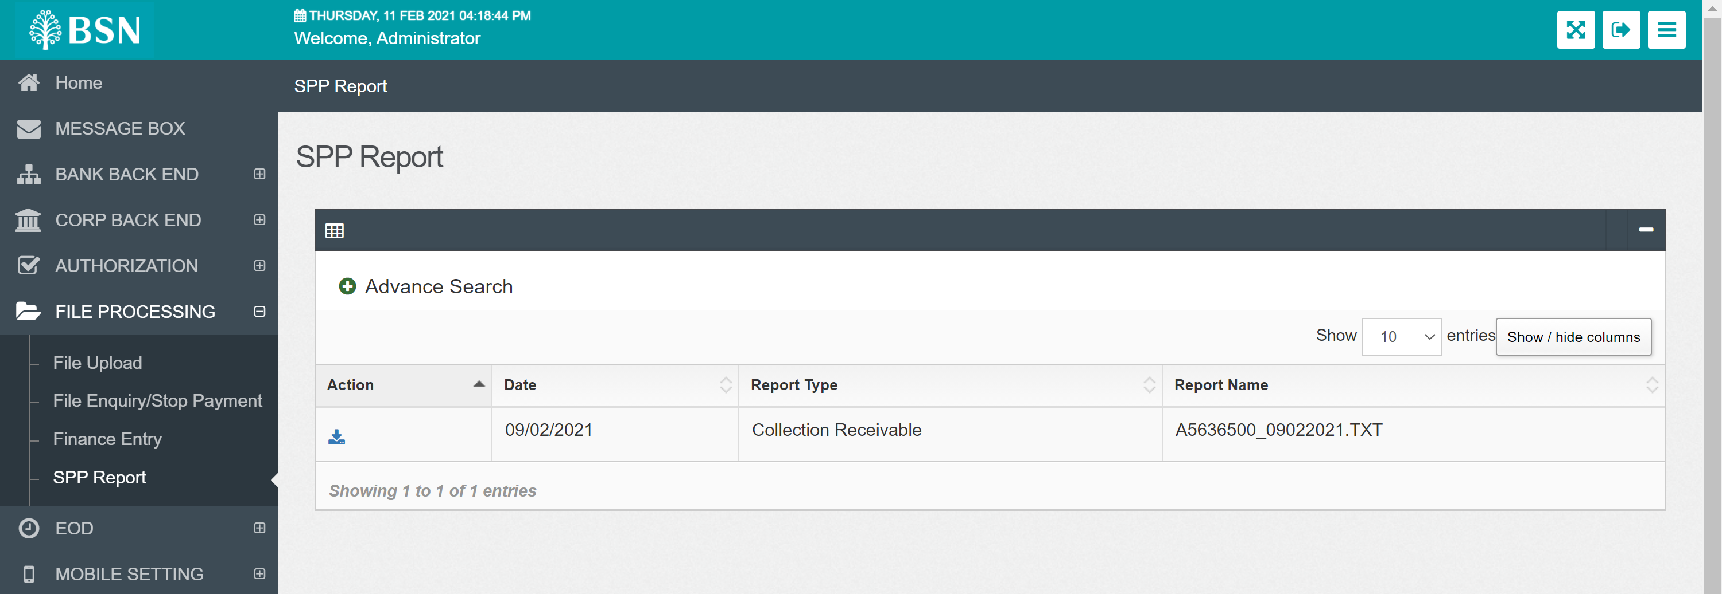

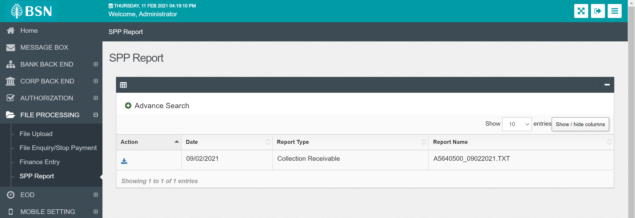

Create file without content

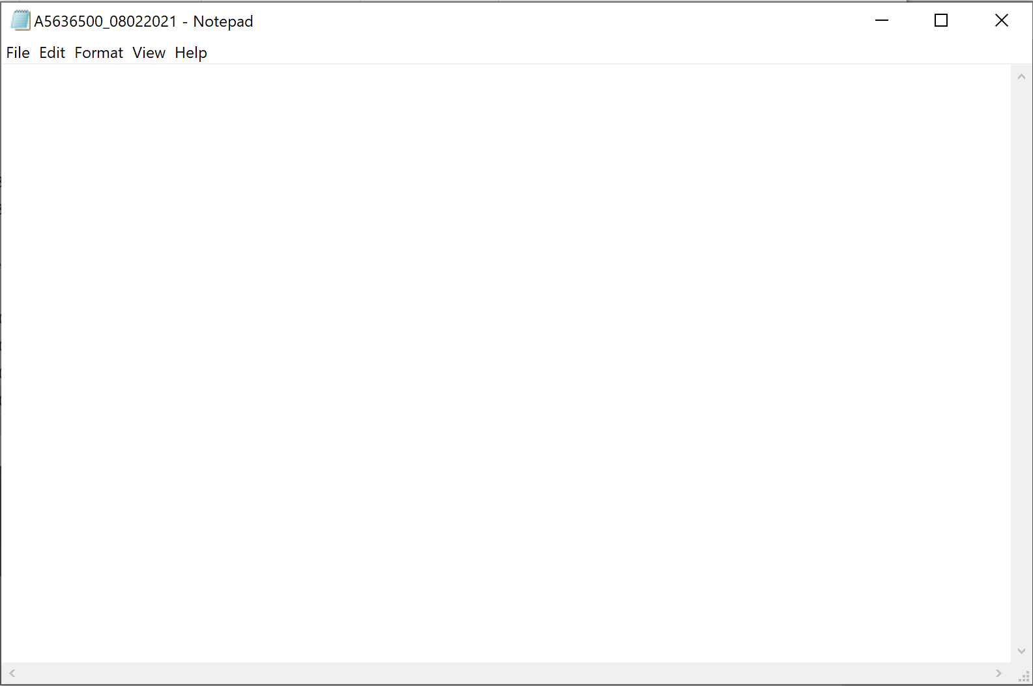 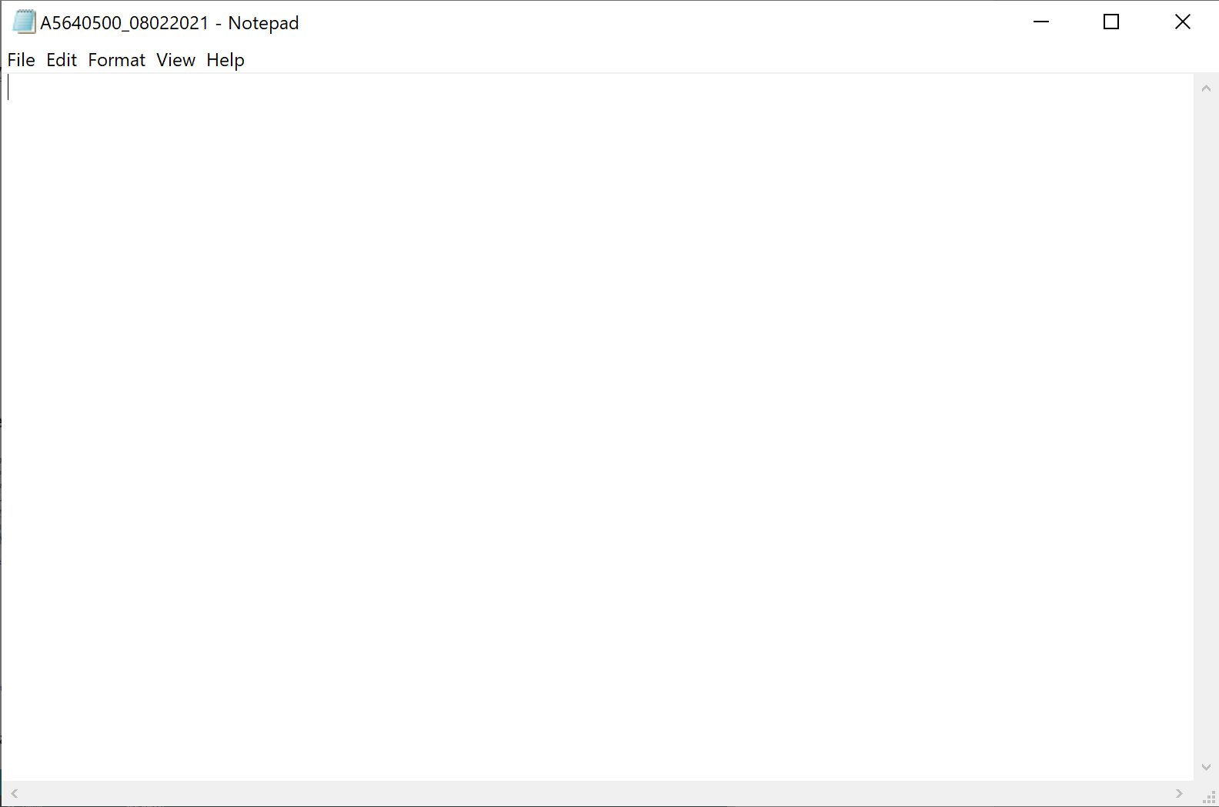

Insert created data to /batch/BSN/BatchFilesSIT/ICBSReports/Data/

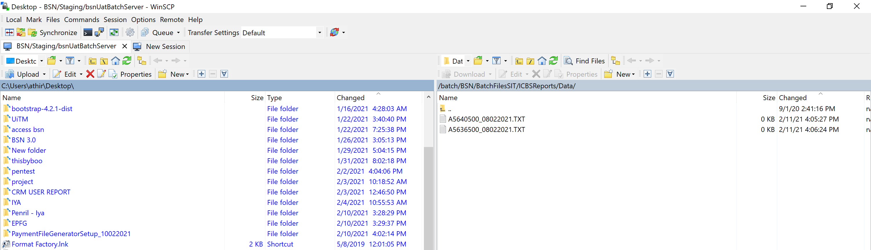

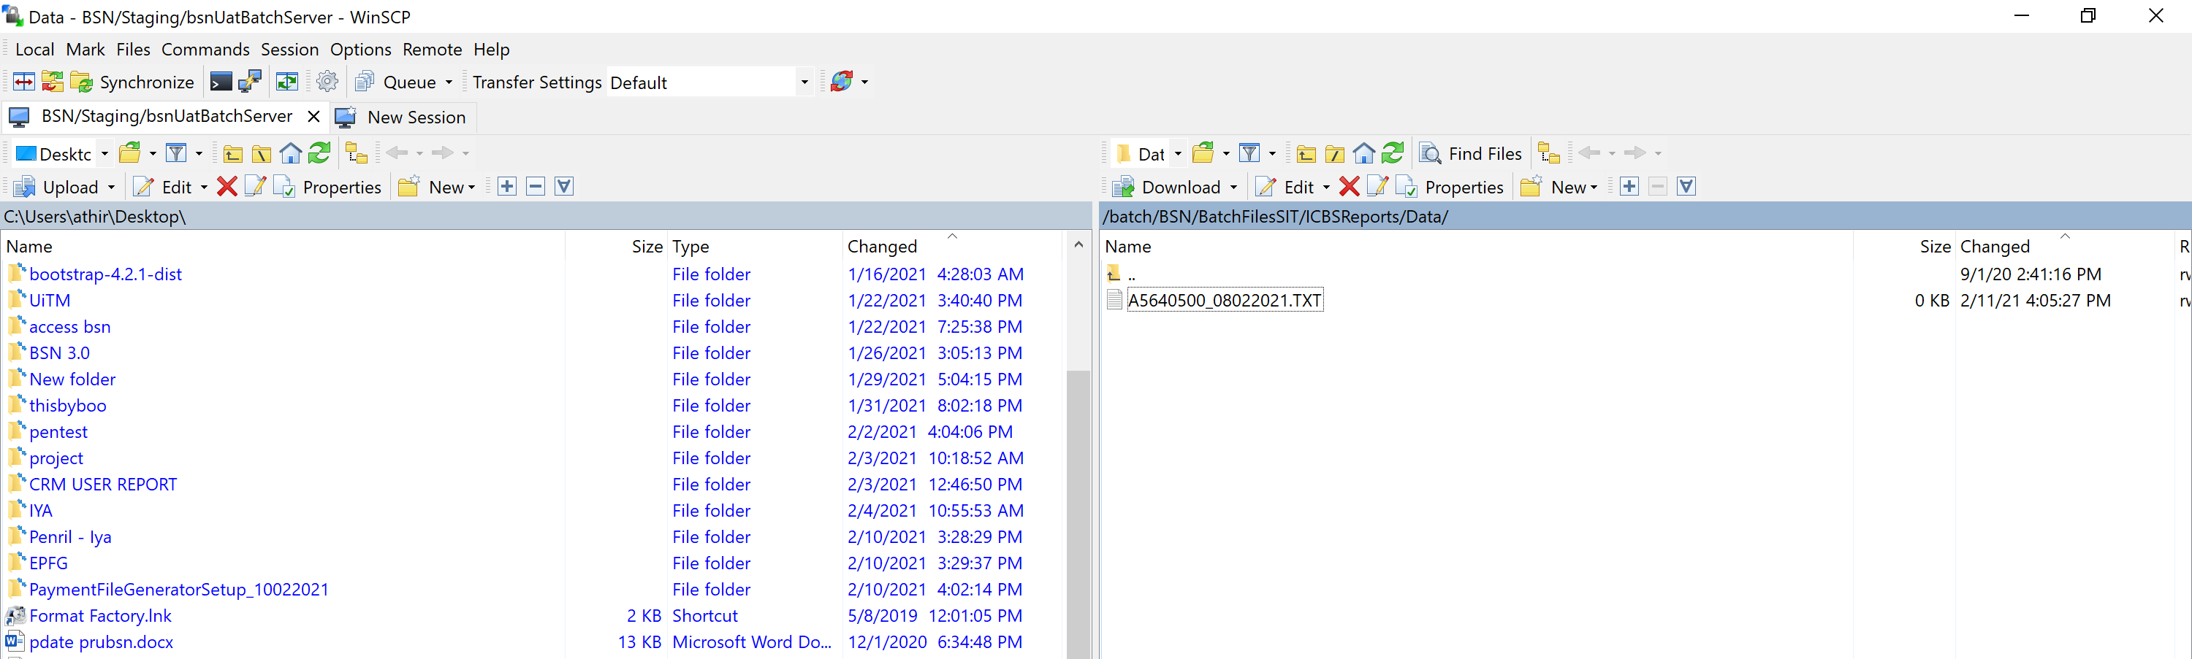

System only process file A5636500

