Issue:  
Bulk Payment stop payment not available in weekend but the service info operation is set to NO, meaning it should be available 24 hours

Finding:  
Bulk payment stop payment operation hour and weekend status checking is wrong due to number to boolean conversion

IBAM setting:  
Operation hour = NO  
Weekend = YES

CDB read as:  
Operation hour = YES  
Weekend = NO

Solution:  
Remove the number to boolean conversion. Check the operation hour and weekend status by its original value.

Test Case A:

1. Access IBAM>BBE>Content>Service Info>Bulk Payment Cancel File
2. Set Operation hour = NO
3. Set Weekend = YES
4. Expected result, eBiz shows Bulk Payment>History Listing>Stop button 24 hours and everyday

Test Case B:

1. Access IBAM>BBE>Content>Service Info>Bulk Payment Cancel File
2. Set Operation hour = NO
3. Set Weekend = NO
4. Expected result, eBiz shows Bulk Payment>History Listing>Stop button 24 hours and everyday (weekend only impact only if Operation Hour = Yes)

Test Case C:

1. Access IBAM>BBE>Content>Service Info>Bulk Payment Cancel File
2. Set Operation hour = YES
3. Set Operation time = 0800 - 2000
4. Set Weekend = YES
5. Expected result, eBiz shows Bulk Payment>History Listing>Stop button only between 8am to 8pm every day including weekend

Test Case D:

1. Access IBAM>BBE>Content>Service Info>Bulk Payment Cancel File
2. Set Operation hour = YES
3. Set Operation time = 0800 - 2000
4. Set Weekend = NO
5. Expected result, eBiz shows Bulk Payment>History Listing>Stop button displayed only between 8am to 8pm on week days

# Test Case A

1. Access IBAM>BBE>Content>Service Info>Bulk Payment Cancel File
2. Set Operation hour = NO
3. Set Weekend = YES
4. Expected result, eBiz shows Bulk Payment>History Listing>Stop button 24 hours and everyday

Test Result: Stop Button at Bulk Payment displayed 24 hour at every day, even when operation Start/End Time set to be: 0800-1000

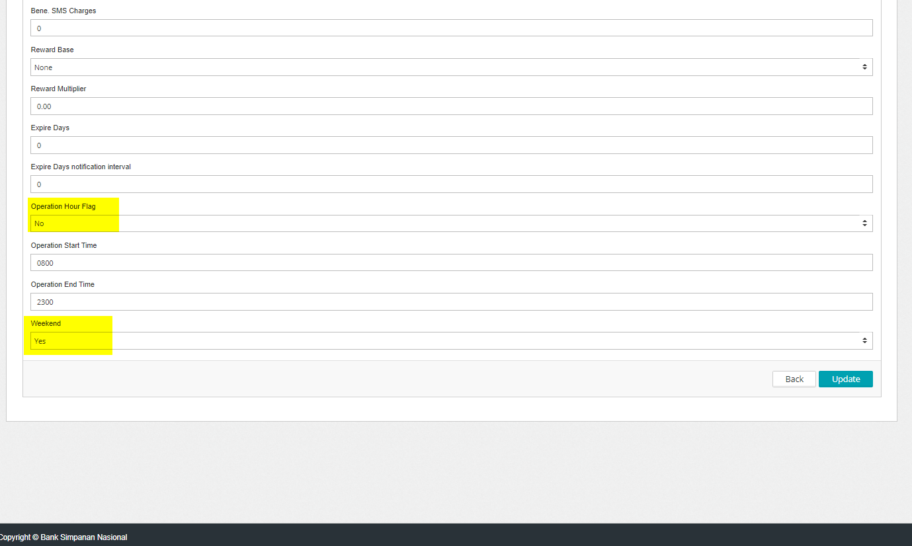

Monday at 1124

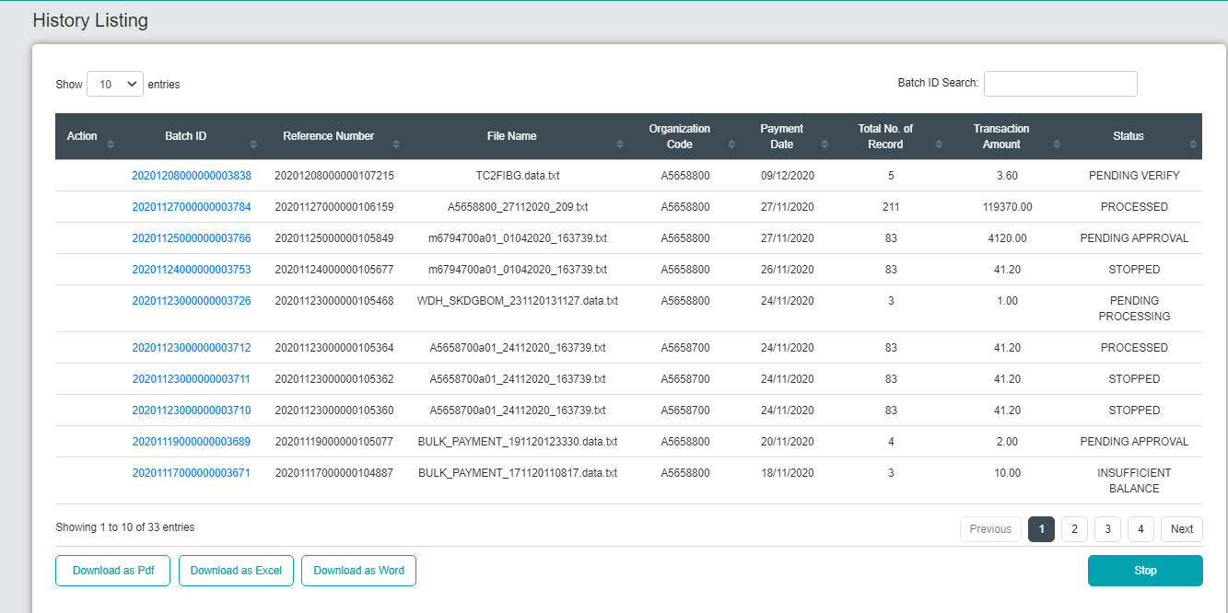

Sunday at 1156

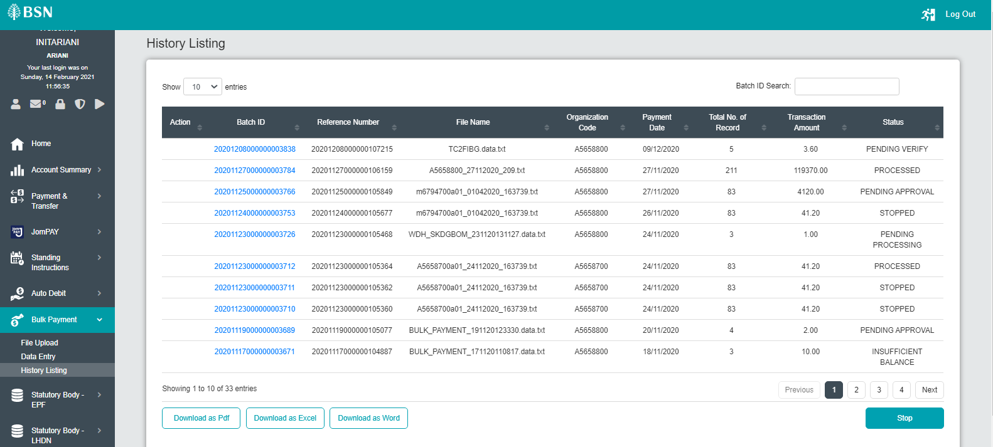

# Test Case B

1. Access IBAM>BBE>Content>Service Info>Bulk Payment Cancel File
2. Set Operation hour = NO
3. Set Weekend = NO
4. Expected result, eBiz shows Bulk Payment>History Listing>Stop button 24 hours and everyday (weekend only impact only if Operation Hour = Yes)

Test Result: Stop Button at Bulk Payment displayed 24 hour at every day, even when operation Start/End Time set to be: 0800-1000

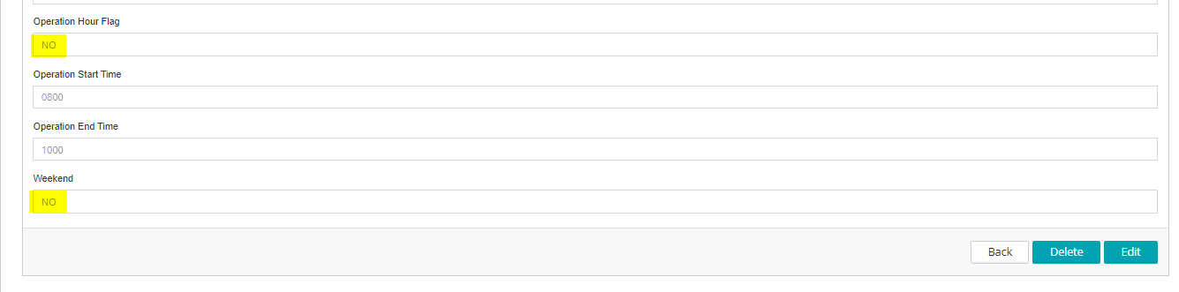

Monday at 1134

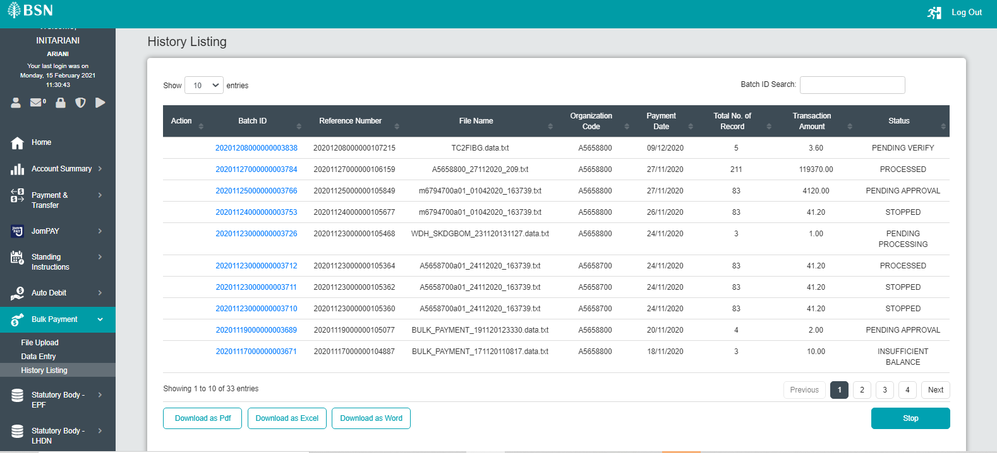

Sunday at 1156



# Test Case C

1. Access IBAM>BBE>Content>Service Info>Bulk Payment Cancel File
2. Set Operation hour = YES
3. Set Operation time = 0800 - 1000
4. Set Weekend = YES
5. Expected result, eBiz shows Bulk Payment>History Listing>Stop button only between 8am to 8pm every day including weekend

Test Result: “Stop” button not display when set operation hour 0800-1000 at Sunday, 1209

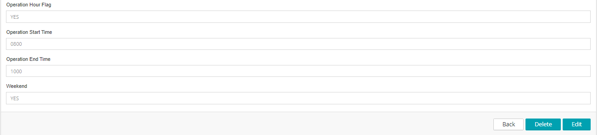

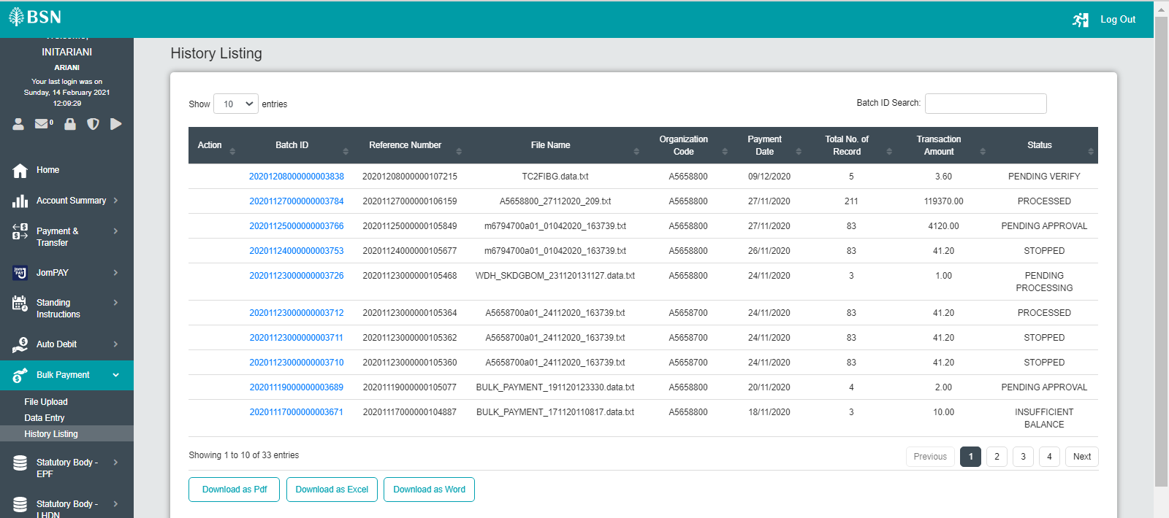

Test Result: “Stop” button display when set operation hour 0800-2100 at Sunday, 1209

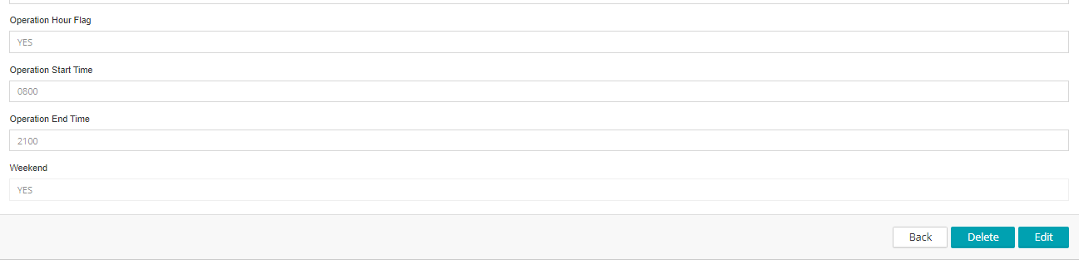

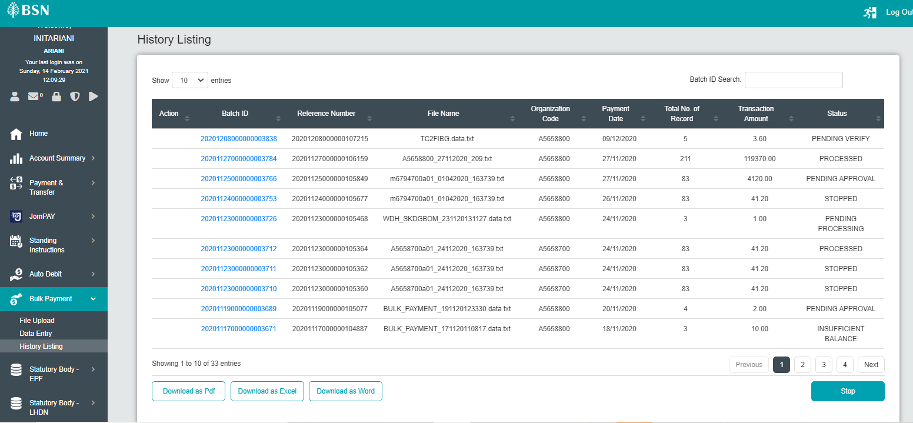

Test Result: “Stop” button not display when set operation hour 0800-1000 at Monday, 1209

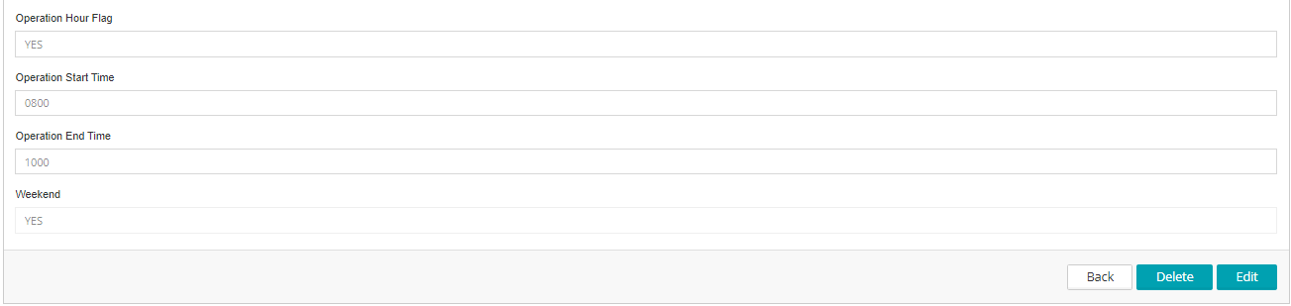

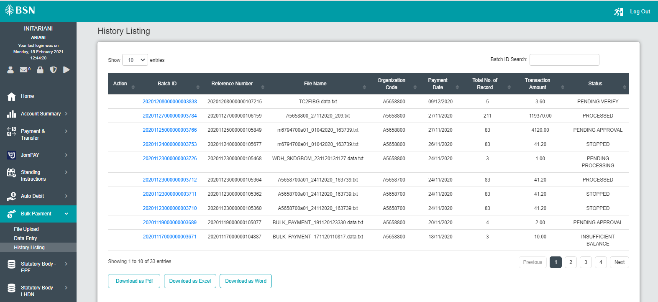

Test Result: “Stop” button display when set operation hour 0800-2100 at Monday, 1209

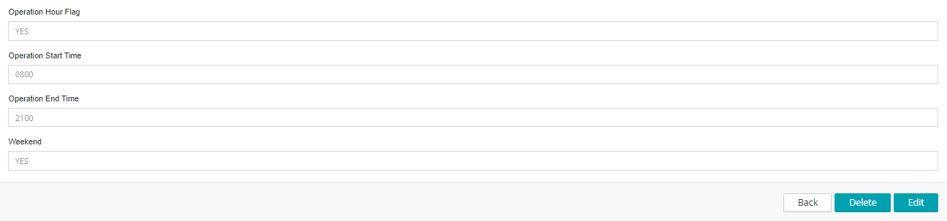

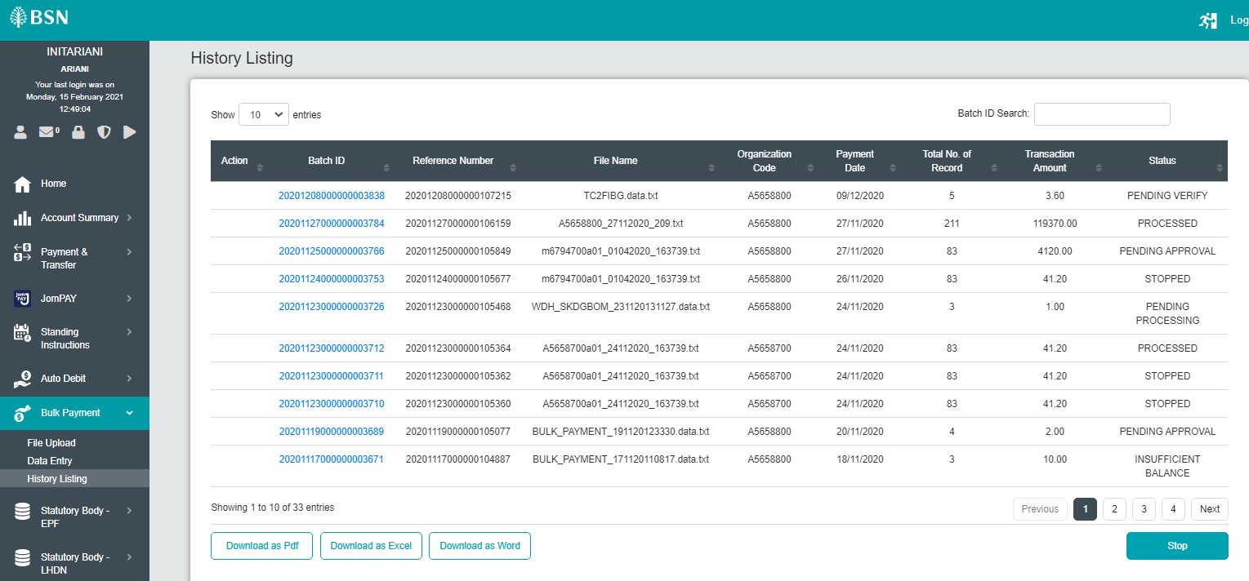

# Test Case D

1. Access IBAM>BBE>Content>Service Info>Bulk Payment Cancel File
2. Set Operation hour = YES
3. Set Operation time = 0800 - 2000
4. Set Weekend = NO
5. Expected result, eBiz shows Bulk Payment>History Listing>Stop button displayed only between 8am to 8pm on week days

Test Result: “Stop” button not display when set operation hour 0800-1000 at Sunday, 1209

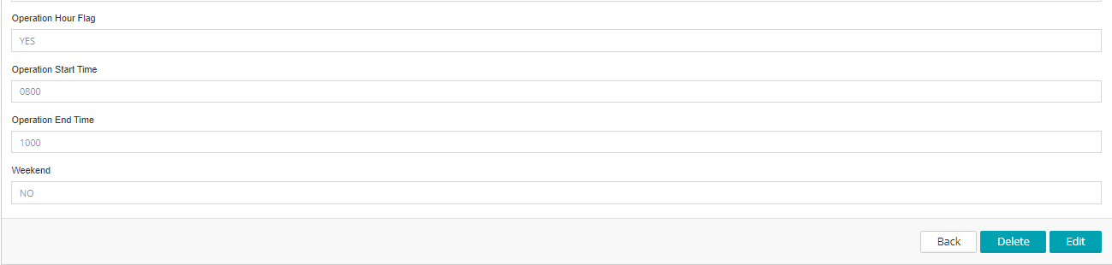

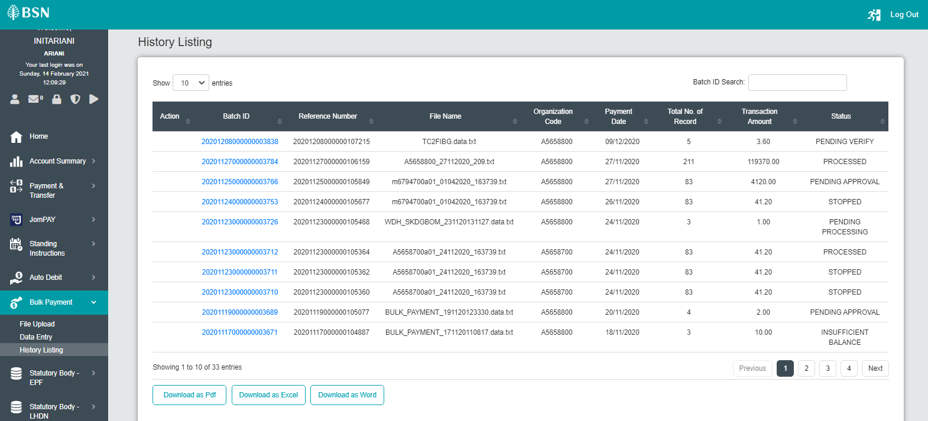

Test Result: “Stop” button not display when set operation hour 0800-2100 at Sunday, 1229

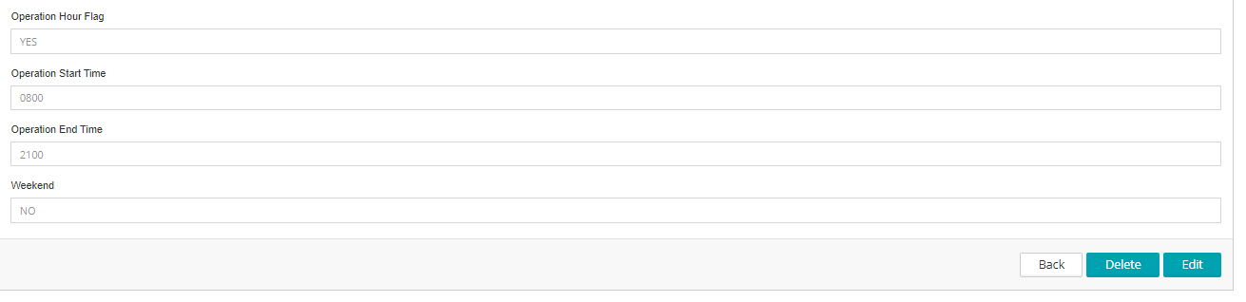

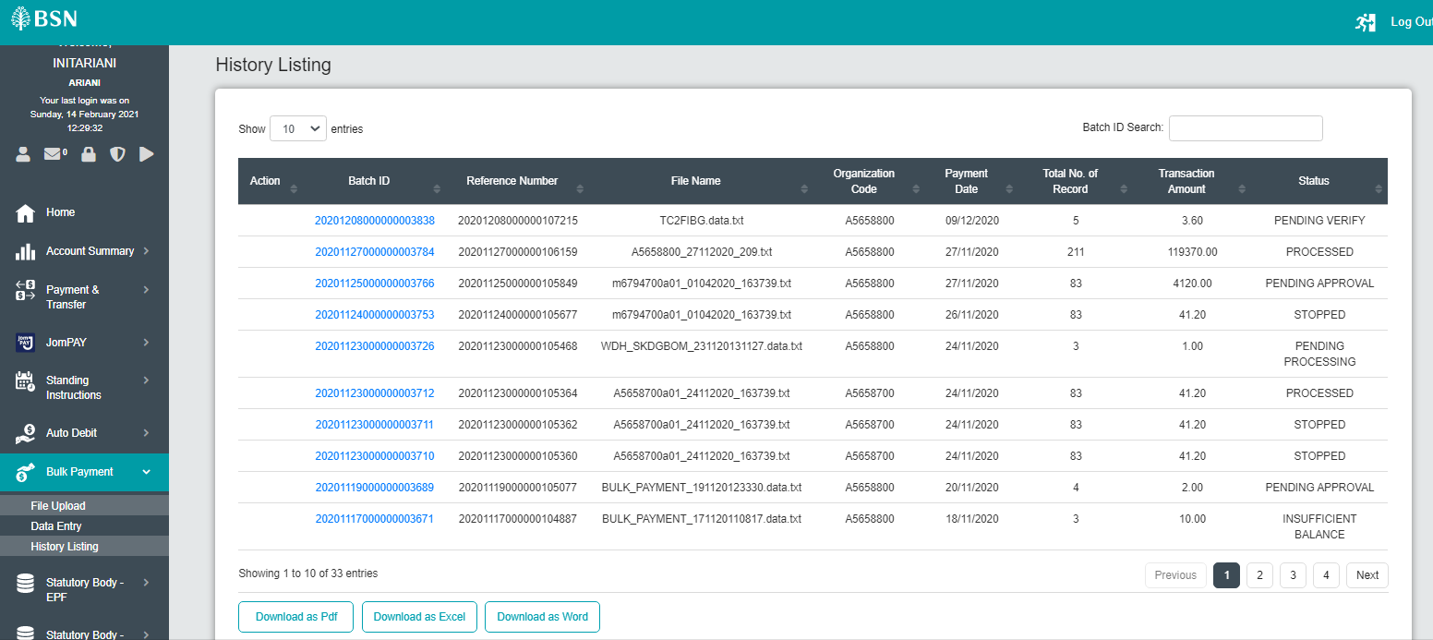

Test Result: “Stop” button not display when set operation hour 0800-1000 at Monday, 1229

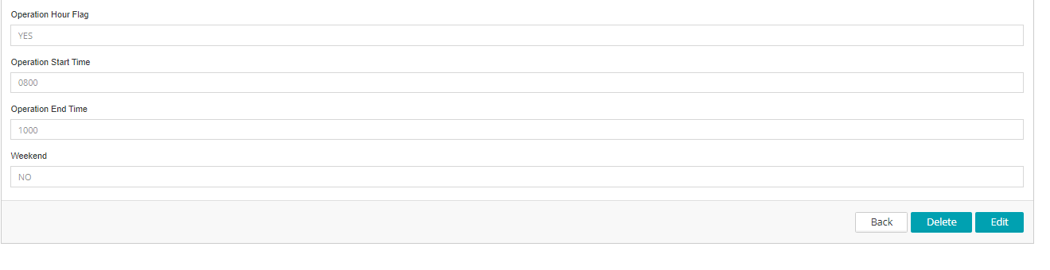

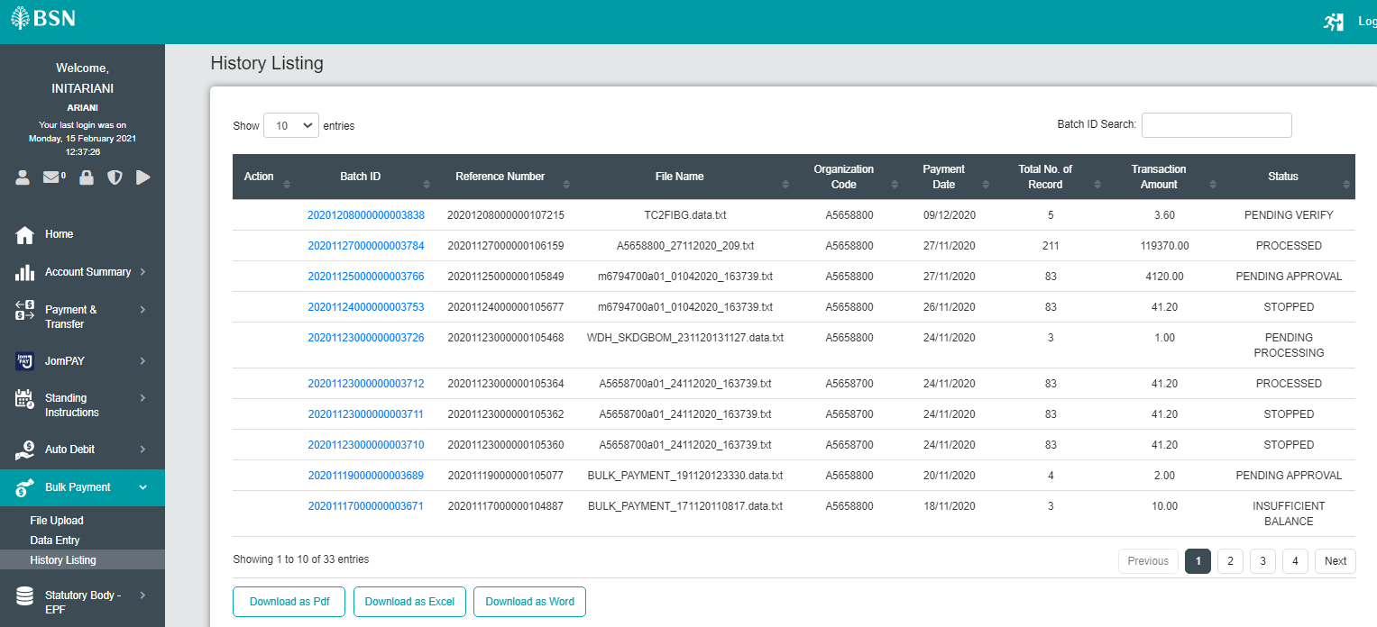

Test Result: “Stop” button display when set operation hour 0800-2100 at Monday, 1229

