Mandatory to check duplicate for first time

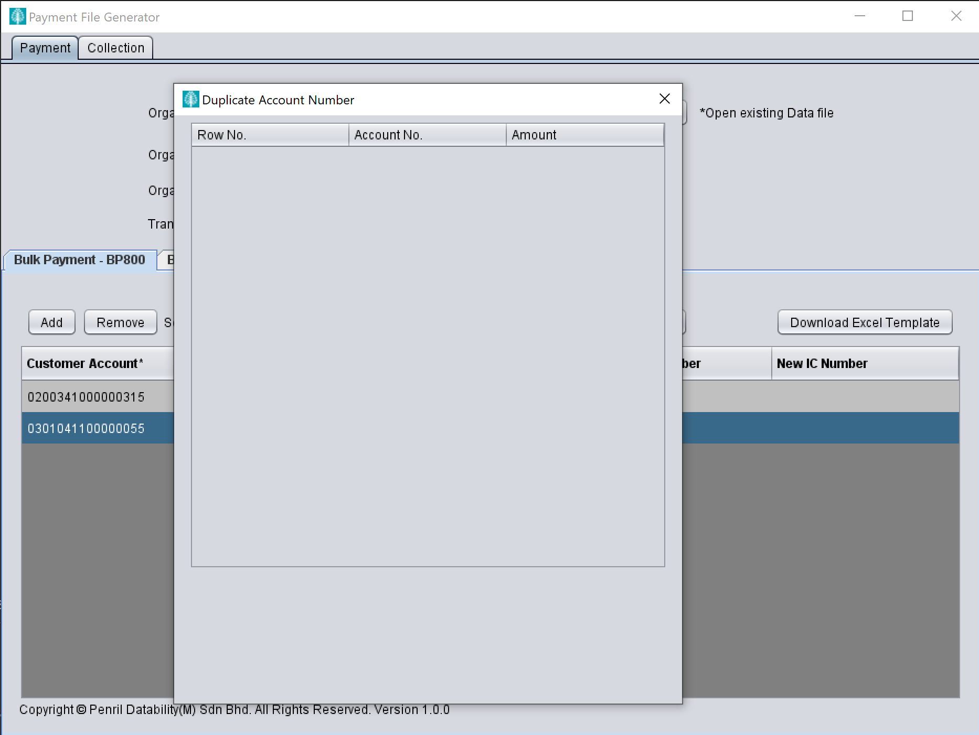

Save file

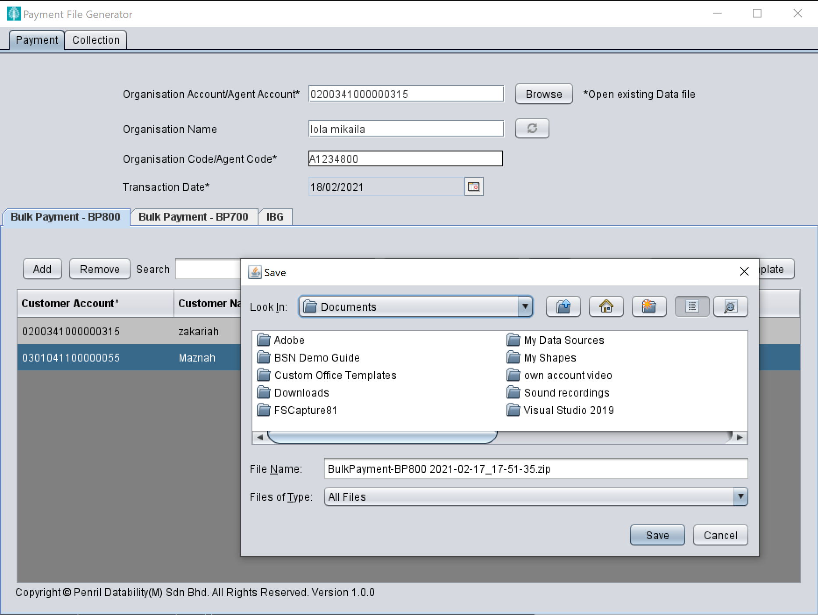

Result : Check duplicate no longer mandatory

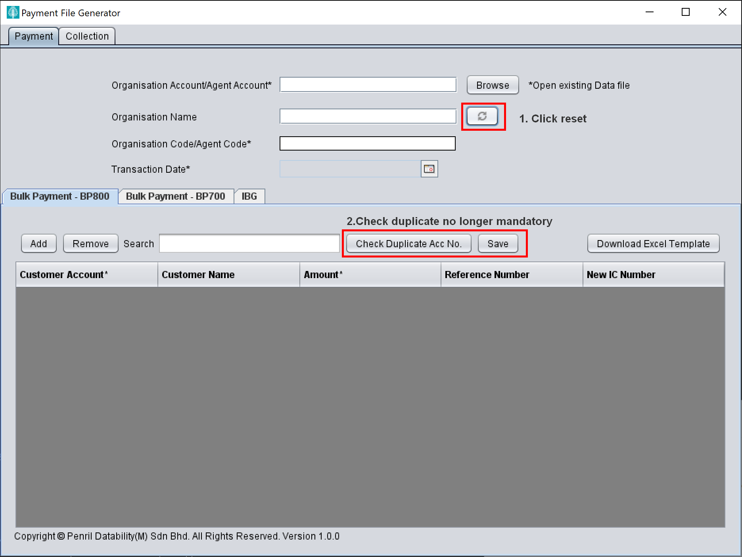

Expected : System should still forced user to do check duplicate button.