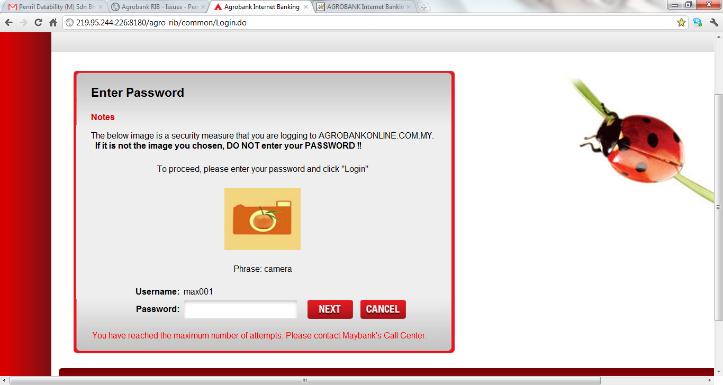

1. The word “Maybank” is used instead of “Agro” for the login error message.