1. When the status of the RIB account become "unlock" in IBAM, the security question will only accept the answer of the first existing security question, when trying to reset the security questions in the RIB account.
2. After resetting the security question with invalid answer (using the answer of the first existing security question for any questions ), the RIB account cannot be accessed as shown below:

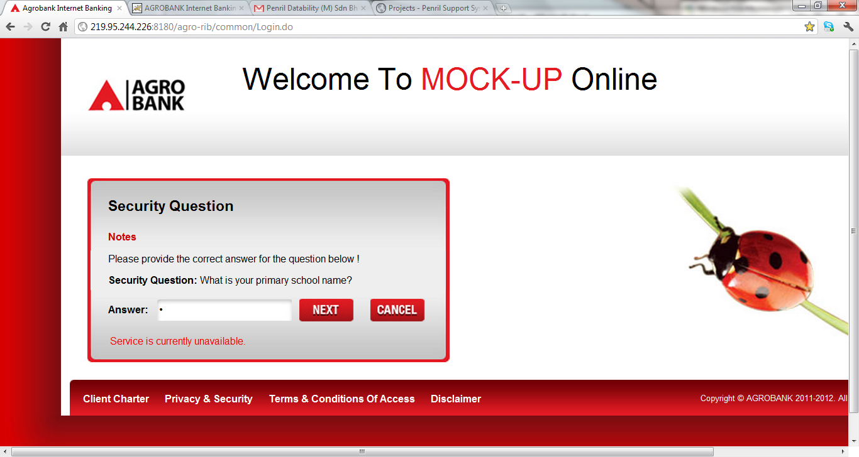

1. When the login process is cancelled by the user and re-login again, it states that the RIB account has been locked, but the status shown in IBAM is “unlock”.