|  |  |  |  |  |  |  |  |  |  |  |  |  |  |  |  |  |  |  |  |  |
| --- | --- | --- | --- | --- | --- | --- | --- | --- | --- | --- | --- | --- | --- | --- | --- | --- | --- | --- | --- | --- |
| Less Length | | | | | | No Value | | | | | | Entering Space | | | | | | Blank File | Wrong File Format | Correct File with wrong Value |
| Header | | Footer | | Content | | Header | | Footer | | Content | | Header | | Footer | | Content | |
| ✓ | LHDNLLH | ✓ | LHDNLLF | ✓ | LHDNLLC | ✓ | LHDNNVH | ✓ | LHDNNVF | ✓ | LHDNNVC | ✓ | LHDNESH | ✓ | LHDNESF | ✓ | LHDNES | LHDNBF✓ | LHDNWFF✓ | LHDNID✓ |

### 

### LHDNLLH

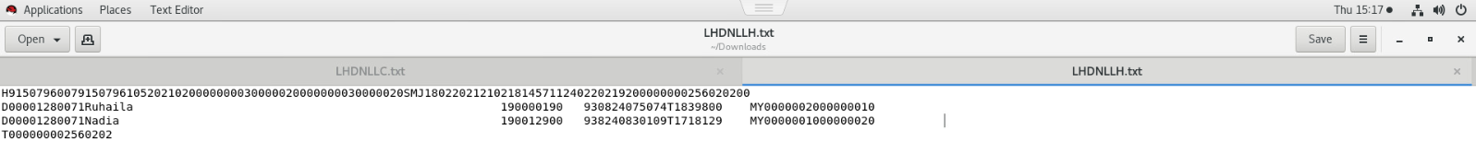

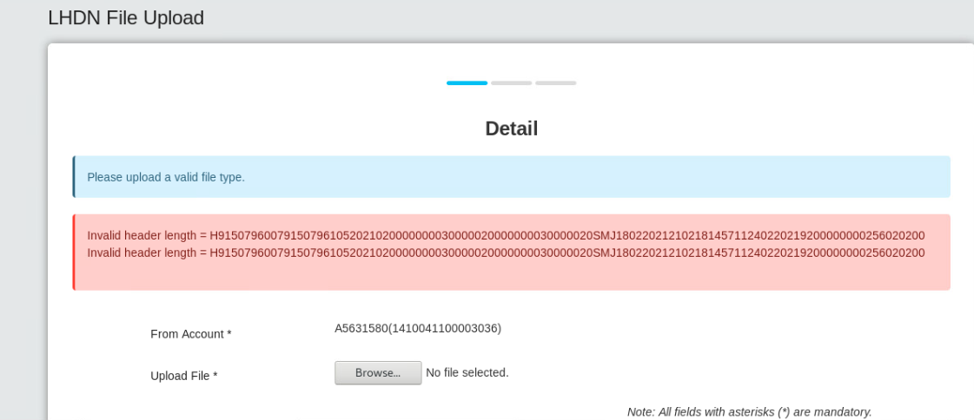

### LHDNLLF



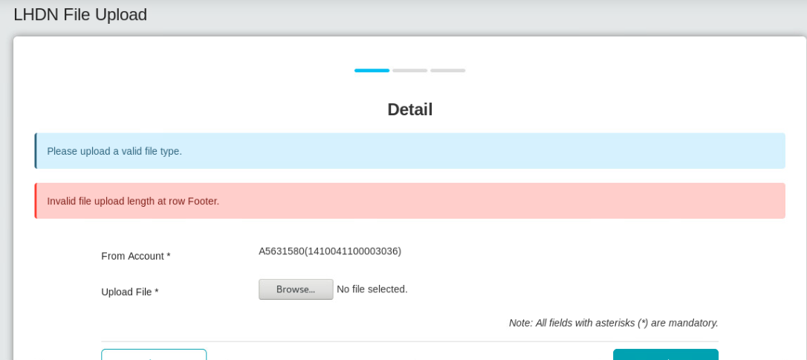

### LHDNLLC



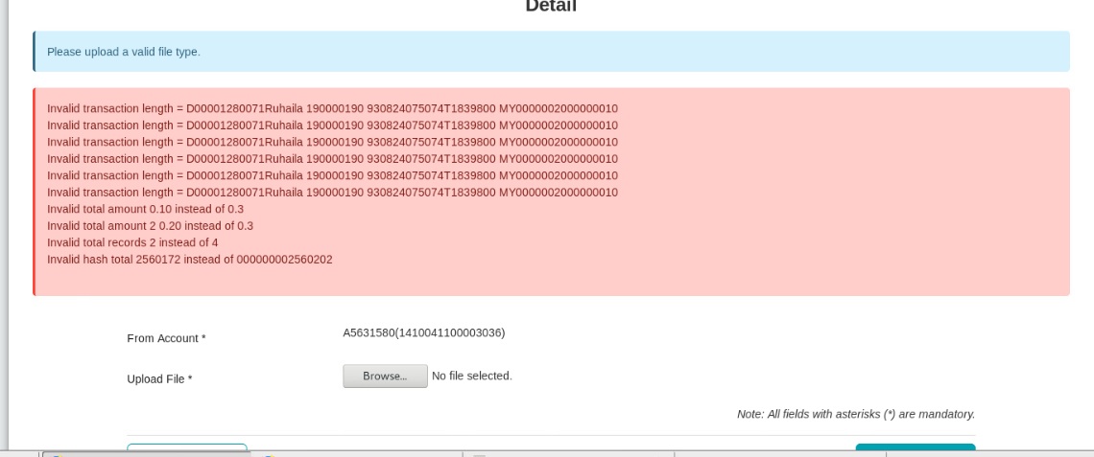

### LHDNNVH



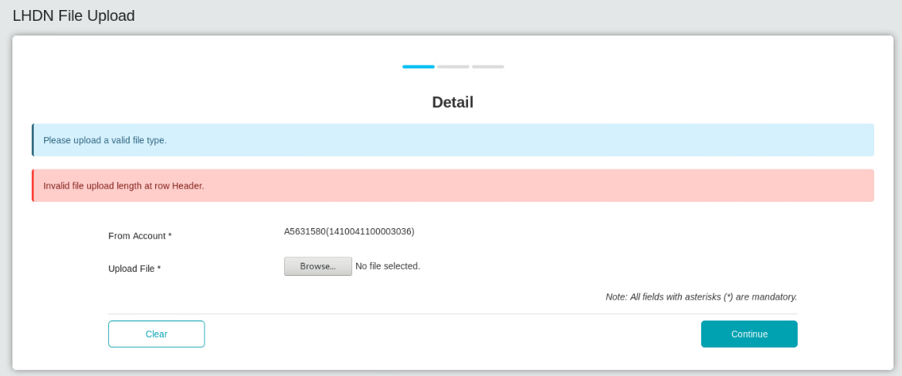

### LHDNNVF



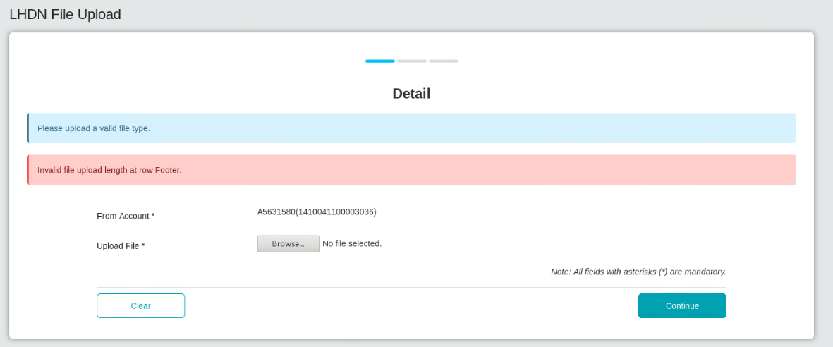

### LHDNNVC



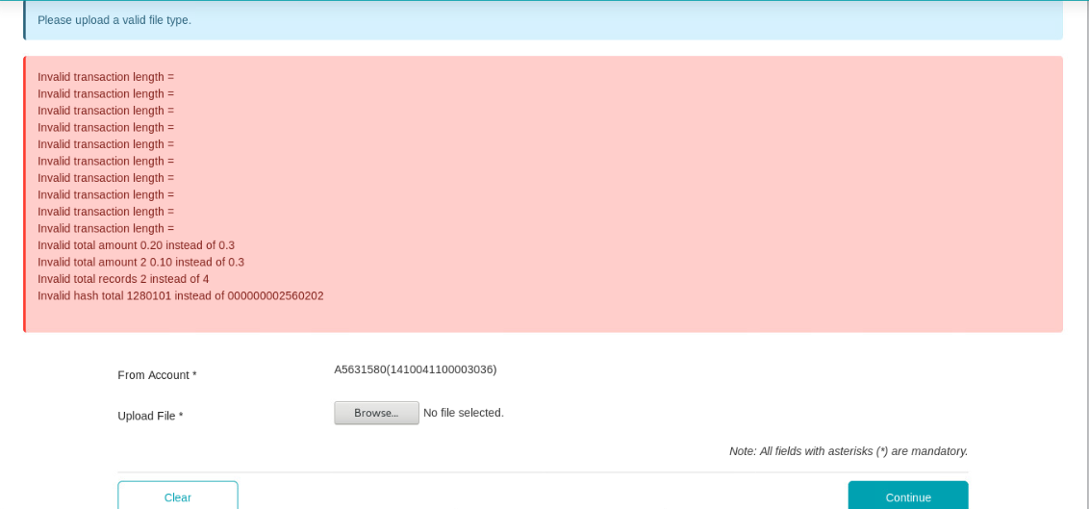

### LHDNESH



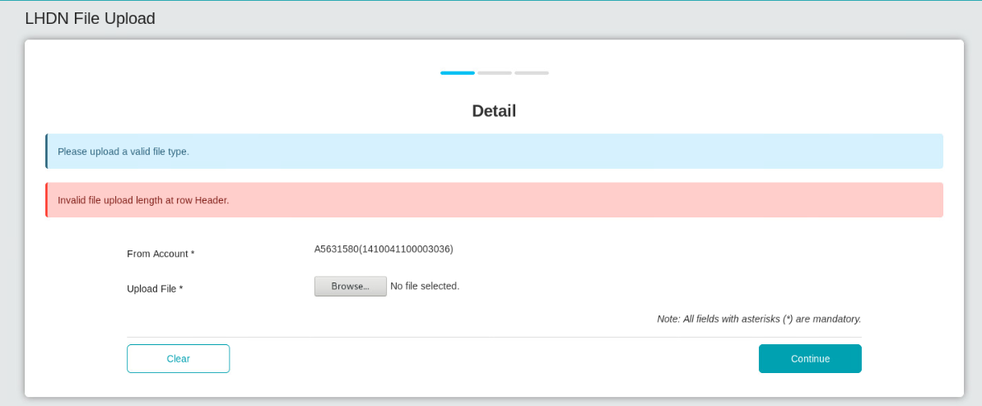

### LHDNESF



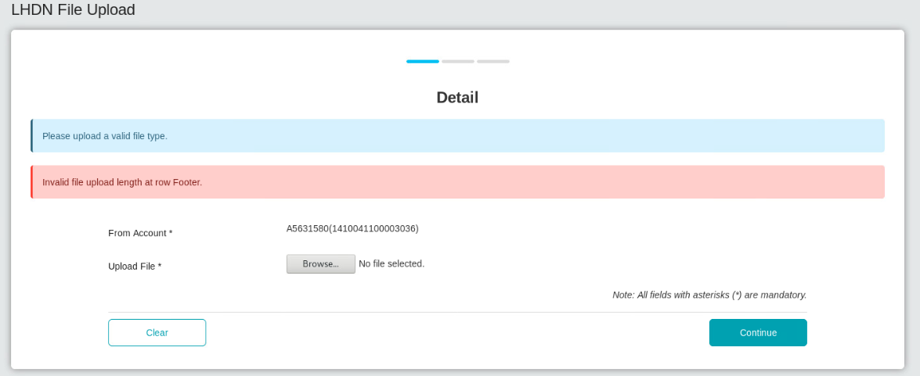

### LHDNESC



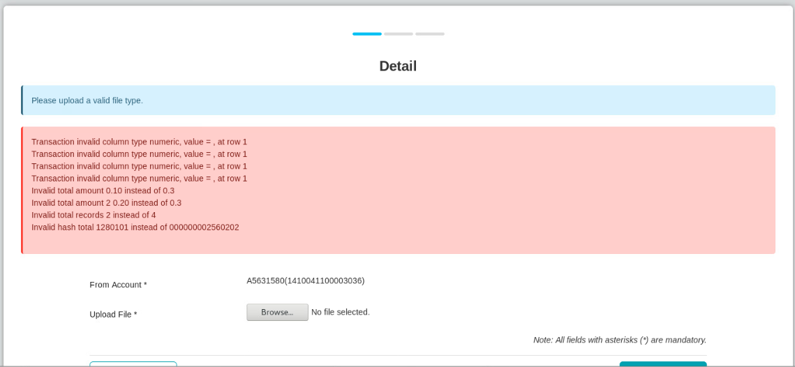

### LHDNBF



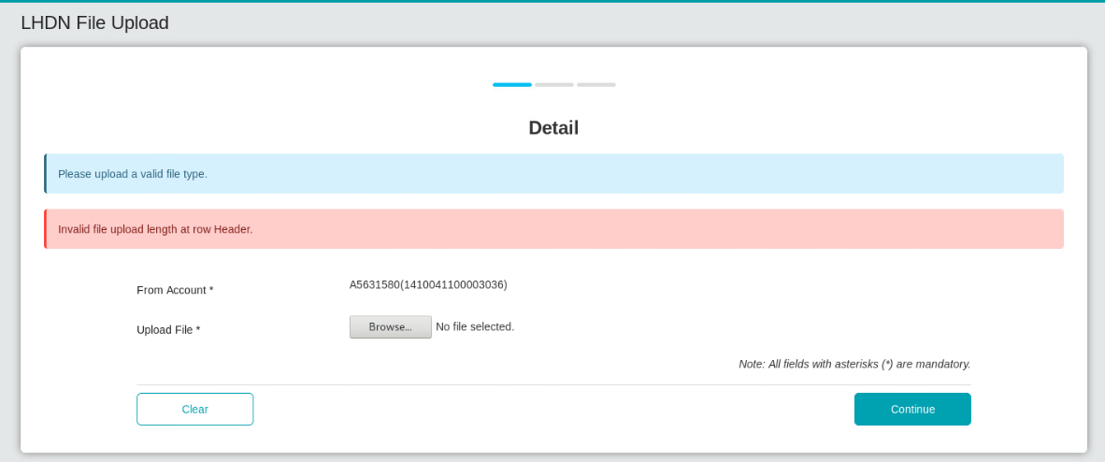

### LHDNWFF

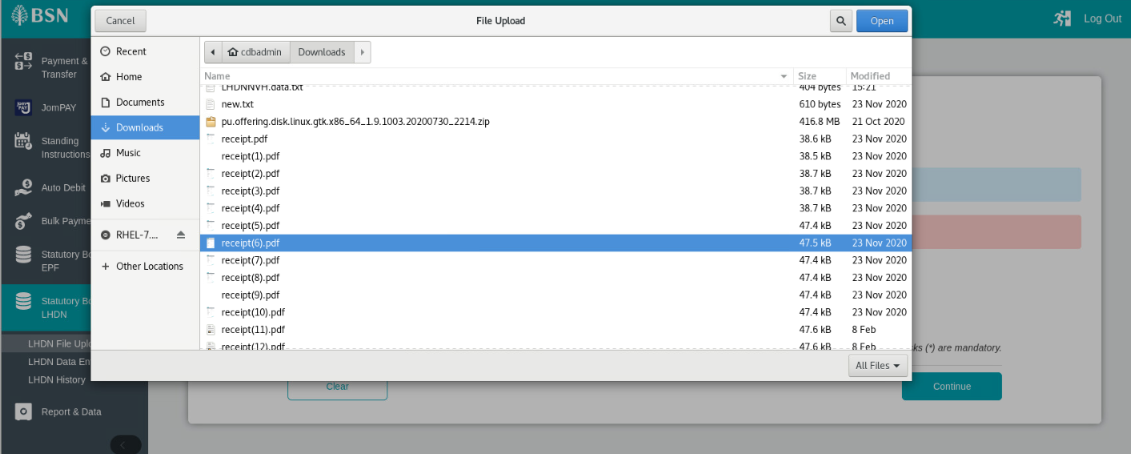

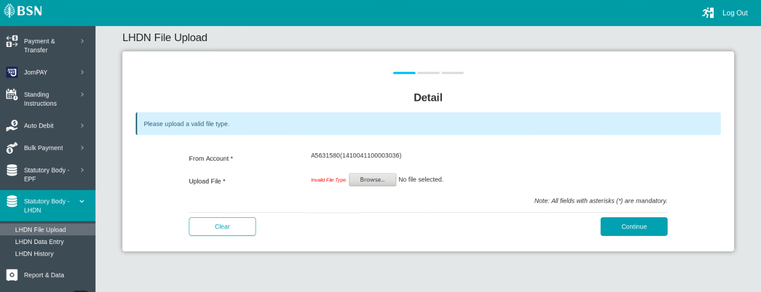

### LHDNID



