Issue:  
UKB upload old Bolt Bulk Payment file to IBAM and get error hash total.  
JTM suggest UKB to use eBiz Bulk Payment Data Entry Edit to download new file with new hash total.  
UKB get error at Bulk Payment File Upload but successful at Bulk Payment Data Entry Edit.

Finding:

1. File upload issue related to Support [#11577](https://hub.penril.net/redmine/issues/11577)
2. Data entry issue in SIT due to service info max limit

Solution:

1. Fix max limit according to Service info Bulk Payment Data Entry
2. Update IBAM>BBE>Service info>Bulk Payment Data Entry Max limit to 1 million
3. Update error message Invalid transaction amount at row #. Max limit is #.

Test steps A:

1. Access IBAM>BBE>Service info>Bulk Payment Data Entry
2. Set Max limit to 1 million
3. Access eBiz Bulk Payment Data Entry Edit
4. Upload the testing file
5. Expected result, Bulk Payment Data Entry Edit can be completed

Test steps B:

1. Access IBAM>BBE>Service info>Bulk Payment Data Entry
2. Set Max limit to 10
3. Access eBiz Bulk Payment Data Entry Edit
4. Upload the testing file
5. Expected result, will get error message with max limit

# Scenario A

1. Access IBAM>BBE>Service info>Bulk Payment Data Entry
2. Set Max limit to 1 million
3. Access eBiz Bulk Payment Data Entry Edit
4. Upload the testing file
5. Expected result, Bulk Payment Data Entry Edit can be completed



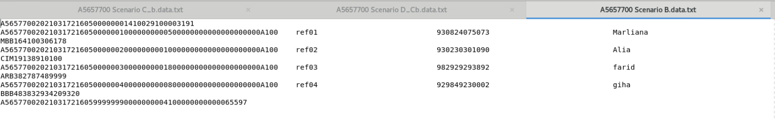

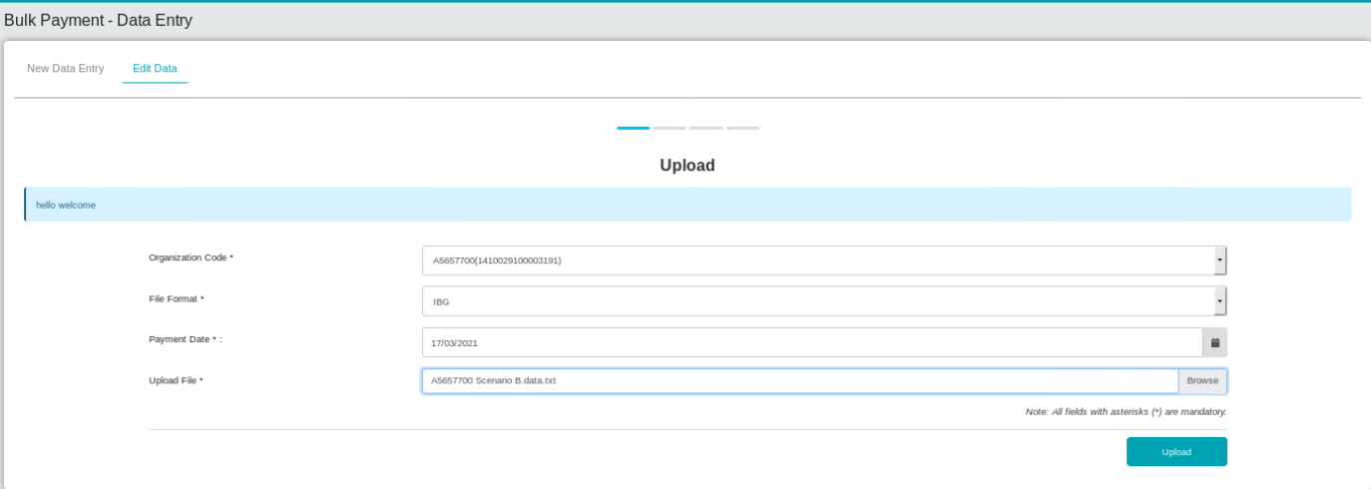

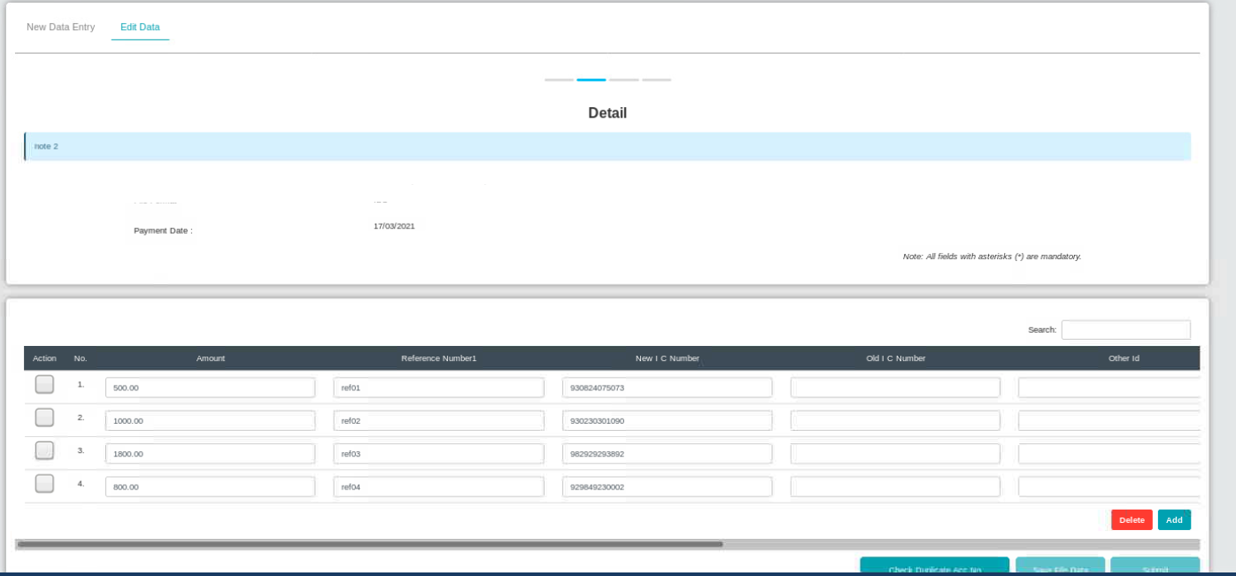

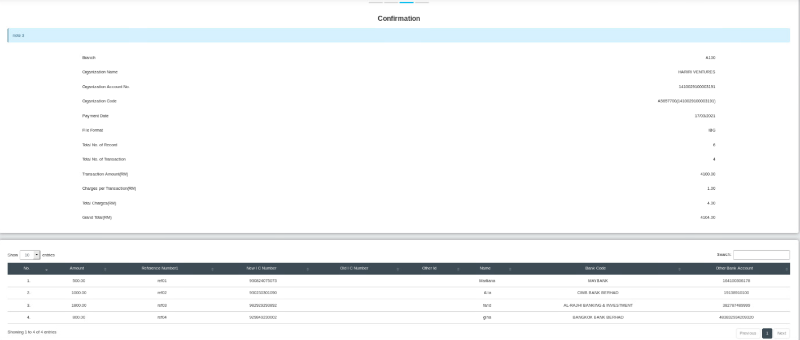

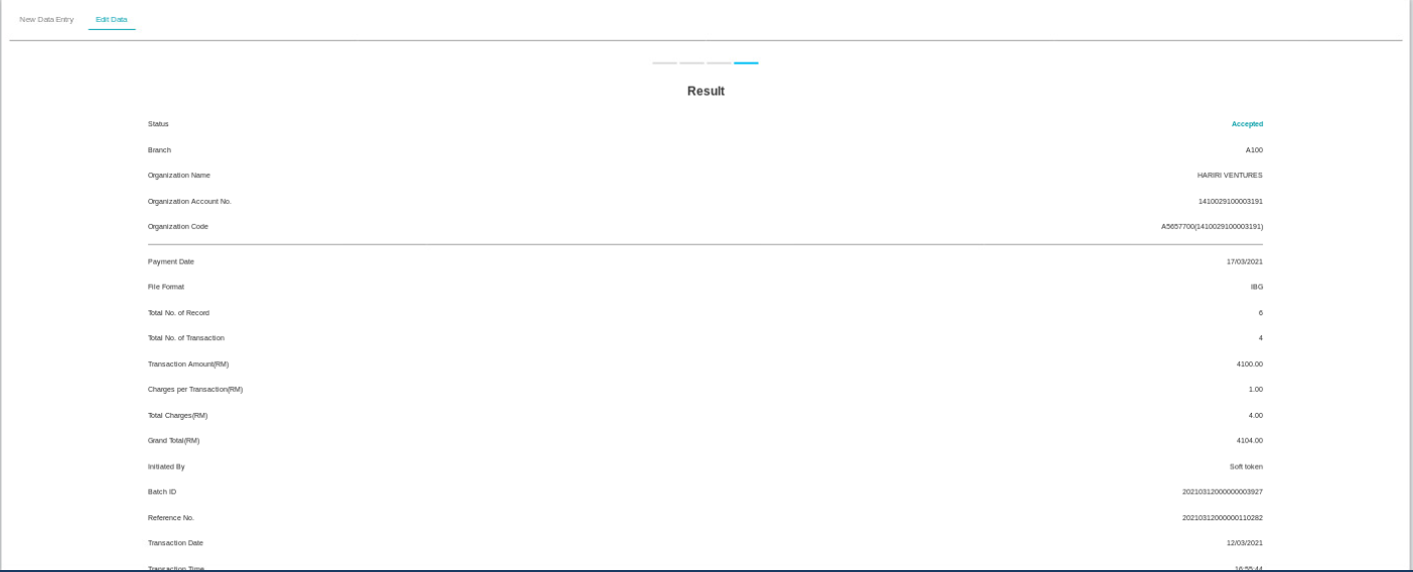

# Scenario B

1. Access IBAM>BBE>Service info>Bulk Payment Data Entry
2. Set Max limit to 10
3. Access eBiz Bulk Payment Data Entry Edit
4. Upload the testing file
5. Expected result, will get error message with max limit





