Issue:  
UKB upload old Bolt Bulk Payment file to IBAM and get error hash total.  
JTM suggest UKB to use eBiz Bulk Payment Data Entry Edit to download new file with new hash total.  
UKB get error at Bulk Payment File Upload.

Finding:

1. Issue only for Bulk Payment File Upload IBG
2. Bulk payment max limit is read from Interbank Transfer max limit.
3. File upload validation translate cent amount. Eg RM12,500.00 to RM1,250,000.00 which over max limit set or 1 million.

Solution:

1. Fix max limit according to Service info Bulk Payment File Upload
2. Update IBAM>BBE>Service info>Bulk Payment File Upload Max limit to 1 million
3. Update error message Transaction invalid amount for field #, value = #, at row #. Max limit is #

Test steps A:

1. Access IBAM>BBE>Service info>Bulk Payment File Upload
2. Set Max limit to 1 million
3. Access eBiz Bulk Payment File Upload
4. Select IBG
5. Upload the testing file
6. Expected result, Bulk Payment Data File Upload can be completed

Test steps B:

1. Access IBAM>BBE>Service info>Bulk Payment File Upload
2. Set Max limit to 10
3. Access eBiz Bulk Payment Data File Upload
4. Select IBG
5. Upload the testing file
6. Expected result, will get error message with max limit

Test steps C:

1. Repeat Test A and B for IBAM File Upload

Test steps D:

1. Repeat Test A, B and C for non-IBG file
2. Expected result, there is no amount limit validation

# Scenario A

1. Access IBAM>BBE>Service info>Bulk Payment File Upload
2. Set Max limit to 1 million
3. Access eBiz Bulk Payment File Upload
4. Select IBG
5. Upload the testing file
6. Expected result, Bulk Payment Data File Upload can be completed

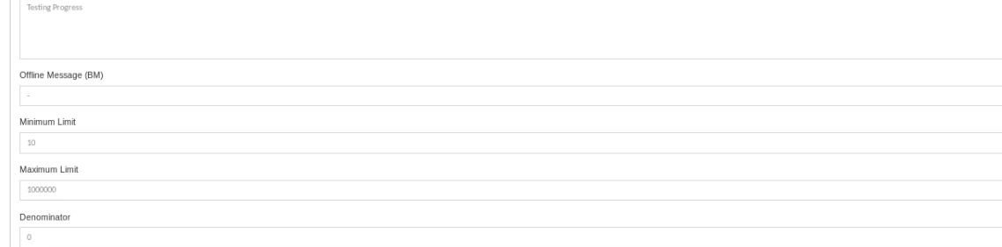

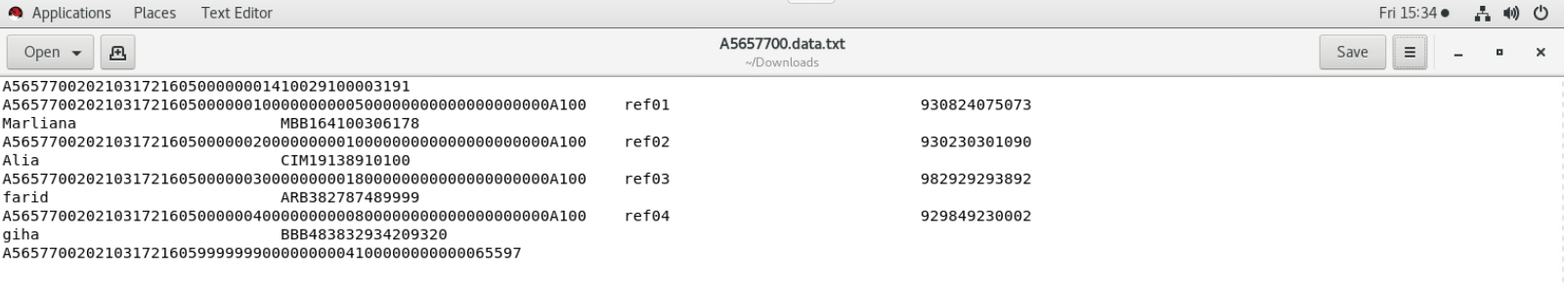

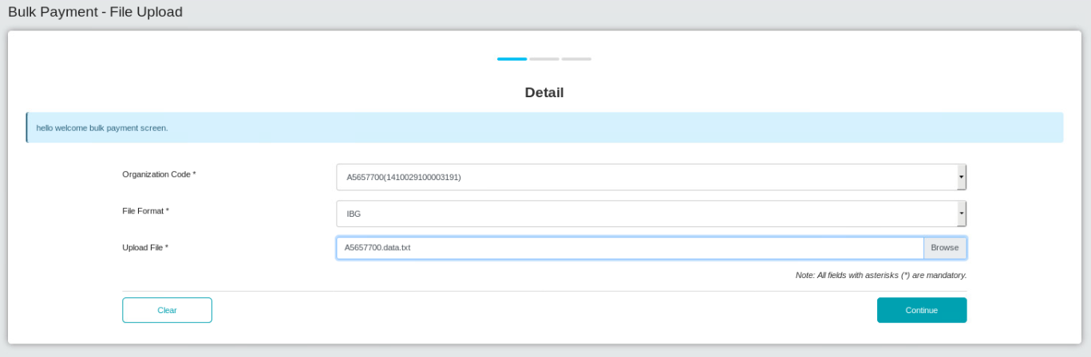

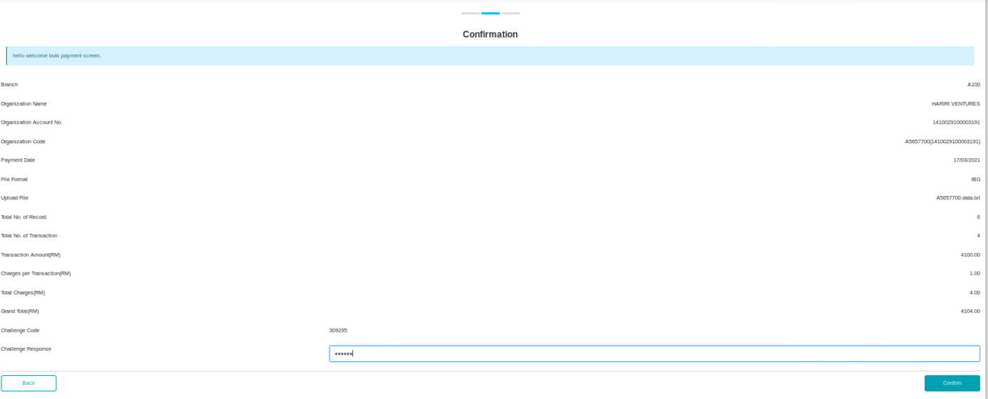

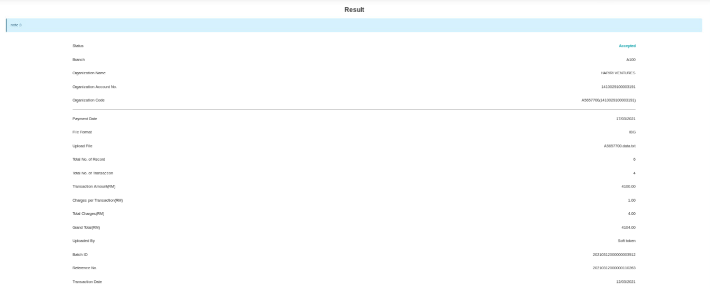

# Scenario B

1. Access IBAM>BBE>Service info>Bulk Payment File Upload
2. Set Max limit to 10
3. Access eBiz Bulk Payment Data File Upload
4. Select IBG
5. Upload the testing file
6. Expected result, will get error message with max limit

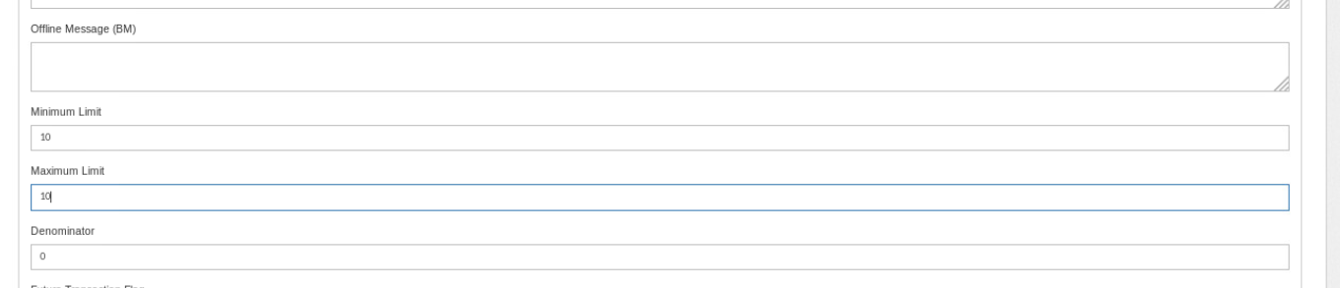

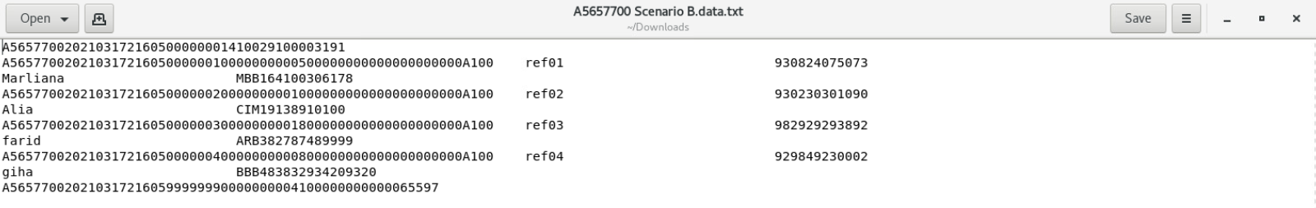

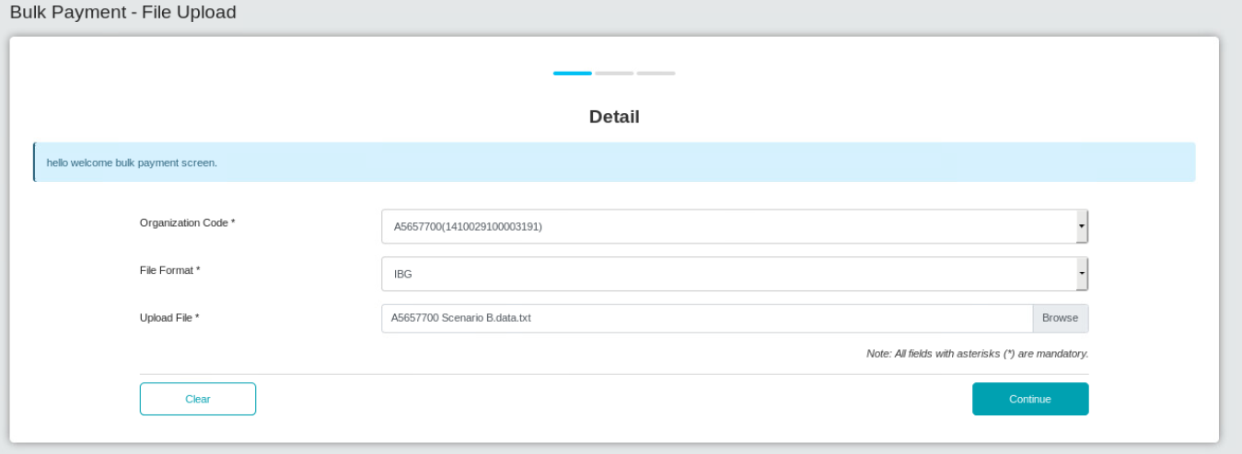

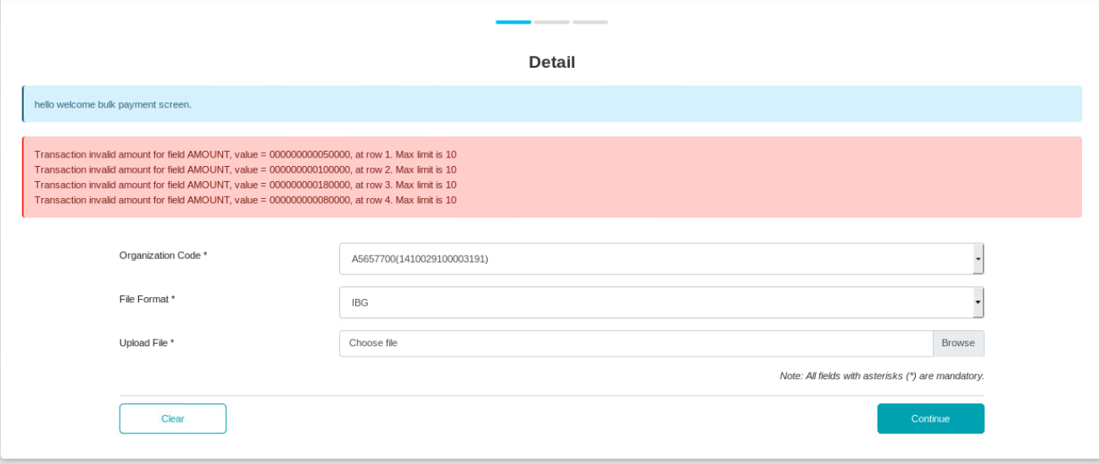

# Scenario C (a)

1. Access IBAM>BBE>Service info>Bulk Payment File Upload
2. Set Max limit to 1 million
3. Access IBAM Bulk Payment File Upload
4. Select IBG
5. Upload the testing file
6. Expected result, Bulk Payment Data File Upload can be completed

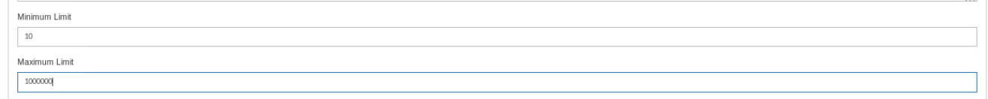

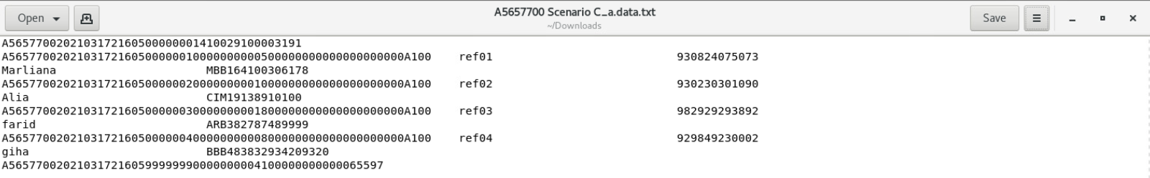

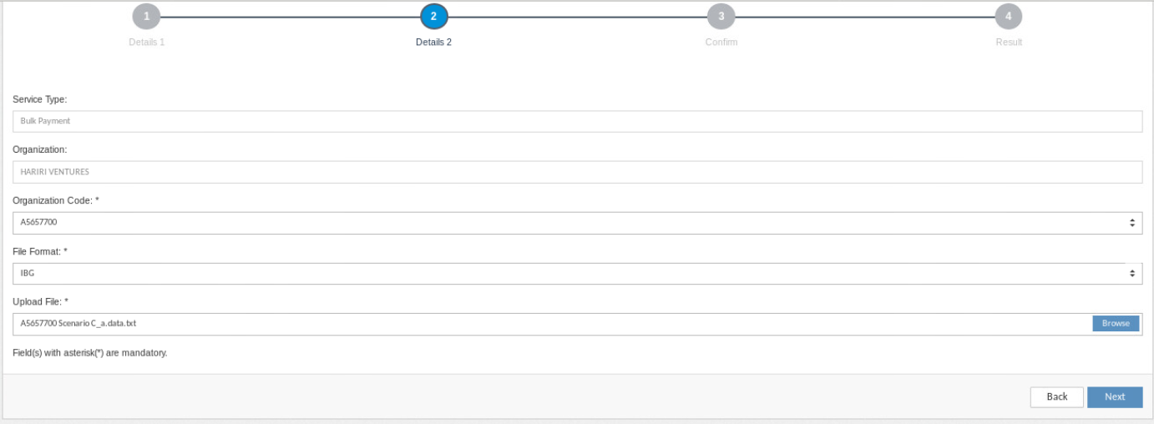

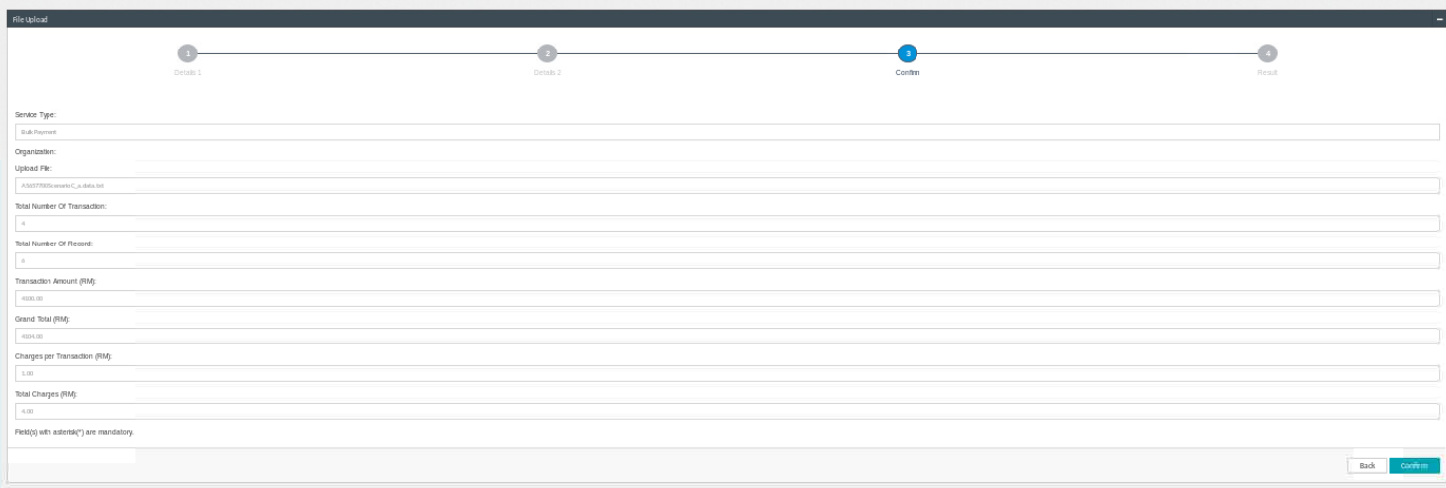

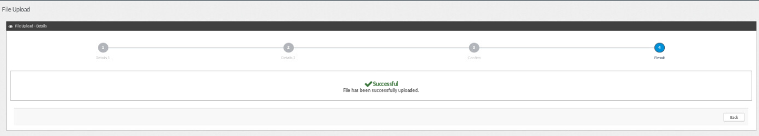

# Scenario C (b)

1. Access IBAM>BBE>Service info>Bulk Payment File Upload
2. Set Max limit to 10
3. Access IBAM Bulk Payment File Upload
4. Select IBG
5. Upload the testing file
6. Expected result, will get error message with max limit



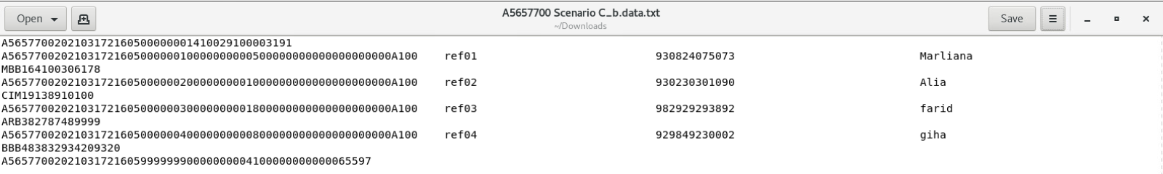

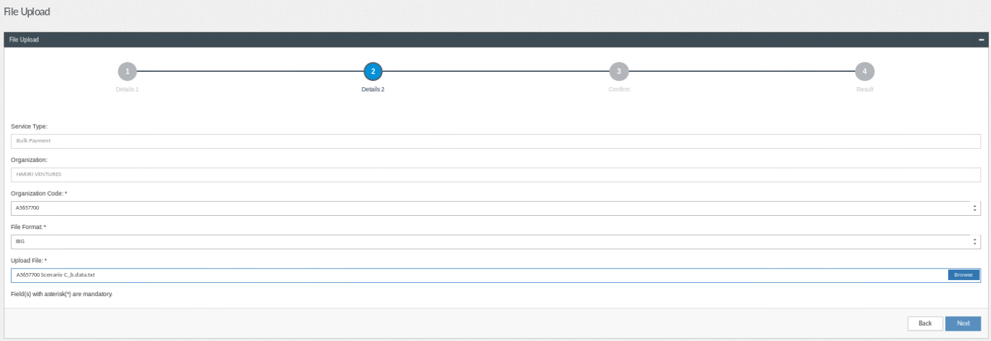

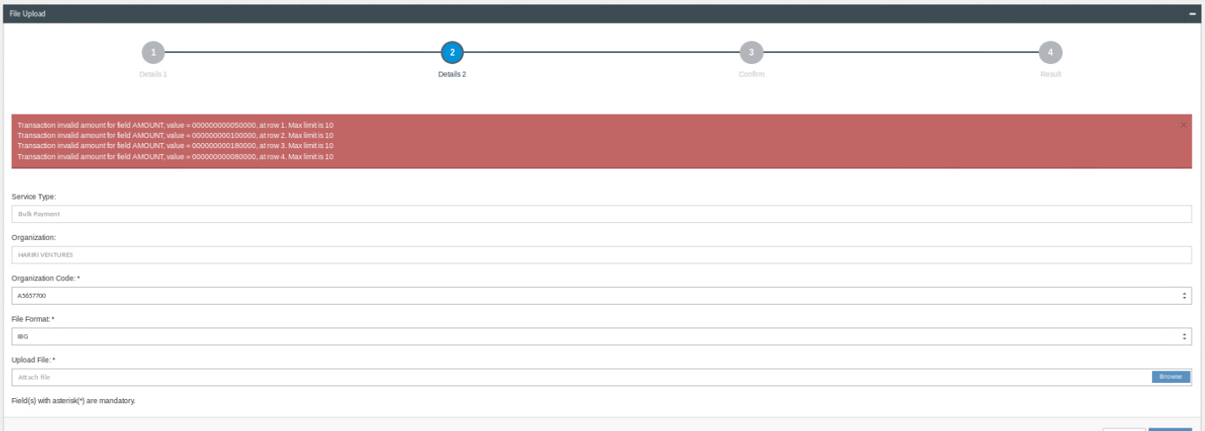

# Scenario D (a)

1. Access IBAM>BBE>Service info>Bulk Payment File Upload
2. Set Max limit to 1 million
3. Access BSNeBiz Bulk Payment File Upload
4. Select non-IBG file
5. Upload the testing file
6. Expected result, there is no amount limit validation



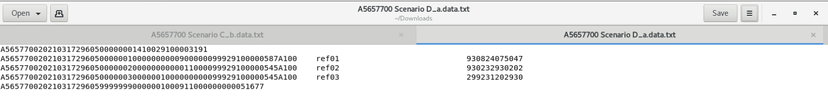

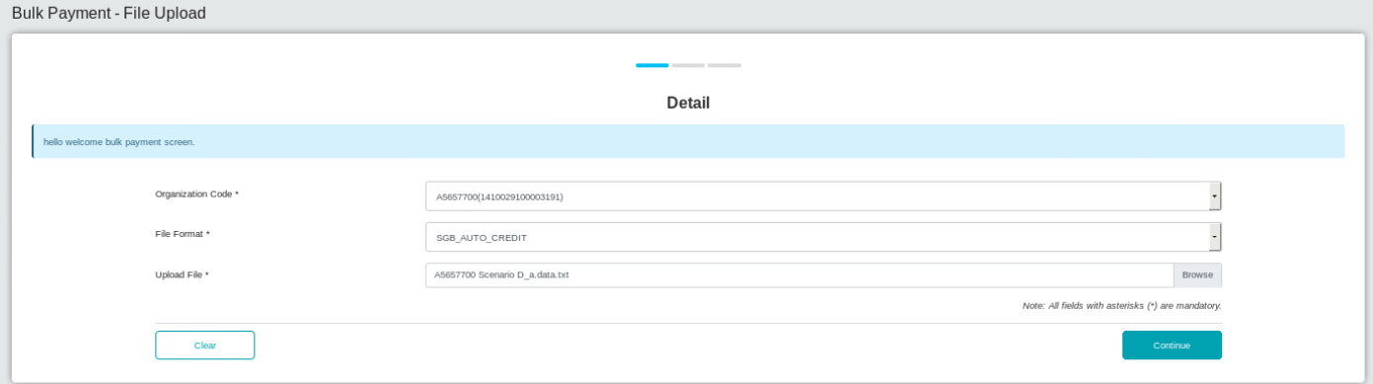

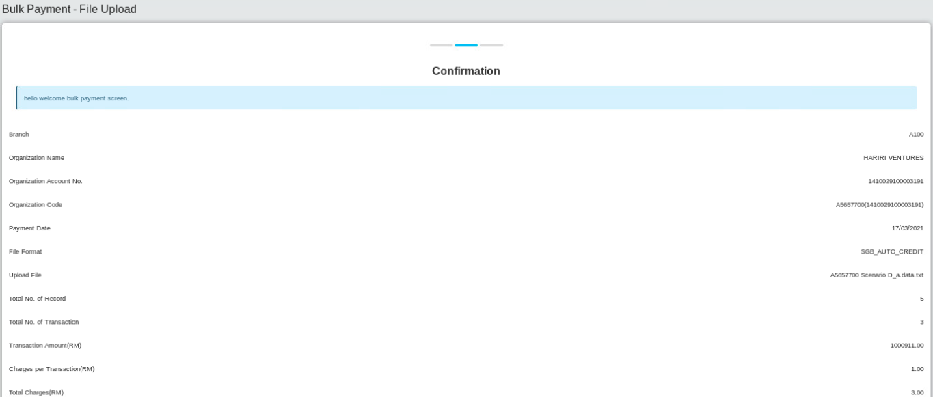

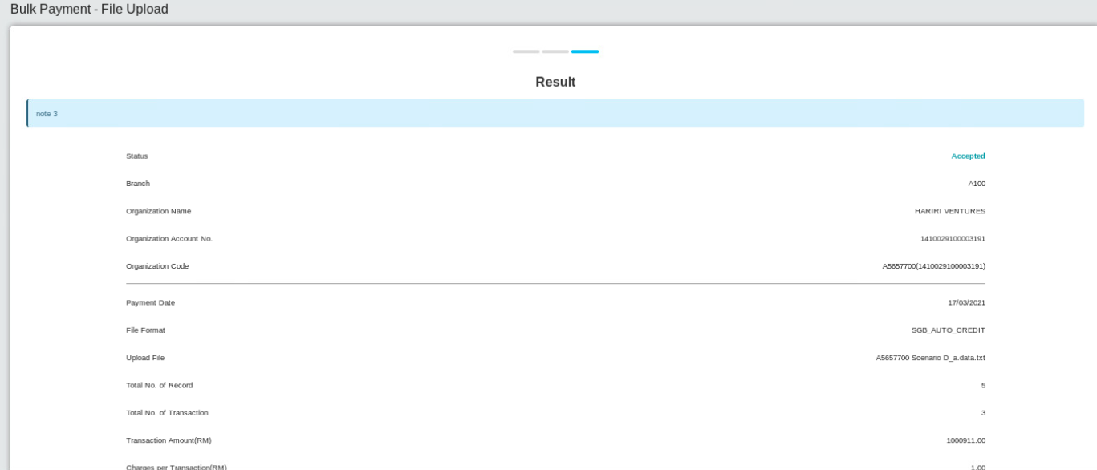

# Scenario D (b)

1. Access IBAM>BBE>Service info>Bulk Payment File Upload
2. Set Max limit to 10
3. Access BSNeBiz Bulk Payment File Upload
4. Select non-IBG file
5. Upload the testing file
6. Expected result, there is no amount limit validation



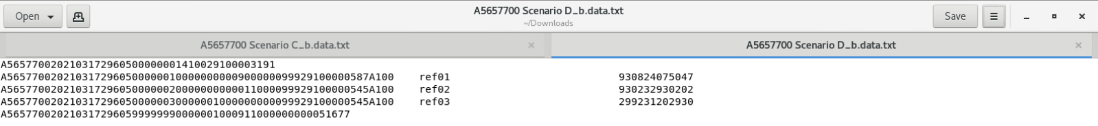

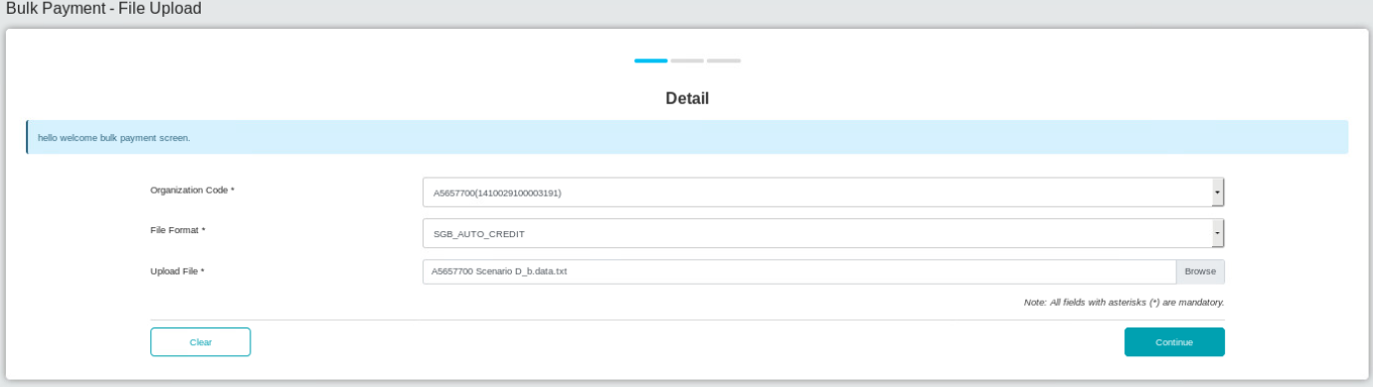

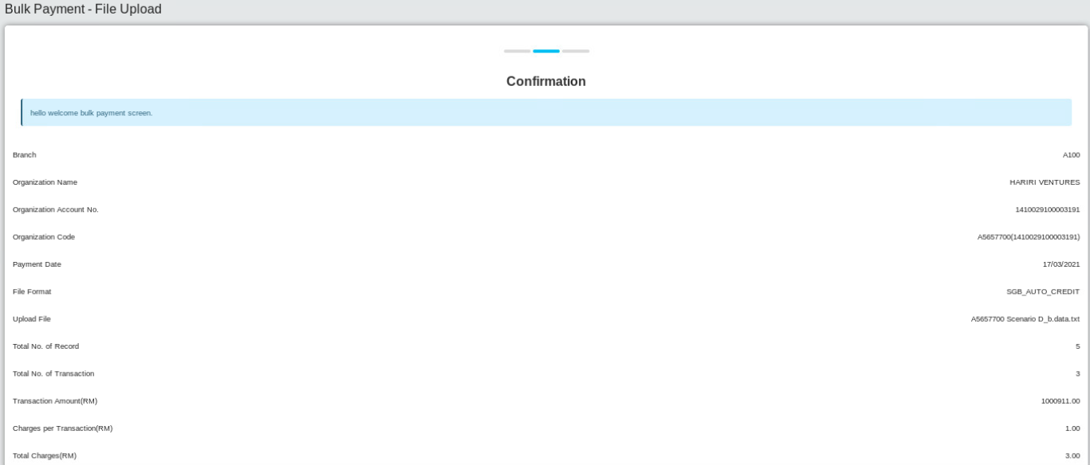

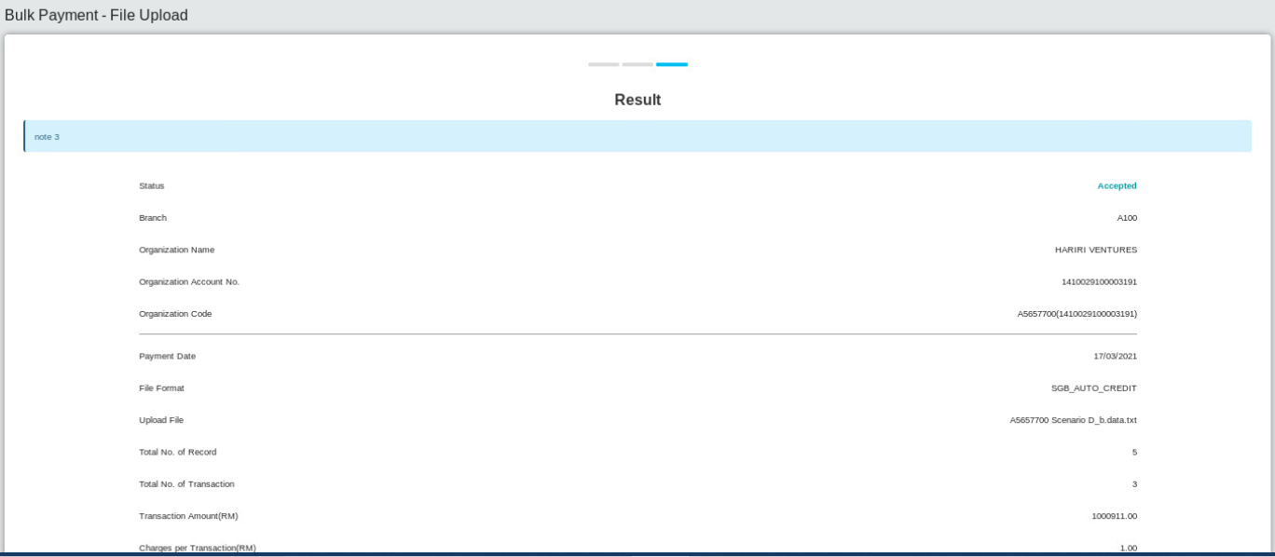

# Scenario D [c (a)]

1. Access IBAM>BBE>Service info>Bulk Payment File Upload
2. Set Max limit to 1 million
3. Access IBAM Bulk Payment File Upload
4. Select non-IBG file
5. Upload the testing file
6. Expected result, there is no amount limit validation



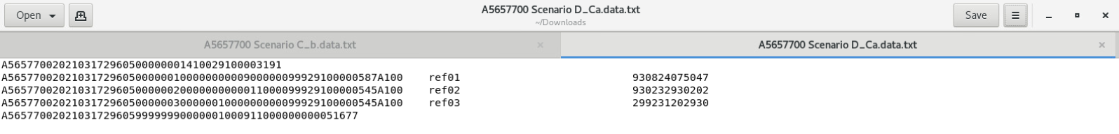

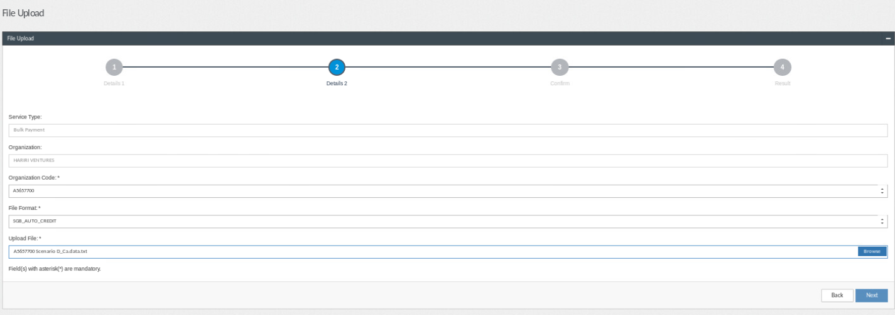

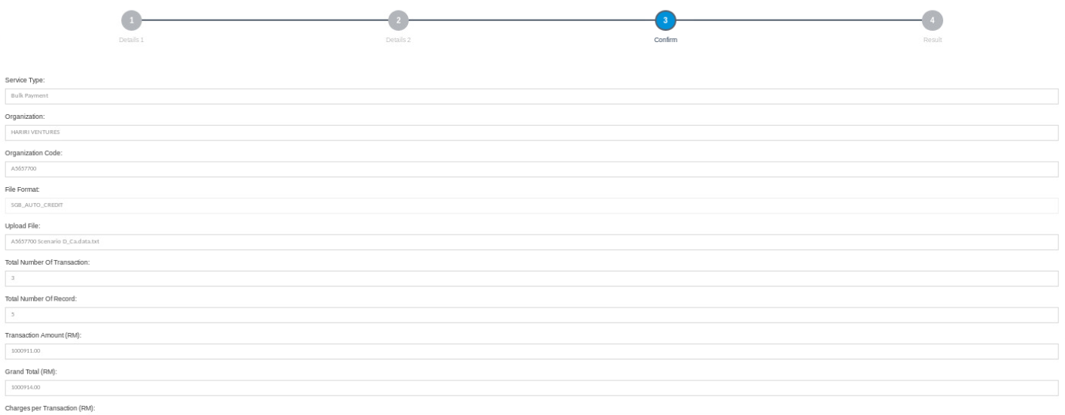

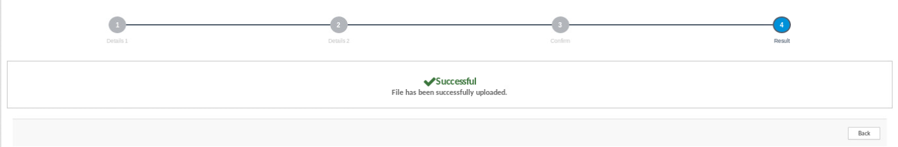

# Scenario D [c (b)]

1. Access IBAM>BBE>Service info>Bulk Payment File Upload
2. Set Max limit to 10
3. Access IBAM Bulk Payment File Upload
4. Select non-IBG file
5. Upload the testing file
6. Expected result, there is no amount limit validation



