1. Perform LHDN transaction

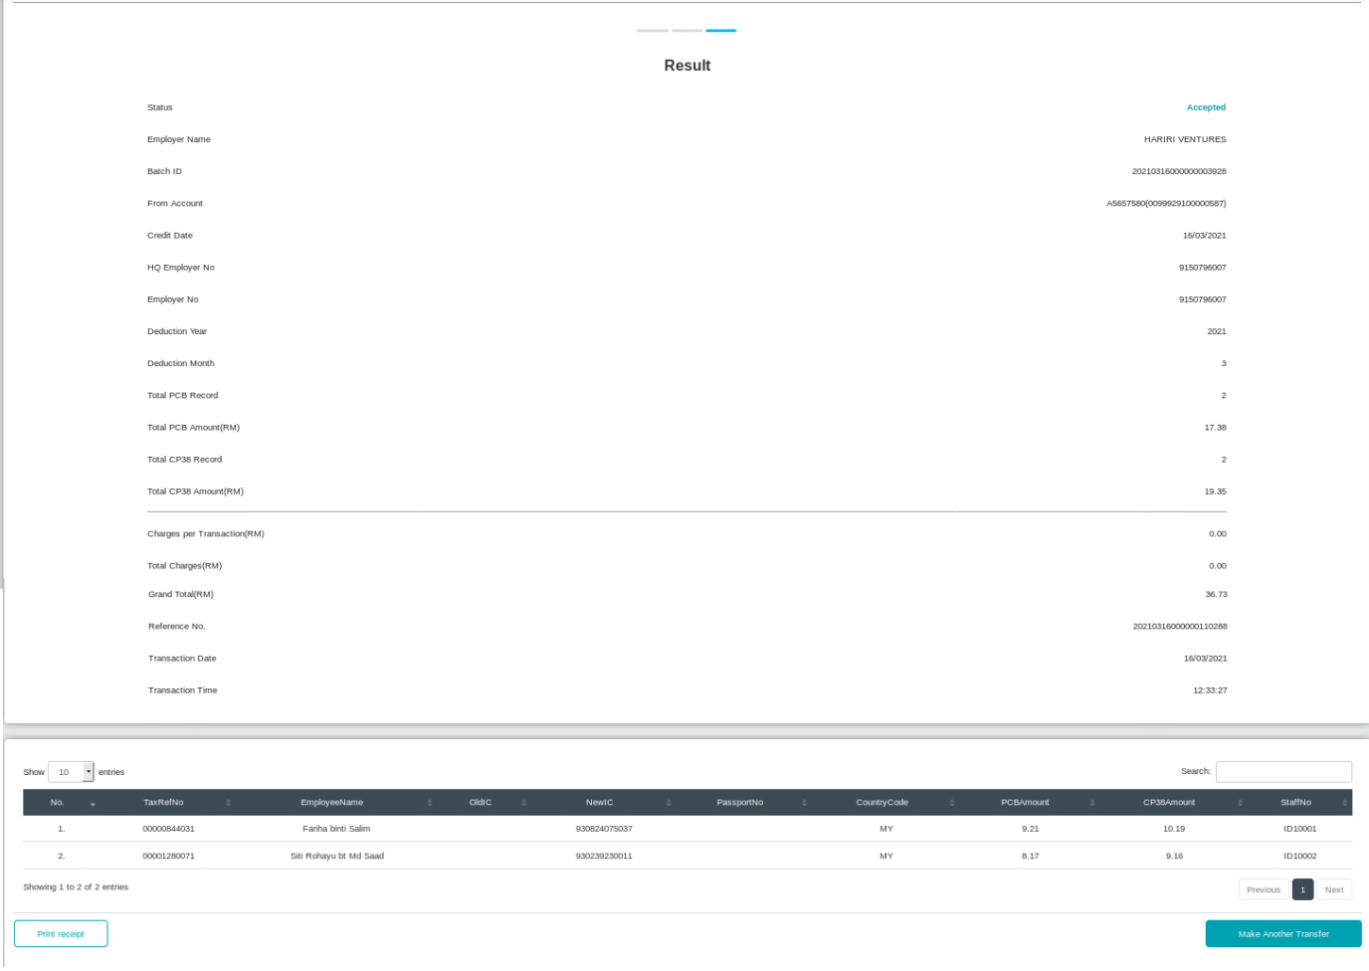

  
2. Run EOD processing

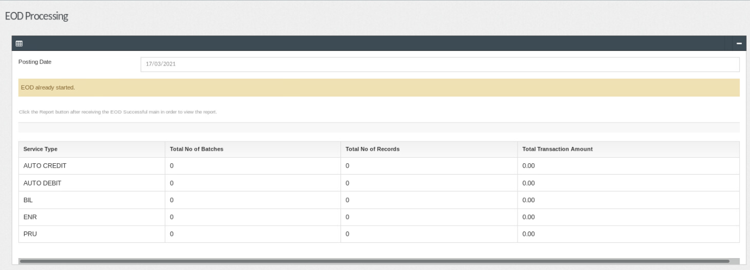

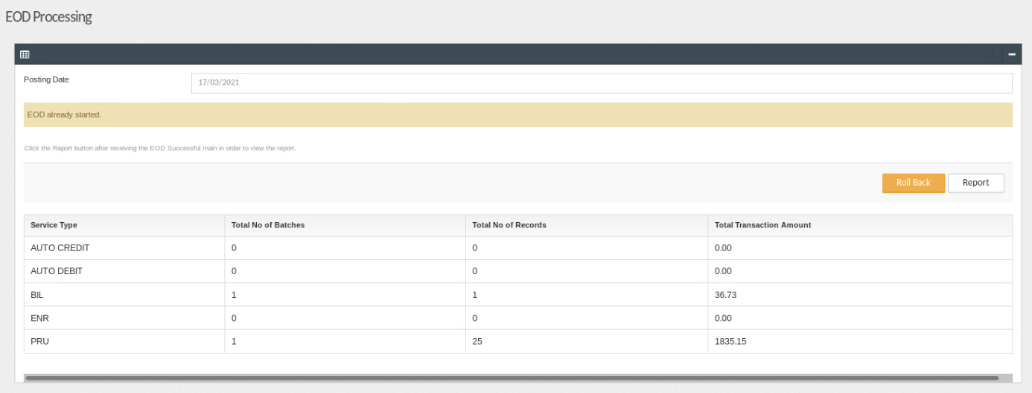

3. Go to /batch/BSN/BatchFilesSIT/EODReports/ to check on agents file

