1. Set Maker and Checker with same group but different state.
2. Maker perform activity
3. Expected Result: Checker does not receive notification and activity performs by Maker does not listed in pending list for Checker approval.
4. Set Maker and Checker with same group but different state.

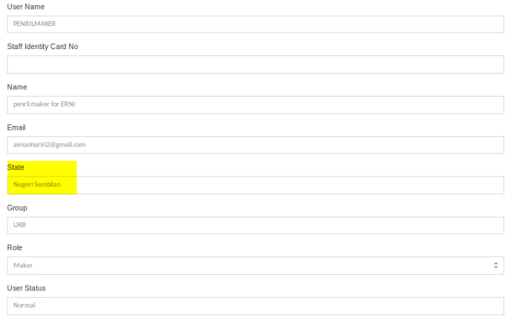

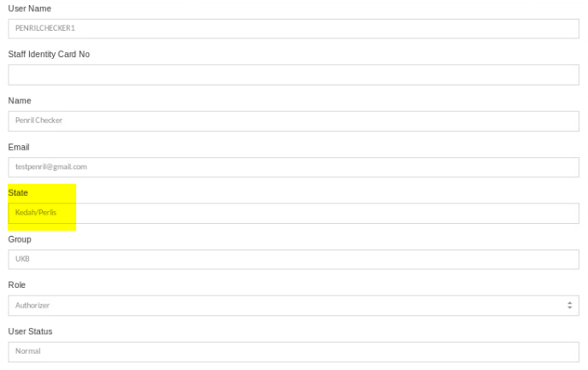

1. Maker perform activity

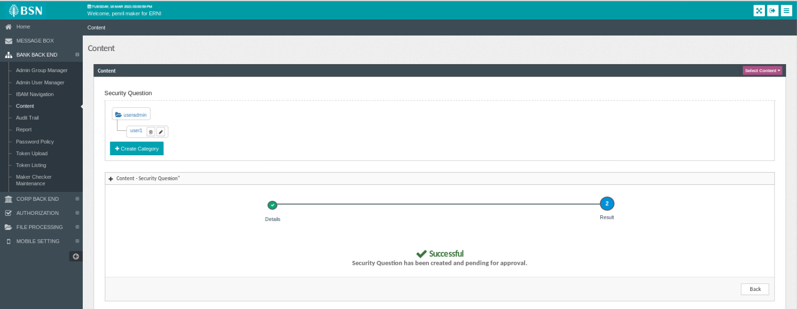

1. Expected Result: Checker does not receive notification and activity performs by Maker does not listed in pending list for Checker approval.

