Issue:  
Updating service info max limit more than 1 million does not affect eBiz Interbank max limit.

Finding:  
There is a max limit 1 million in CDBAppConfig file.

Solution:  
Standardize all limit following service info max limit.

Test steps:

1. Please set max limit=2 million or more to payment modules. Refer note.
2. Access an eBiz payment module as initiator
3. Key in amount greater than the max limit
4. Expected result, will get error amount invalid
5. Key in amount less than or equal the max limit
6. Expected result, payment can be completed
7. Repeat test steps with single user, but make sure balance is sufficient
8. For bulk payment, limit is per row amount, not total amount

Note: List of payment modules with limit:

1. New third party transfer
2. Fav third party transfer
3. New interbank
4. Fav interbank
5. Bulk payment data entry - both new and edit has same limit
6. Bulk payment file upload - only IBG amount is validated

# New third party transfer

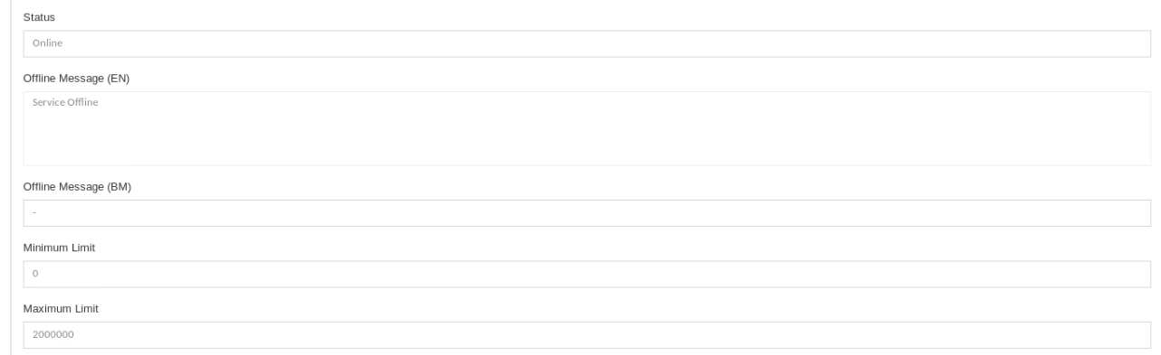

## Key in amount greater than the max limit

### Initiator

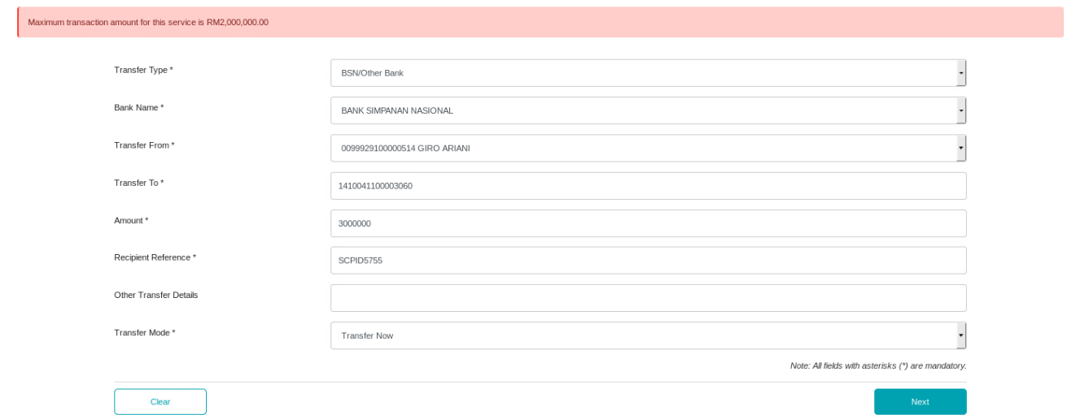

### Single User

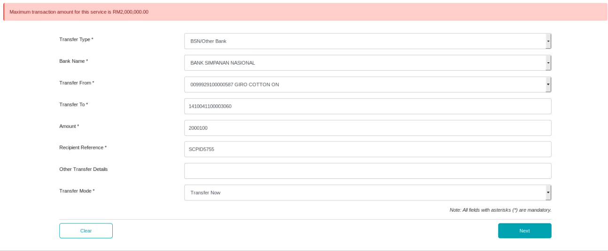

## Key in amount less than or equal the max limit

### Initiator

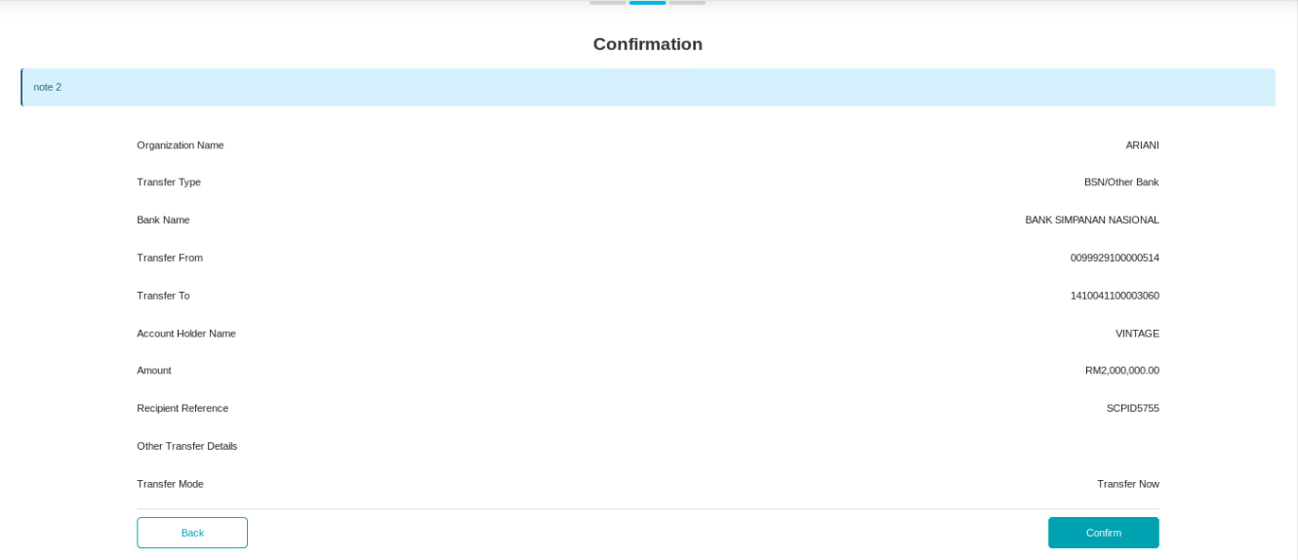

### Single User

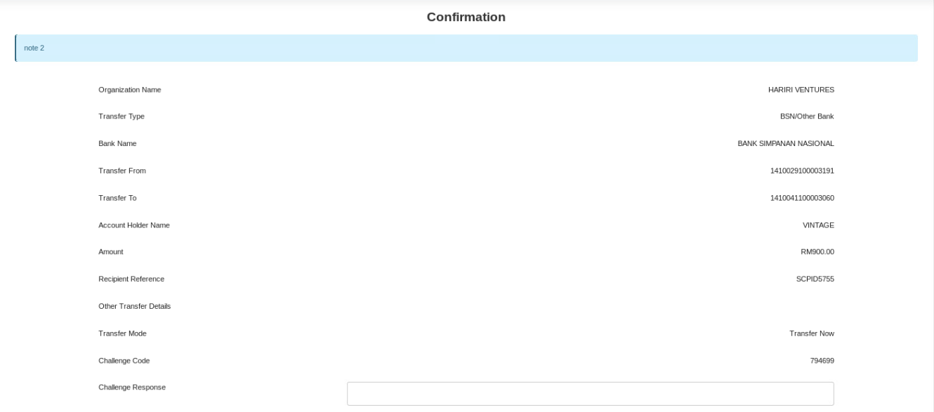

# Fav third party transfer



## Key in amount greater than the max limit

### Initiator

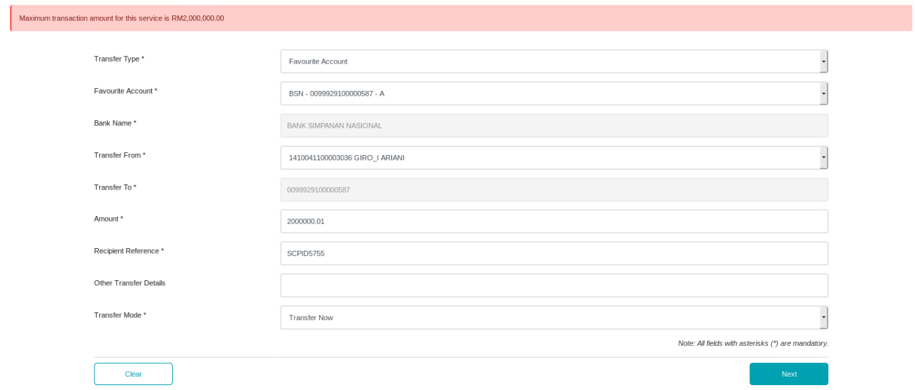

### Single User

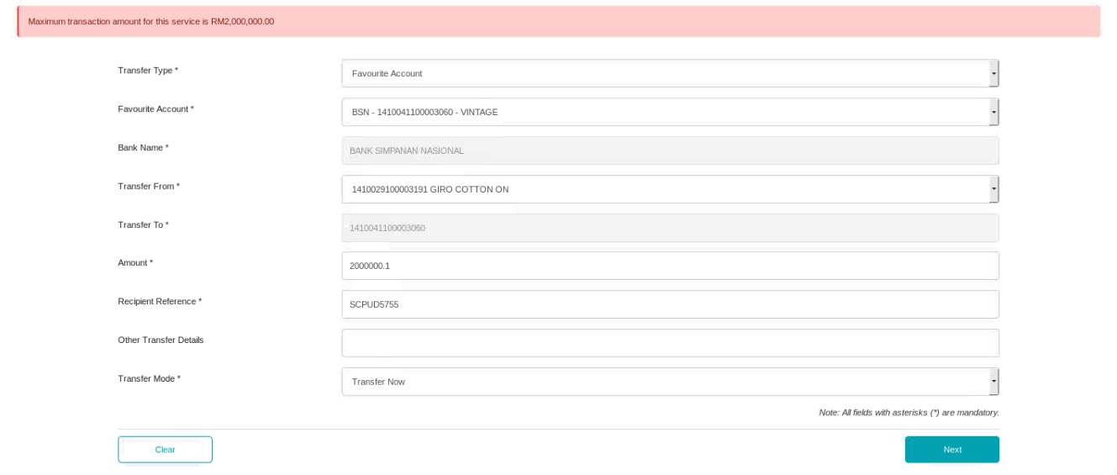

## Key in amount less than or equal the max limit

### Initiator

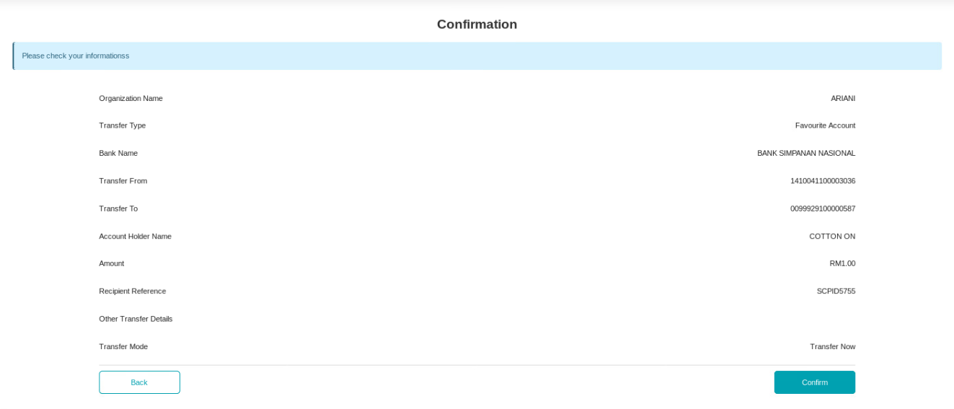

### Single User

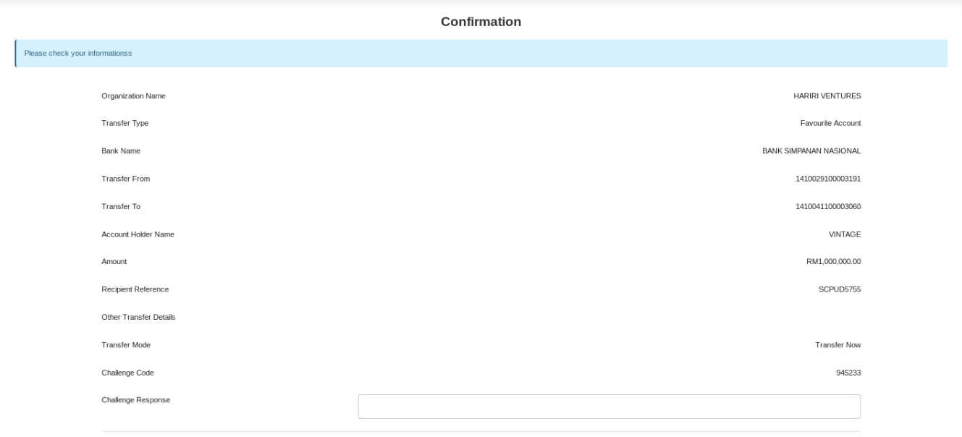

# New interbank



## Key in amount greater than the max limit

### Initiator

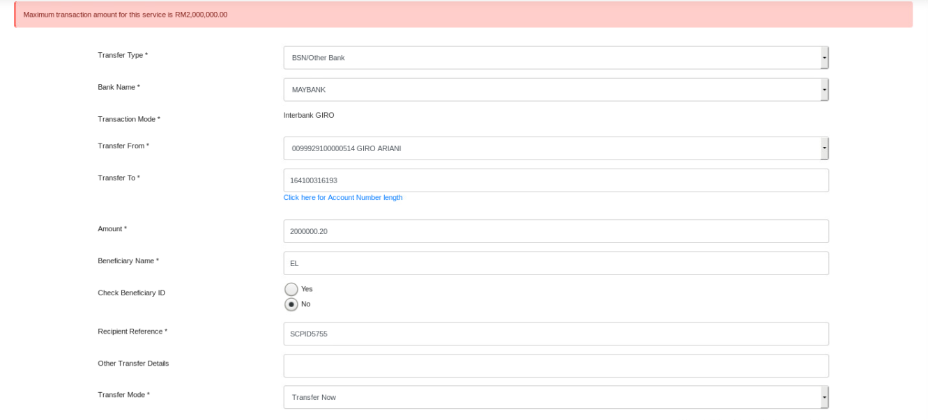

### Single User

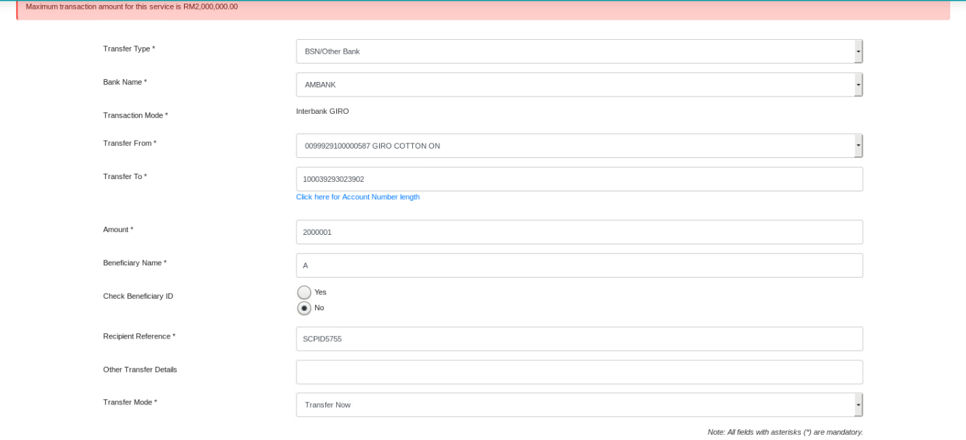

## Key in amount less than or equal the max limit

### Initiator

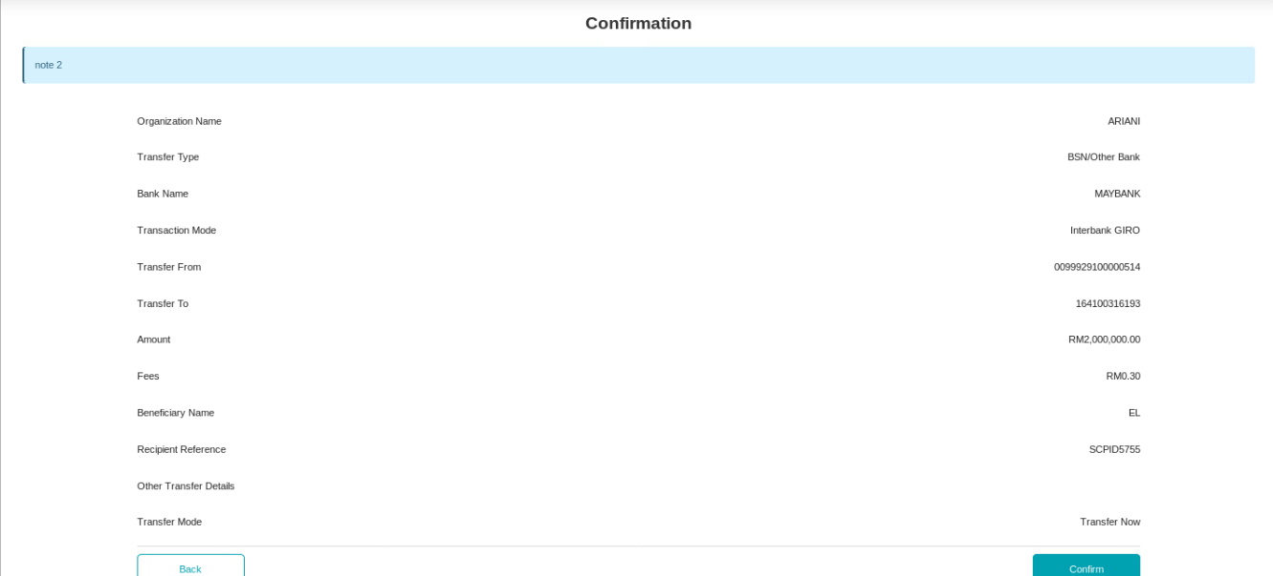

### Single User

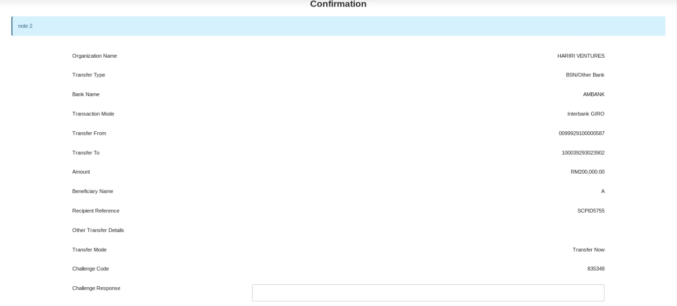

# Fav interbank



## Key in amount greater than the max limit

### Initiator

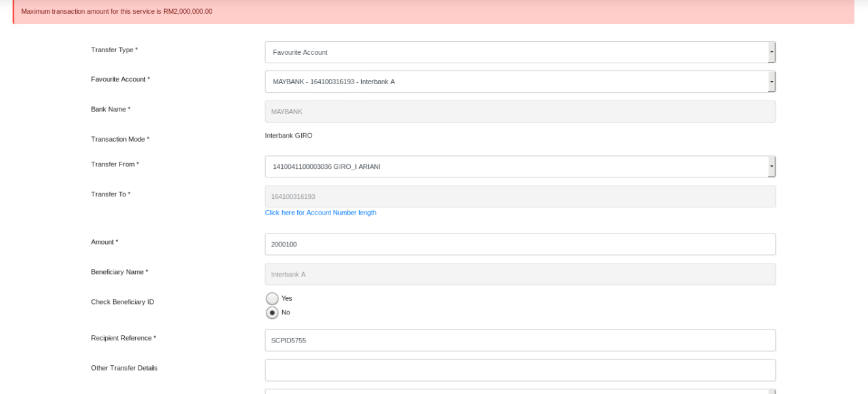

### Single User

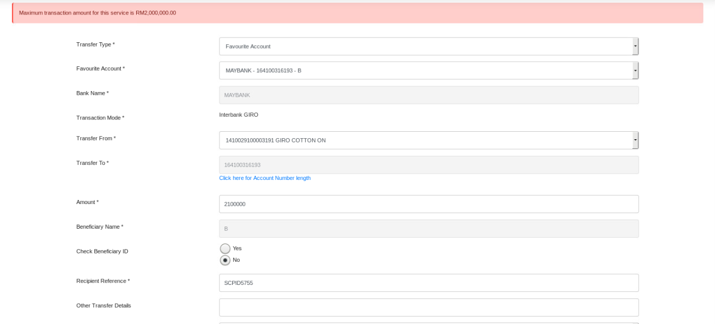

## Key in amount less than or equal the max limit

### Initiator

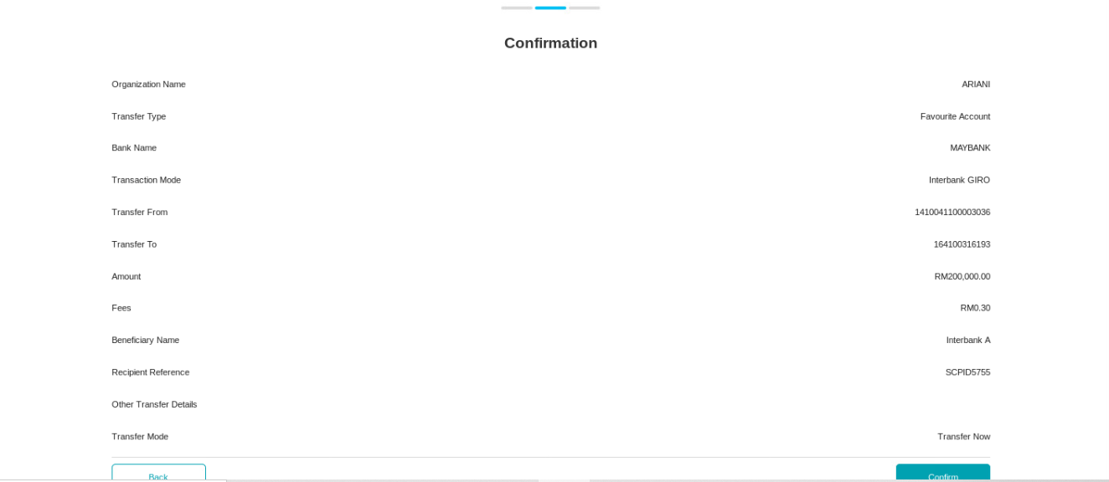

### Single User

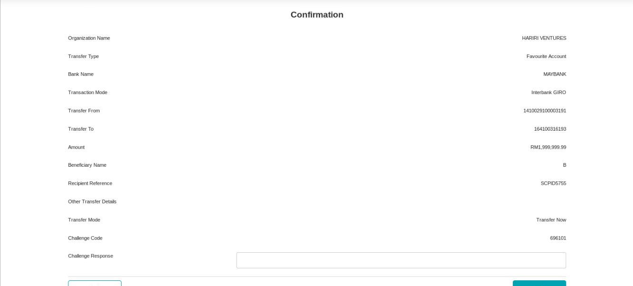

# Bulk payment data entry



## Key in amount greater than the max limit

### Initiator

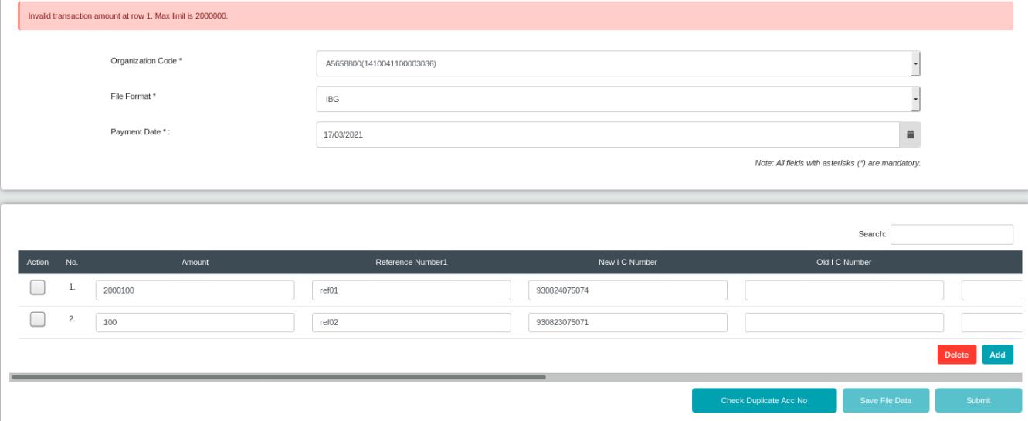

### Single User

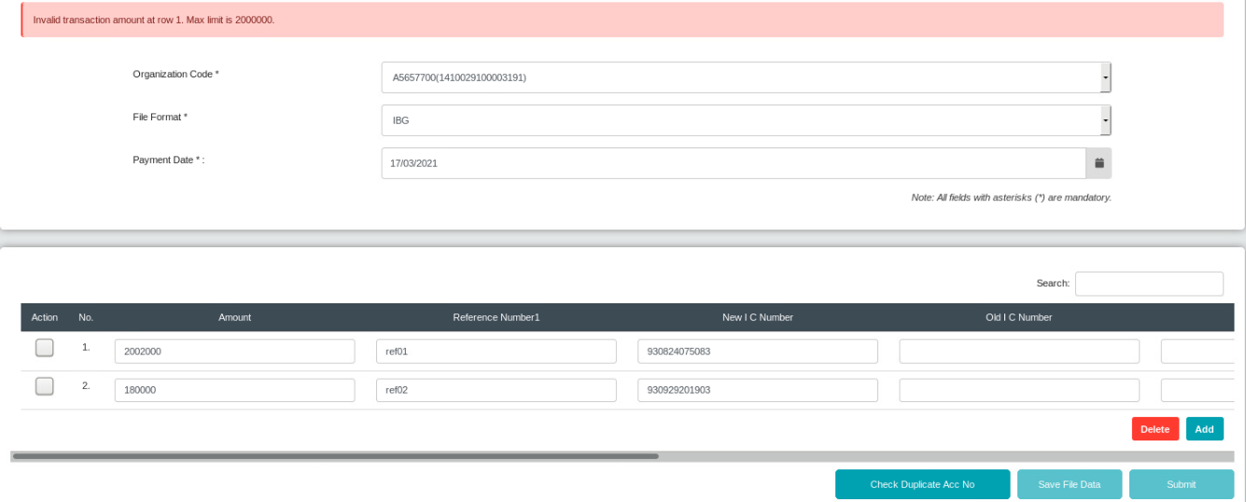

## Key in amount less than or equal the max limit

### Initiator

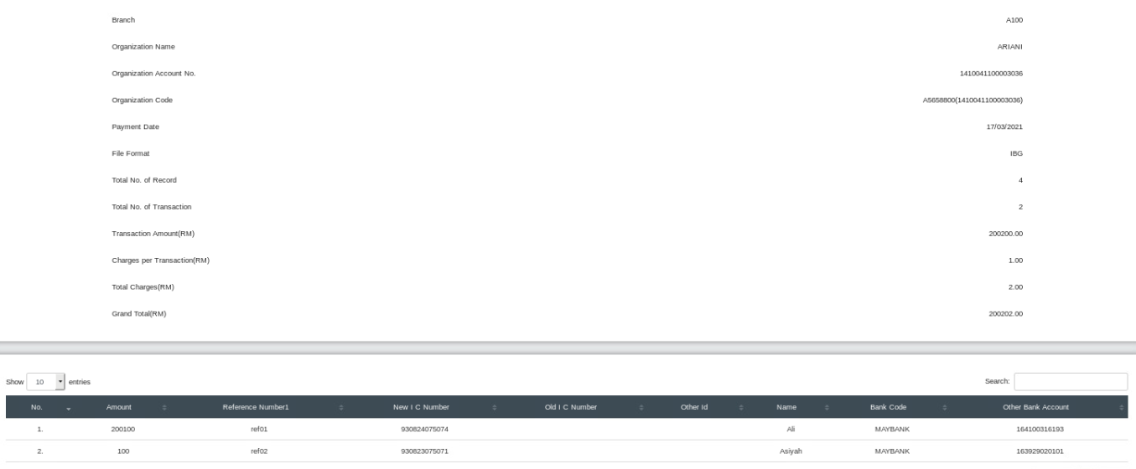

### Single User

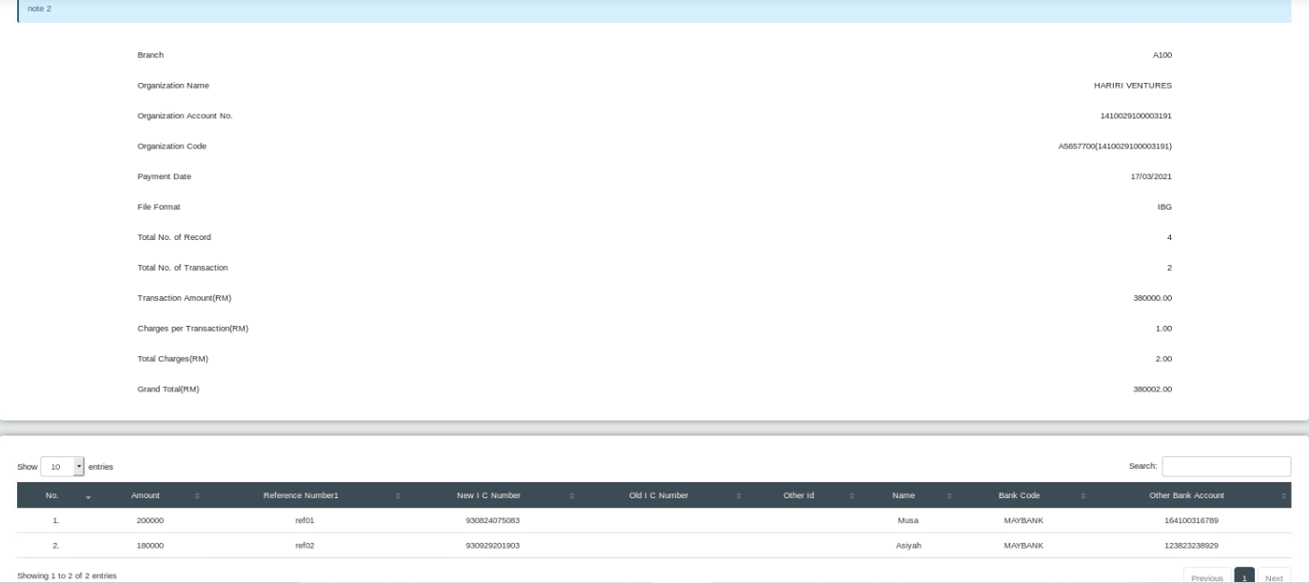

# Bulk payment file upload



## Key in amount greater than the max limit

### Initiator

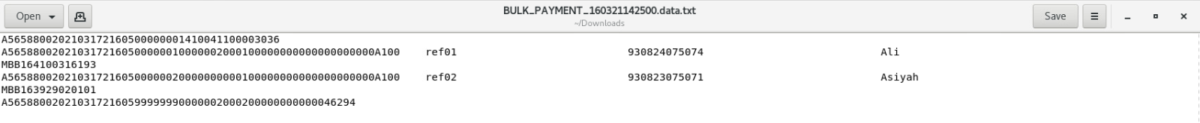

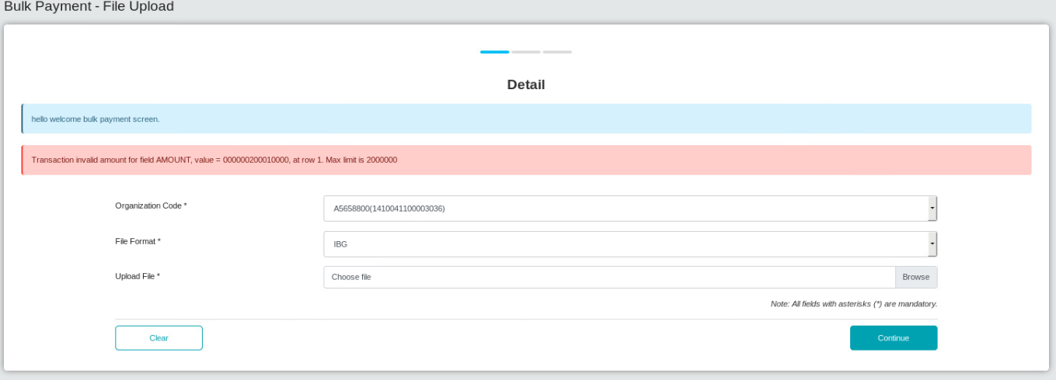

### Single User

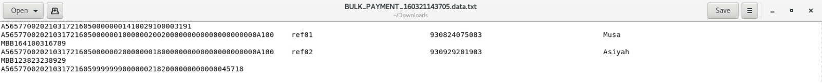

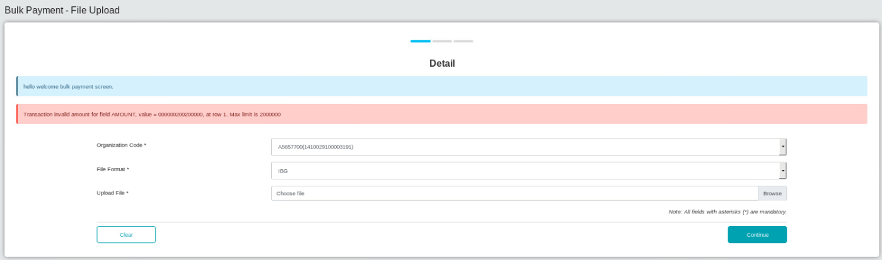

## Key in amount less than or equal the max limit

### Initiator

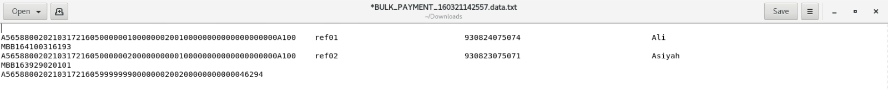

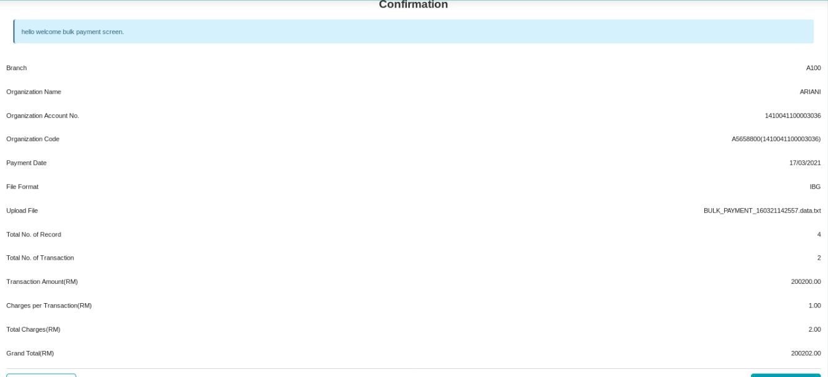

### Single User



