1. Prepare a sample of valid JOMPAYOFFUS file
2. The biller code must match with IBAM>Payee>Payee biller code and has org code of existing company

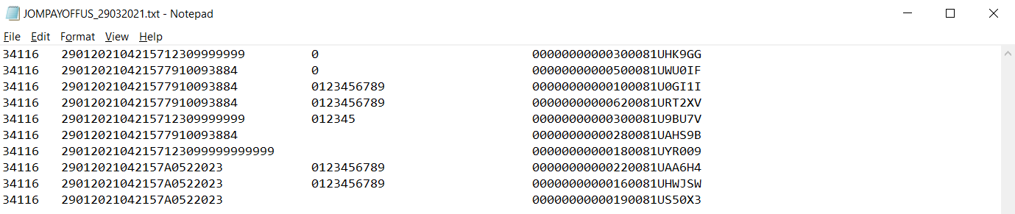

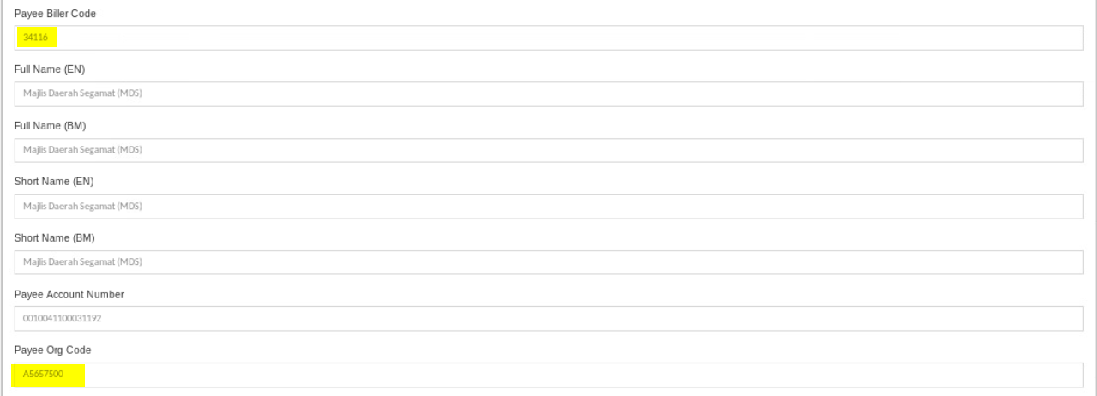

1. Access SIT batch server sacda951
2. Copy JOMPAYOFFUS file to /batch/BSN/BatchFilesSIT/ICBSReports/Data

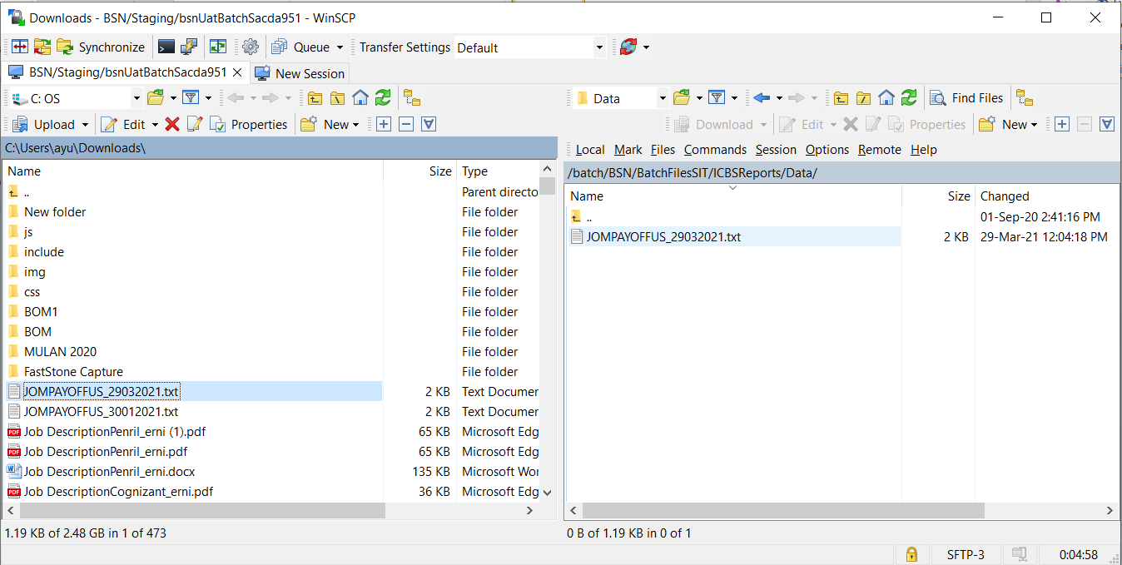

1. Wait 1-2 minutes for cronjob to run
2. Access IBAM>File Processing>Data and Report
3. Search report Collection Receivable and the biller org code

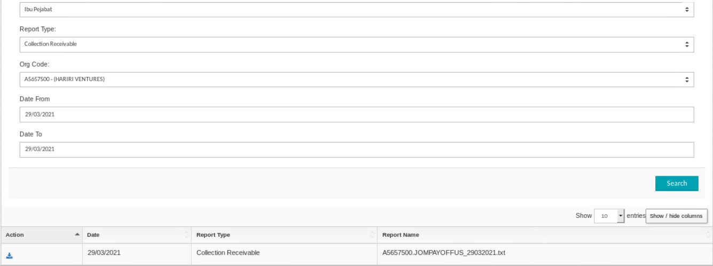

1. Expected result, JOMPAYOFFUS file available for download and the content matching the file from batch server

