1. Select an IBAM checker with testing email. For example, user AHMAD with State Kuala Lumpur

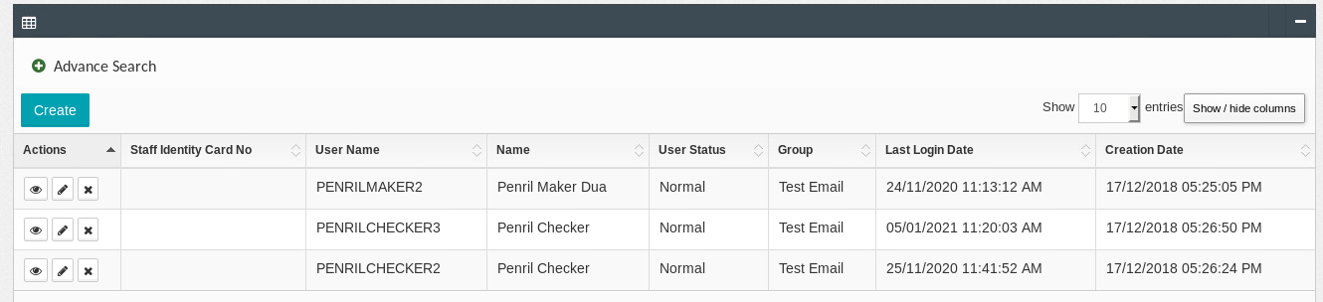

User: penrilmaker2

Role: Maker

State: KL  
Group: Test Email

Email: [sarifah.nurhafizah@penril.net](mailto:sarifah.nurhafizah@penril.net)

User: penrilchecker3

Role: Checker

State: KL

Group: Test Email

Email: [aimanhariri2@gmail.com](mailto:aimanhariri2@gmail.com)

User: penrilchecker2

Role: Checker

State: KL

Group: Test Email

Email: [erniyin@gmail.com](mailto:erniyin@gmail.com)

1. Access IBAM>BBE>Admin User Management>Delete user

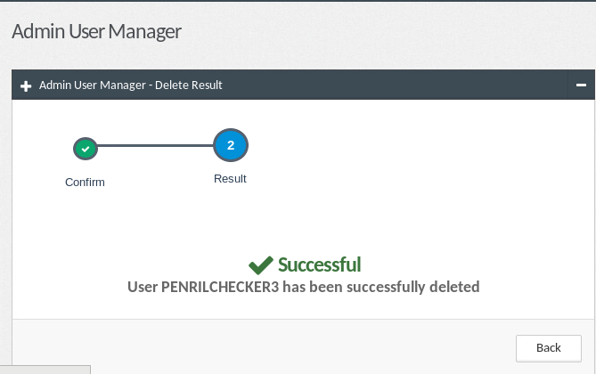

1. Access IBAM > CORPORATE BACK END > CDB Application
2. Create new application / Edit existing application with State Kuala Lumpur
3. Press submit button at confirmation page

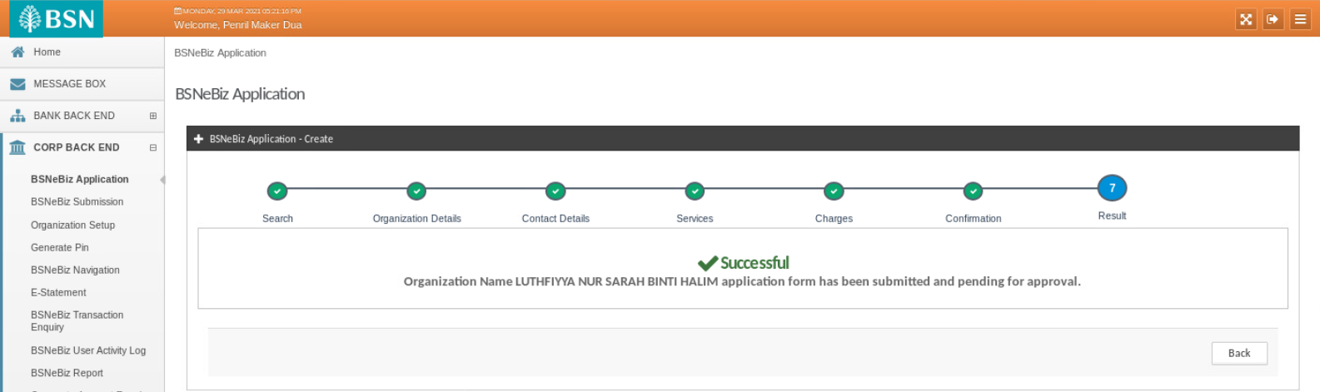

1. Expected result, IBAM will send email to valid Checkers for Approval and display page with "submitted and pending for approval" message. Deleted user will not receive an email.

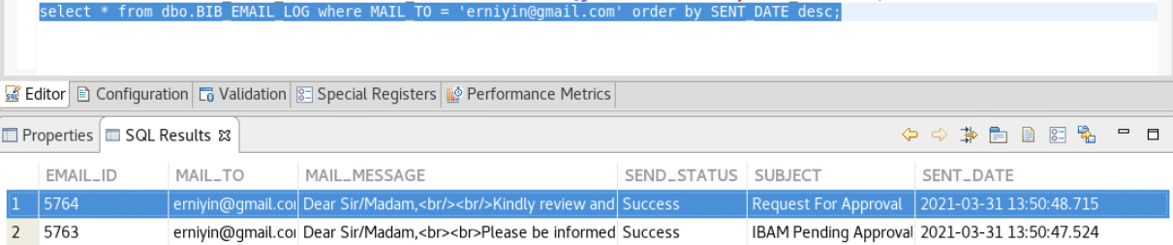

Email sends successfully for other checker in same group

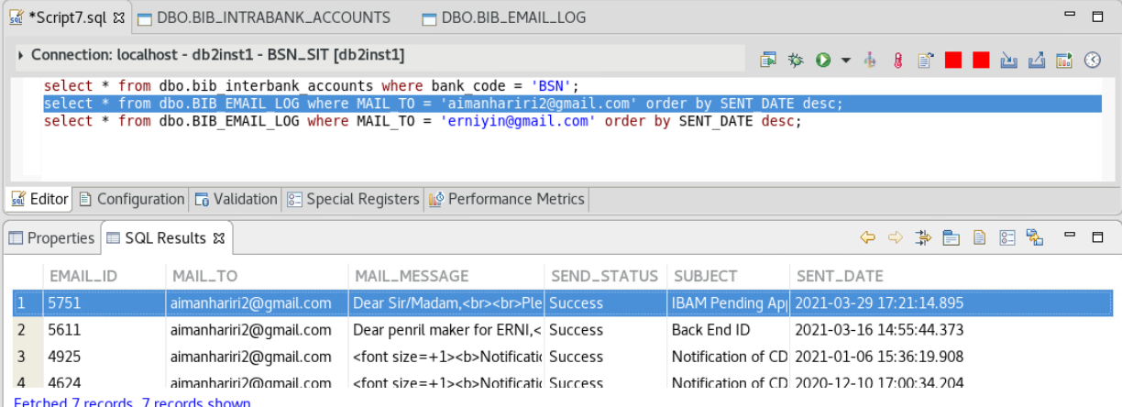

Email does not send to the deleted checker in same group