Deskmate – Directory amendment

Appendix 1

Risk Management Division 11 Nov 2020

Dear Azli/Corporate Communication team,

Please assist to amend the following details at Deskmate, as attached below;

[**RISK MANAGEMENT**](http://deskmate.kfh.com.my/index.php?option=com_contact&view=category&catid=88&Itemid=834)

* + [**Credit ~~Risk~~**](http://deskmate.kfh.com.my/index.php?option=com_contact&view=category&catid=468&Itemid=956) **Review**
  + [**~~Retail Risk & Credit Portfolio~~**](http://deskmate.kfh.com.my/index.php?option=com_contact&view=category&catid=469&Itemid=960)
  + [**~~Market Risk~~**](http://deskmate.kfh.com.my/index.php?option=com_contact&view=category&catid=470&Itemid=957)
  + [**~~Risk Architecture~~**](http://deskmate.kfh.com.my/index.php?option=com_contact&view=category&catid=472&Itemid=959) **Enterprise Risk Management**
  + [**Independent Credit Review**](http://deskmate.kfh.com.my/index.php?option=com_contact&view=category&catid=539&Itemid=1038)
  + [**Non-Financial Risk**](http://deskmate.kfh.com.my/index.php?option=com_contact&view=category&catid=540&Itemid=1039)
  + [**~~Technology & Cyber Security~~**](http://deskmate.kfh.com.my/index.php?option=com_contact&view=category&catid=557&Itemid=1059) **Information Security Risk**
  + [**~~Special Asset Management~~**](http://deskmate.kfh.com.my/index.php?option=com_contact&view=category&catid=492&Itemid=995)
    - [**~~Wholesale Recovery~~**](http://deskmate.kfh.com.my/index.php?option=com_contact&view=category&catid=558&Itemid=1055)
    - [**~~Retail Recovery & Collection~~**](http://deskmate.kfh.com.my/index.php?option=com_contact&view=category&catid=563&Itemid=1056)

**List of staff that require change as follows;**

KFH Malaysia > Risk Management > Noor Azlina Binti Shuib

|  |
| --- |
| **Noor Azlina Shuib** |
| Senior Executive | |
| |  |  |  |  |  |  |  |  |  |  |  |  |  |  |  |  |  |  |  |  |  |  |  |  | | --- | --- | --- | --- | --- | --- | --- | --- | --- | --- | --- | --- | --- | --- | --- | --- | --- | --- | --- | --- | --- | --- | --- | --- | | |  |  |  | | --- | --- | --- | | Address:  Level 25, Menara Prestige | | | | E-mail:  azlina.shuib@kfh.com.my | | |  | |  | | 03-2168 0801 | | | | | |  |  | | --- | --- | | Information: | 08-641 | | | |  | | | | |  | |  |

1. **TO ADD Enterprise Risk Management with staff list below;**

KFH Malaysia > Risk Management > Enterprise Risk Management > Nor Izad

|  |
| --- |
| **Nor Izad Bin Mamud** |
| Assistant Vice President | |
| |  |  |  |  |  |  |  |  |  |  |  |  |  |  |  |  |  |  |  |  |  |  |  |  | | --- | --- | --- | --- | --- | --- | --- | --- | --- | --- | --- | --- | --- | --- | --- | --- | --- | --- | --- | --- | --- | --- | --- | --- | | |  |  |  | | --- | --- | --- | | Address:  Level 25, Menara Prestige | | | | E-mail:  izad@mamud@kfh.com.my | | |  | |  | | 03-2168 0807 | | | | | |  |  | | --- | --- | | Information: | 17-1583 | | | |  | | | | |  | |  |
| KFH Malaysia > Risk Management > Enterprise Risk Management > Jimmy Foong Swee Hun   |  | | --- | | **Jimmy Foong Swee Hun** | | Senior Manager | | | | |  |  |  |  |  |  |  |  |  |  |  |  |  |  |  |  |  |  |  |  |  |  |  |  | | --- | --- | --- | --- | --- | --- | --- | --- | --- | --- | --- | --- | --- | --- | --- | --- | --- | --- | --- | --- | --- | --- | --- | --- | | |  |  |  | | --- | --- | --- | | Address:  Level 25, Menara Prestige | | | | E-mail:  foong.swee.hun@kfh.com.my | | |  | |  | | 03-2168 0811 | | | | | |  |  | | --- | --- | | Information: | 11-1257 | | | |  | | | | |  | | |  | | |
| KFH Malaysia > Risk Management > Enterprise Risk Management > Ng Tzyy Loon   |  | | --- | | **Ng Tzyy Loon** | | Manager | | | | |  |  |  |  |  |  |  |  |  |  |  |  |  |  |  |  |  |  |  |  |  |  |  |  | | --- | --- | --- | --- | --- | --- | --- | --- | --- | --- | --- | --- | --- | --- | --- | --- | --- | --- | --- | --- | --- | --- | --- | --- | | |  |  |  | | --- | --- | --- | | Address:  Level 25, Menara Prestige | | | | E-mail:  ng.tzyy.loon@kfh.com.my | | |  | |  | | 03-2168 0831 | | | | | |  |  | | --- | --- | | Information: | 18-1668 | | | |  | | | | |  | | |  |   KFH Malaysia > Risk Management > Enterprise Risk Management > Ong Lee Eng   |  | | --- | | **Ong Lee Eng** | | Executive | | | | |  |  |  |  |  |  |  |  |  |  |  |  |  |  |  |  |  |  |  |  |  |  |  |  | | --- | --- | --- | --- | --- | --- | --- | --- | --- | --- | --- | --- | --- | --- | --- | --- | --- | --- | --- | --- | --- | --- | --- | --- | | |  |  |  | | --- | --- | --- | | Address:  Level 25, Menara Prestige | | | | E-mail:  ong.lee.eng@kfh.com.my | | |  | |  | | 03-2168 0734 | | | | | |  |  | | --- | --- | | Information: | 08-684 | | | |  | | | | |  | | |  | |  |

KFH Malaysia > Risk Management > Enterprise Risk Management > Lew Chee Shing

|  |
| --- |
| **Lew Chee Shing** |
| Senior Manager | | |
| |  |  |  |  |  |  |  |  |  |  |  |  |  |  |  |  |  |  |  |  |  |  |  |  | | --- | --- | --- | --- | --- | --- | --- | --- | --- | --- | --- | --- | --- | --- | --- | --- | --- | --- | --- | --- | --- | --- | --- | --- | | |  |  |  | | --- | --- | --- | | Address:  Level 25, Menara Prestige | | | | E-mail:  lew.chee.shing@kfh.com.my | | |  | |  | | 03-2168 0850 | | | | | |  |  | | --- | --- | | Information: | 18-1698 | | | |  | | | | |  | | |  |

KFH Malaysia > Risk Management > Enterprise Risk Management > Badrul Zaman Bin Bahaman

|  |
| --- |
| **Badrul Zaman Bin Bahaman** |
| Senior Manager | | |
| |  |  |  |  |  |  |  |  |  |  |  |  |  |  |  |  |  |  |  |  |  |  |  |  | | --- | --- | --- | --- | --- | --- | --- | --- | --- | --- | --- | --- | --- | --- | --- | --- | --- | --- | --- | --- | --- | --- | --- | --- | | |  |  |  | | --- | --- | --- | | Address:  Level 25, Menara Prestige | | | | E-mail:  badrulzaman.bahaman@kfh.com.my | | |  | |  | | 03-2168 0822 | | | | | |  |  | | --- | --- | | Information: | 18-1713 | | | |  | | | | |  | | |  |

KFH Malaysia > Risk Management > Enterprise Risk Management > Suziana Ibrahim

|  |
| --- |
| **Suziana Ibrahim** |
| Assistant Manager | | |
| |  |  |  |  |  |  |  |  |  |  |  |  |  |  |  |  |  |  |  |  |  |  |  |  | | --- | --- | --- | --- | --- | --- | --- | --- | --- | --- | --- | --- | --- | --- | --- | --- | --- | --- | --- | --- | --- | --- | --- | --- | | |  |  |  | | --- | --- | --- | | Address:  Level 25, Menara Prestige | | | | E-mail:  suziana.ibrahim@kfh.com.my | | |  | |  | | 03-2168 0820 | | | | | |  |  | | --- | --- | | Information: | 11-1079 | | | |  | | | | |  | | |  |

KFH Malaysia > Risk Management > Enterprise Risk Management > Norhairomey Binti Ismail

|  |
| --- |
| **Norhairomey Binti Ismail** |
| Senior Executive | | |
| |  |  |  |  |  |  |  |  |  |  |  |  |  |  |  |  |  |  |  |  |  |  |  |  | | --- | --- | --- | --- | --- | --- | --- | --- | --- | --- | --- | --- | --- | --- | --- | --- | --- | --- | --- | --- | --- | --- | --- | --- | | |  |  |  | | --- | --- | --- | | Address:  Level 25, Menara Prestige | | | | E-mail:  norhairomey.ismail@kfh.com.my | | |  | |  | | 03-2168 0824 | | | | | |  |  | | --- | --- | | Information: | 12-1391 | | | |  | | | | |  | | |  |

KFH Malaysia > Risk Management > Enterprise Risk Management > Haidy Bin Khaizy

|  |
| --- |
| **Haidy Bin Khaizy** |
| Senior Executive | | |
| |  |  |  |  |  |  |  |  |  |  |  |  |  |  |  |  |  |  |  |  |  |  |  |  | | --- | --- | --- | --- | --- | --- | --- | --- | --- | --- | --- | --- | --- | --- | --- | --- | --- | --- | --- | --- | --- | --- | --- | --- | | |  |  |  | | --- | --- | --- | | Address:  Level 25, Menara Prestige | | | | E-mail:  haidy.khaizy@kfh.com.my | | |  | |  | | 03-2168 0800 | | | | | |  |  | | --- | --- | | Information: | 16-1546 | | | |  | | | | |  | | |  |

1. **TO ADD & AMEND - NON-FINANCIAL RISK;**

KFH Malaysia > Risk Management > Non-Financial Risk> Noor Aida Mastura

|  |
| --- |
| **Noor Aida Mastura Binti Hazizi** |
| Manager | | |
| |  |  |  |  |  |  |  |  |  |  |  |  |  |  |  |  |  |  |  |  |  |  |  |  | | --- | --- | --- | --- | --- | --- | --- | --- | --- | --- | --- | --- | --- | --- | --- | --- | --- | --- | --- | --- | --- | --- | --- | --- | | |  |  |  | | --- | --- | --- | | Address:  Level 25, Menara Prestige | | | | E-mail:  nooraida.mastura@kfh.com.my | | |  | |  | | 03-2168 0816 | | | | | |  |  | | --- | --- | | Information: | 10-844 | | | |  | | | | |  | | |  |

**Pls add Nita’s name in Non-Financial risk**

KFH Malaysia > Risk Management > Non-Financial Risk> Nita Aidura Mokhtar

|  |
| --- |
| **Nita Aidura Mokhtar** |
| Senior Executive | | |
| |  |  |  |  |  |  |  |  |  |  |  |  |  |  |  |  |  |  |  |  |  |  |  |  | | --- | --- | --- | --- | --- | --- | --- | --- | --- | --- | --- | --- | --- | --- | --- | --- | --- | --- | --- | --- | --- | --- | --- | --- | | |  |  |  | | --- | --- | --- | | Address:  Level 25, Menara Prestige | | | | E-mail:  nita.aidura@kfh.com.my | | |  | |  | | 03-2168 0821 | | | | | |  |  | | --- | --- | | Information: | 07-409 | | | |  | | | | |  | | |  |

**TO AMEND AND ROTATE MOHD FADLY’S PHOTO IN POTRAIT SIZE**

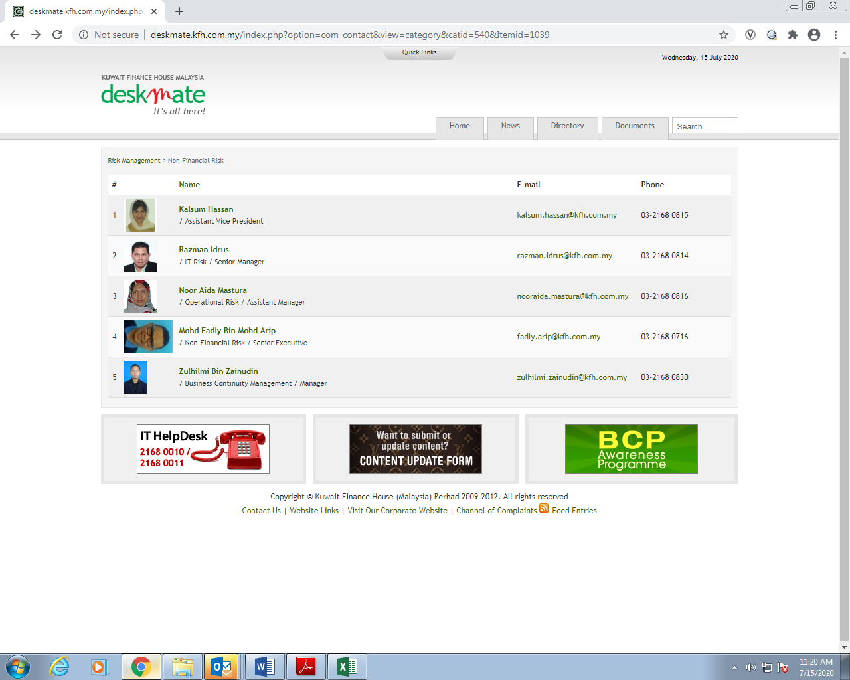

KFH Malaysia > Risk Management > Non-Financial Risk> Mohd Fadly Bin Mohd Arip

|  |
| --- |
| **Mohd Fadly Bin Mohd Arip** |
| Senior Executive | | |
| |  |  |  |  |  |  |  |  |  |  |  |  |  |  |  |  |  |  |  |  |  |  |  |  | | --- | --- | --- | --- | --- | --- | --- | --- | --- | --- | --- | --- | --- | --- | --- | --- | --- | --- | --- | --- | --- | --- | --- | --- | | |  |  |  | | --- | --- | --- | | Address:  Level 25, Menara Prestige | | | | E-mail:  fadly.arip@kfh.com.my | | |  | |  | | 03-2168 0716 | | | | | |  |  | | --- | --- | | Information: | 17-1660 | | | |  | | | | |  | | |  |

1. **CHANGE OF NAME, TO AMEND TECHNOLOGY & CYBERSECURITY RISK with the following details;**

KFH Malaysia > Risk Management > ~~Technology & Cybersecurity risk~~ > Information Security Risk> Rozita Daud

|  |
| --- |
| **Rozita Daud** |
| Assistant Vice President | | |
| |  |  |  |  |  |  |  |  |  |  |  |  |  |  |  |  |  |  |  |  |  |  |  |  | | --- | --- | --- | --- | --- | --- | --- | --- | --- | --- | --- | --- | --- | --- | --- | --- | --- | --- | --- | --- | --- | --- | --- | --- | | |  |  |  | | --- | --- | --- | | Address:  Level 25, Menara Prestige | | | | E-mail:  rozita.daud@kfh.com.my | | |  | |  | | 03-2168 0100 | | | | | |  |  | | --- | --- | | Information: | 07-209 | | | |  | | | | |  | | |  |

KFH Malaysia > Risk Management > ~~Technology & Cybersecurity risk~~ > Information Security Risk> Razman Bin Idrus

|  |
| --- |
| **Razman Idrus** |
| IT Risk/Senior Manager | | |
| |  |  |  |  |  |  |  |  |  |  |  |  |  |  |  |  |  |  |  |  |  |  |  |  | | --- | --- | --- | --- | --- | --- | --- | --- | --- | --- | --- | --- | --- | --- | --- | --- | --- | --- | --- | --- | --- | --- | --- | --- | | |  |  |  | | --- | --- | --- | | Address:  Level 25, Menara Prestige | | | | E-mail:  razman.idrus@kfh.com.my | | |  | |  | | 03-2168 0814 | | | | | |  |  | | --- | --- | | Information: | 17-1657 | | | |  | | | | |  | | |  |