SRS Requirement for Edit Participant.
1. To Change Service Subscribed name to Service Type
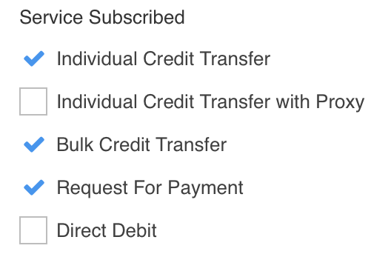
2. To add asterisk (*) at PIC 2 field as a mandatory field.


3. Error message still display ”This field is required” which field system refer to?


4. Error message still display old error
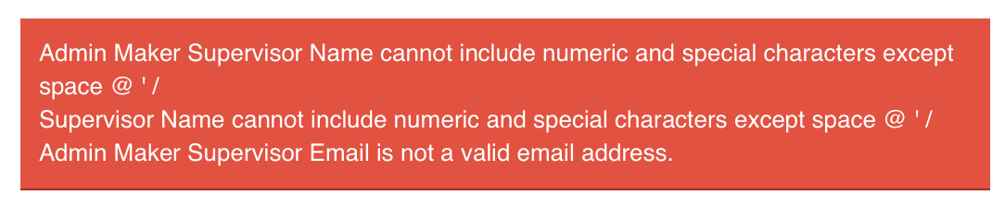
5. Edit on Service Type unselected. System not throw any error message. Click on Next button system still carry old value.
To display Service Type in array or text area to avoid Service type value cross the system display.
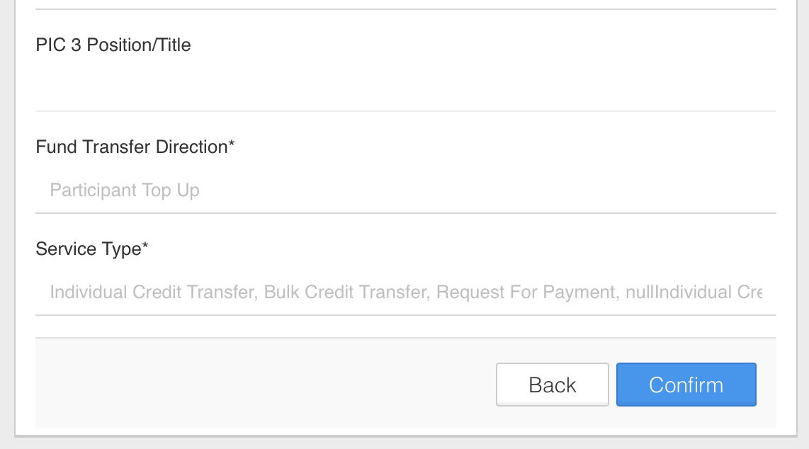

6. Don’t clear Fund Transfer Direction value each time system throw error message.

