11565 – account management update

[SCP ID :##5775##] : Maker unable to edit Account Management

Test Steps:

1. Use IBAM Maker to login
2. Access IBAM > CORPORATE BACK END > Organization Setup > Find Organization Name "Penril Datability" > Press Action "Edit" icon > Account Management
3. Disactivate an active invalid digit account
4. Press Next button to confirmation page
5. Press Confirm button to result page
6. Excepted result from Maker, will see "Accounts has been edited and pending for approval" message

Maker

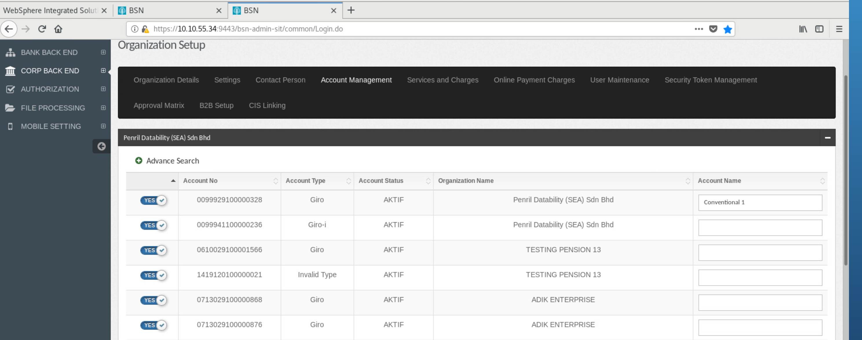

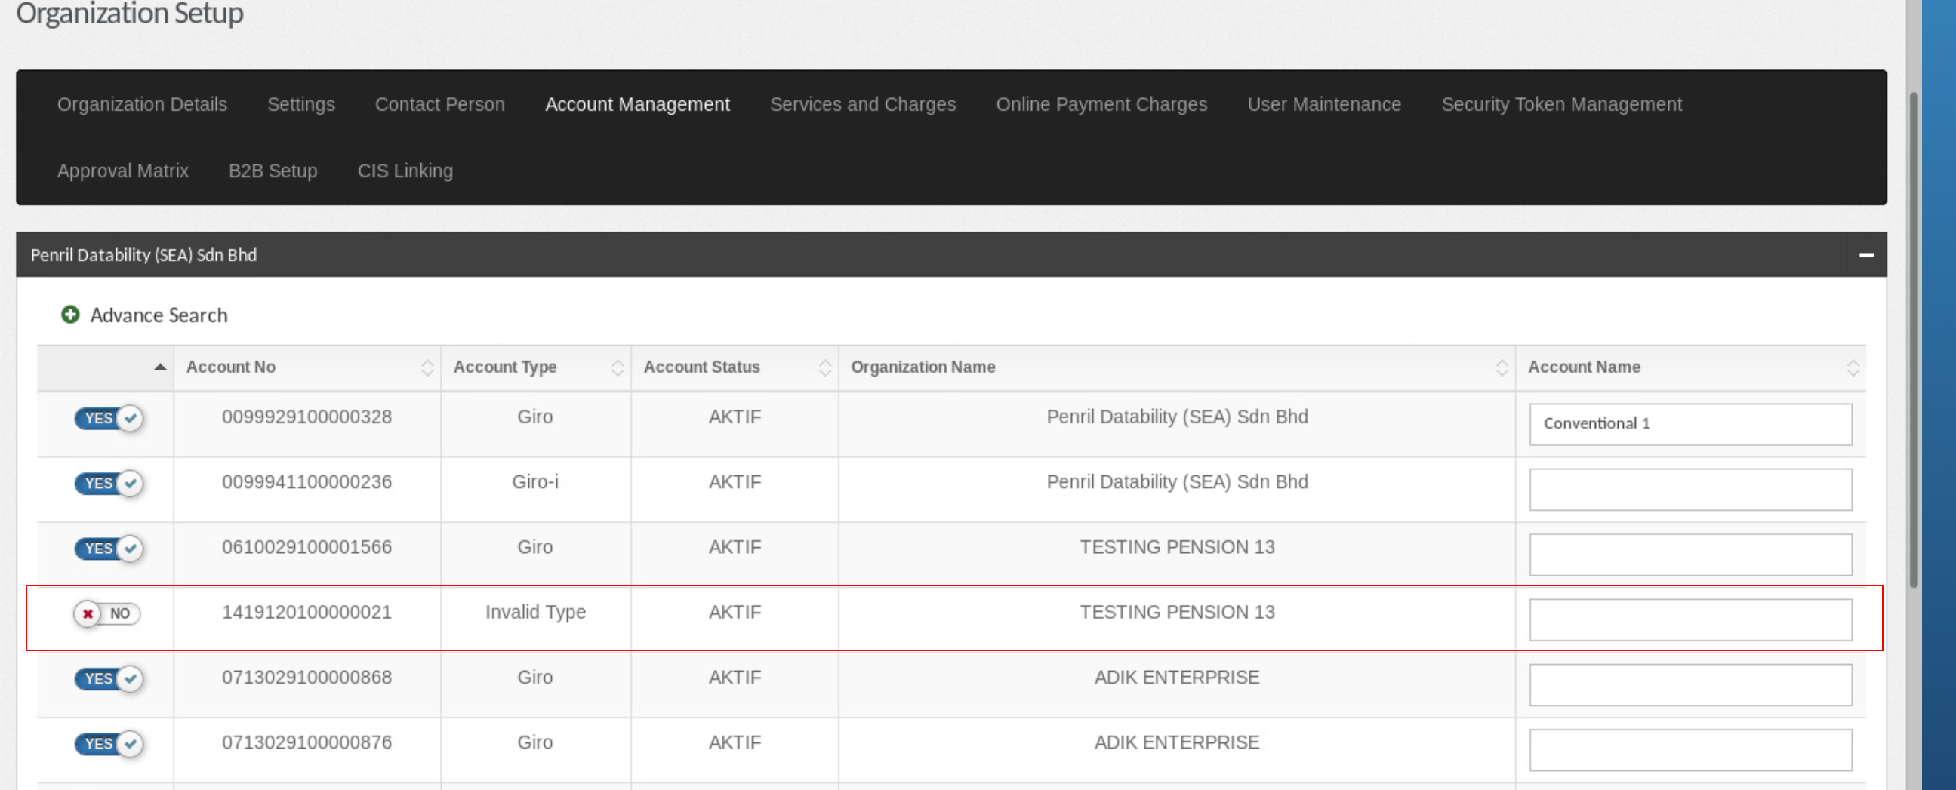

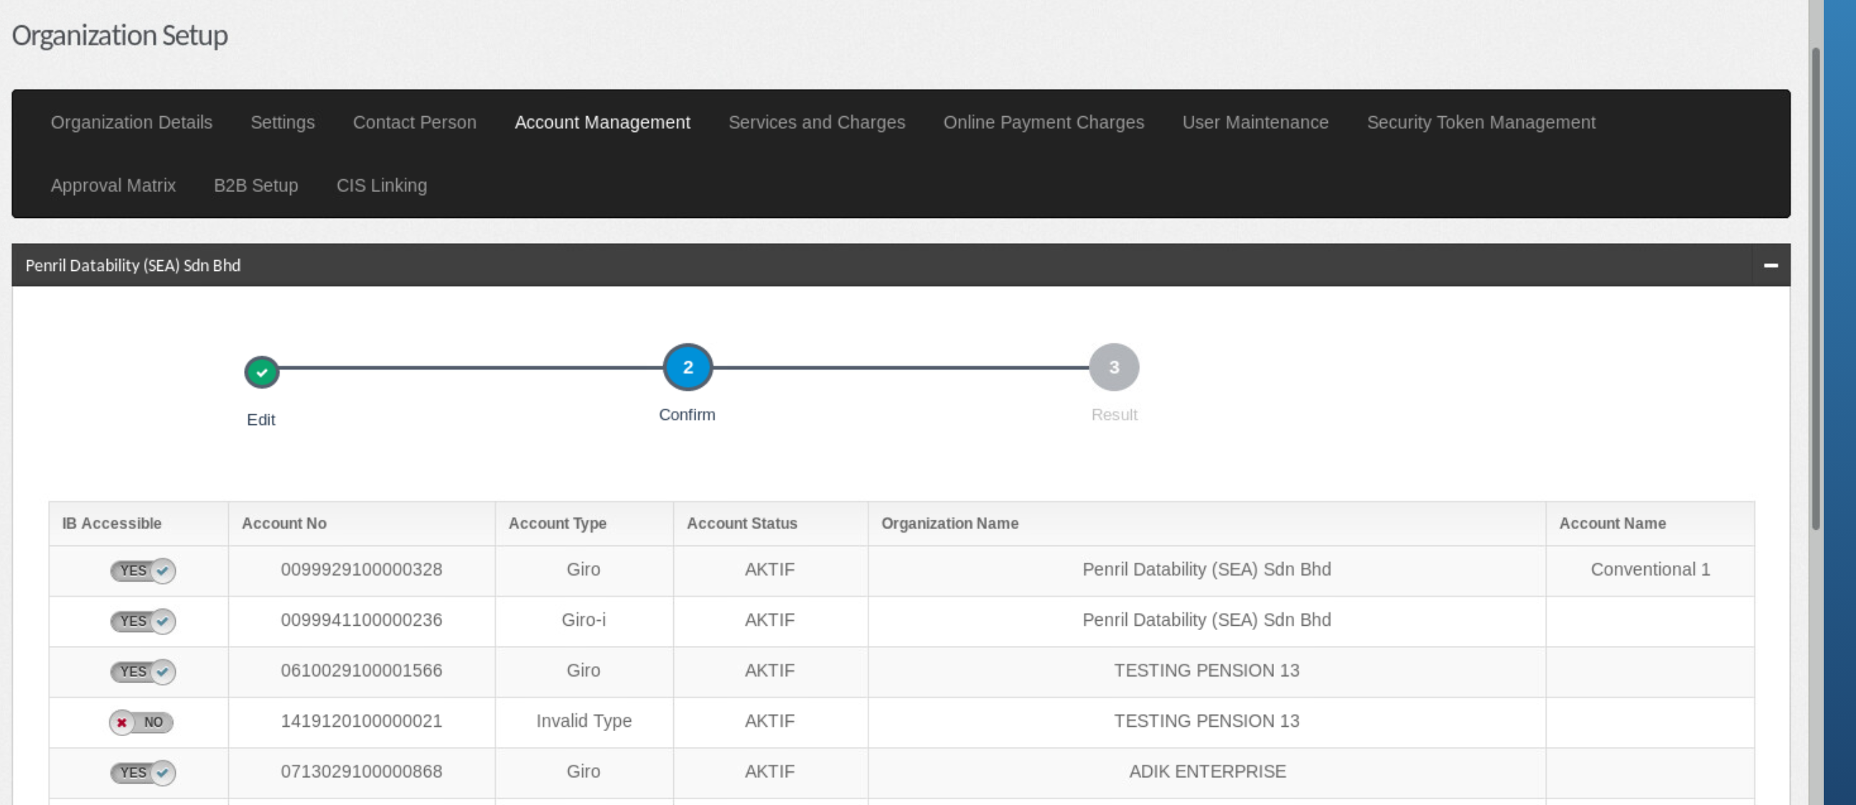

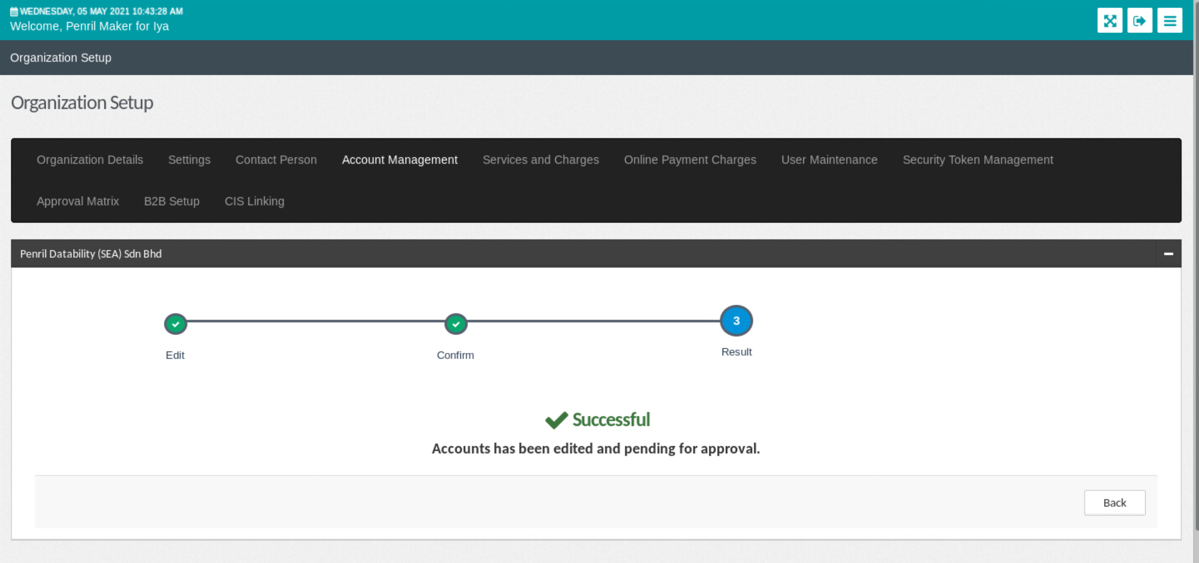



Checker

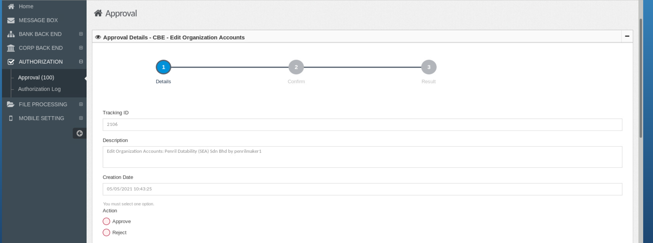

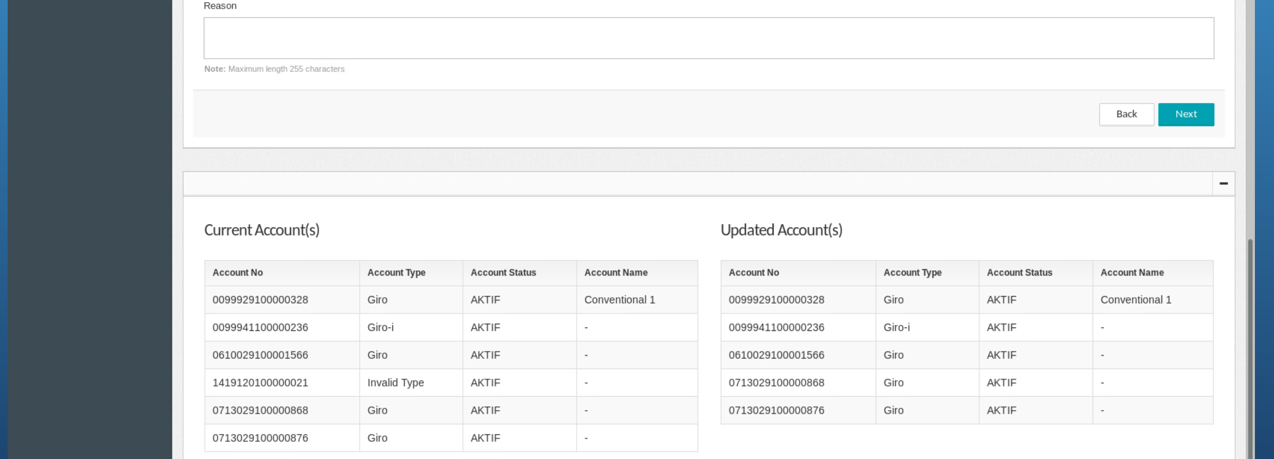

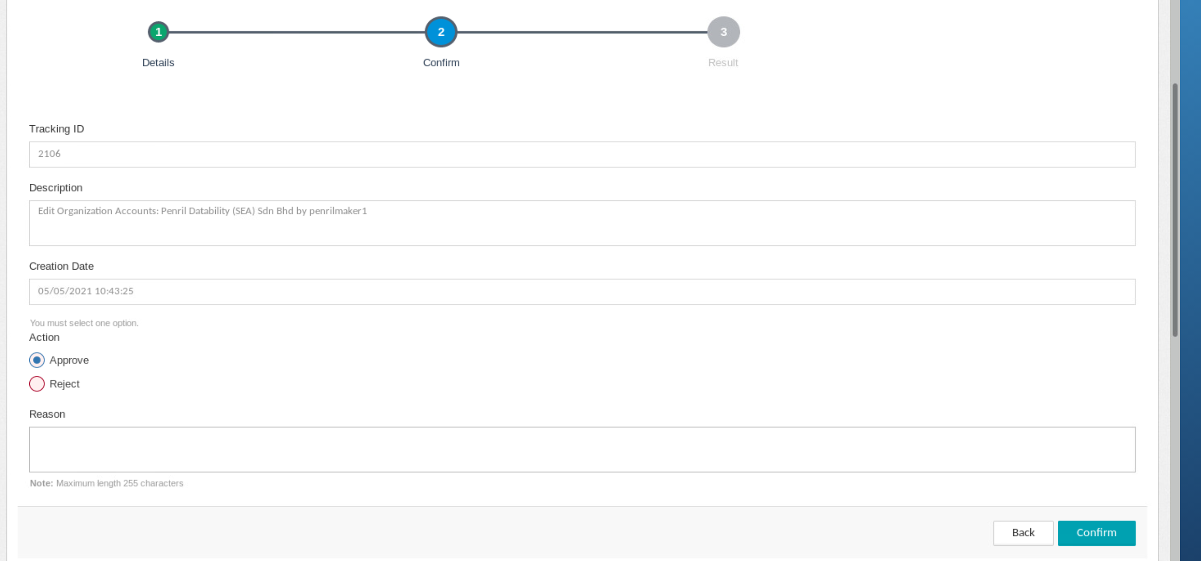

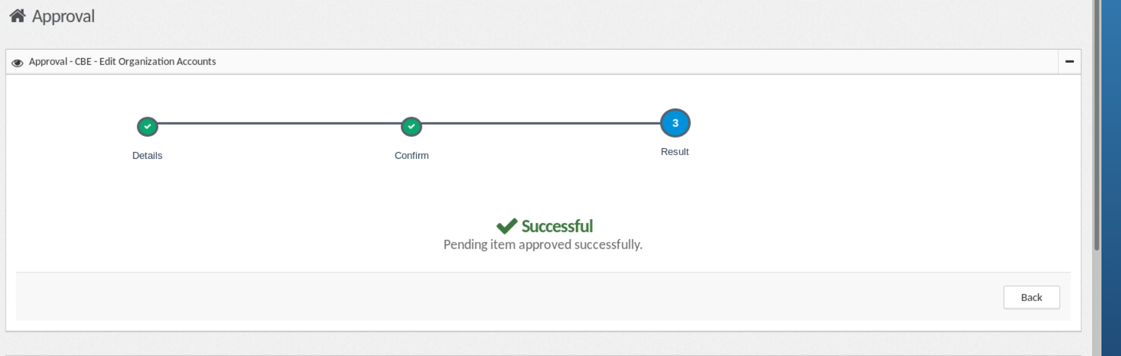

Result : Succeed deactivated invalid account

