No | Staff | Remarks
1. | 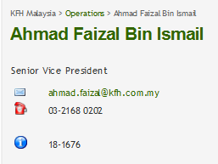 | - No location –L8 Menara Prestige
2. | 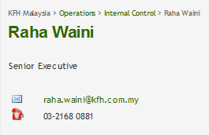 | - No location – L8 Menara Prestige  - No Staff ID – 15-1502  - No picture
3. | 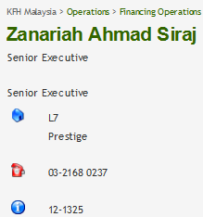 | - No Email – zanariah.siraj@kfh.com.my
4. | 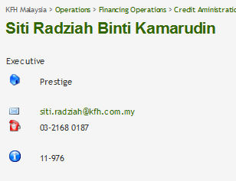 | - No location – Level 7
5. | 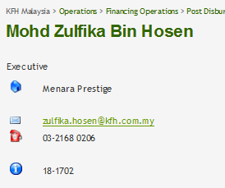 | - No location – Level 7  - No picture
6. | 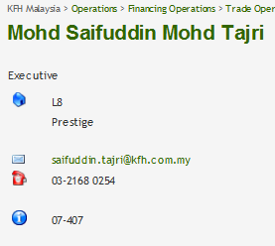 | - Location – change to Level 7
7. | 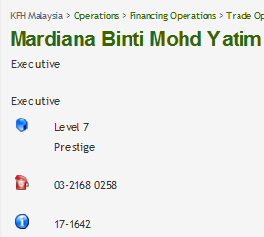 | - No Email – mardiana.yatim@kfh.com.my  - No Picture
8. | 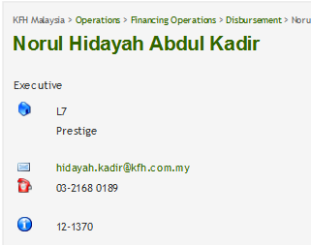 | - Transfer from Disbursement to Trade Operations
9. | 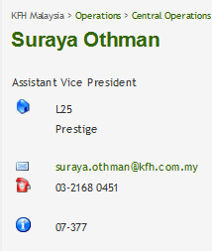 | - Location change to L8 Menara Prestige
10. | 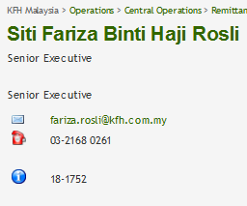 | - No location – L8 Menara Prestige  - No picture
11. | 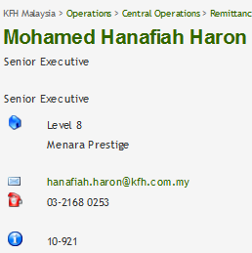 | - No picture
12. | 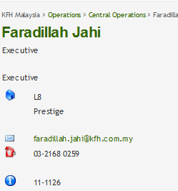 | - Central Operations change to Remittance & Clearing
13. | 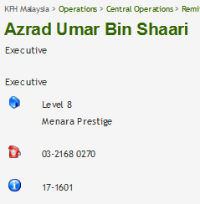 | - No Email – azrad.umar@kfh.com.my
14. | 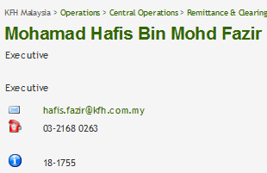 | - No location – L8 Menara Prestige  - No picture
16. | 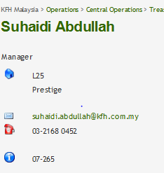 | - Location change to L8 Menara Prestige
17. | 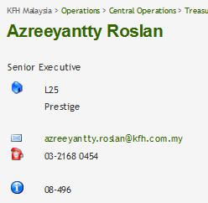 | - Location change to L8 Menara Prestige
18. | 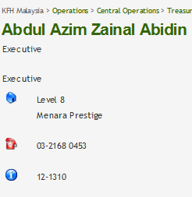 | - No Email – azim.zainal@kfh.com.my  - No picture
19. | 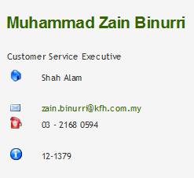 | - Transfer to Treasury Operations  - Remove “Customer Service”  - Location change to L8 Menara Prestige  - Number change to 03 – 2168 0457
15. |  | - Remove Fairozasmal & Suffia from Treasury Operations
20. | 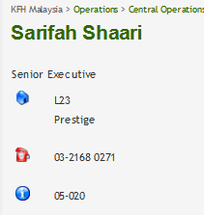 | - Location change to L8 Menara Prestige  - No Email – sarifah.shaari@kfh.com.my
21. | 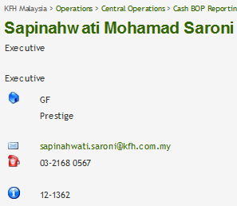 | - Title change to Senior Executive  - Location change to L8 Menara Prestige  - Number change to 03 – 2168 0267
23. |  | - Transfer Rahmat Abu Bakar to Vendor Management
22. | 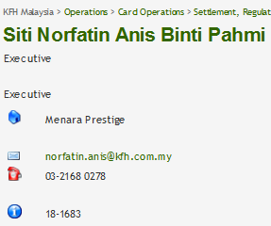 | - No location – L8 Menara Prestige  - No picture
24. | 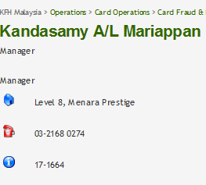 | - No Email – kandasamy.mariappan@kfh.com.my
25. | 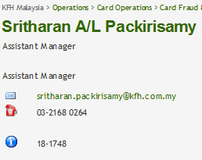 | - No location – L8 Menara Prestige  - No picture
26. | 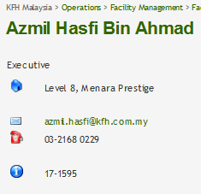 | - Location change to Level 7
27. |  | - Remove Jeyalani from Facility Services  - To add under CEO’s Office
28. | 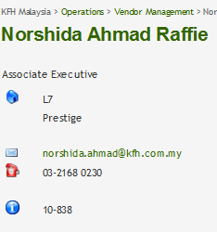 | - Location change to L8 Menara Prestige
29. | 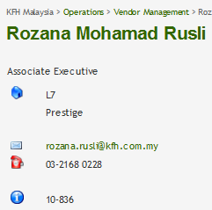 | - Location change to L8 Menara Prestige

