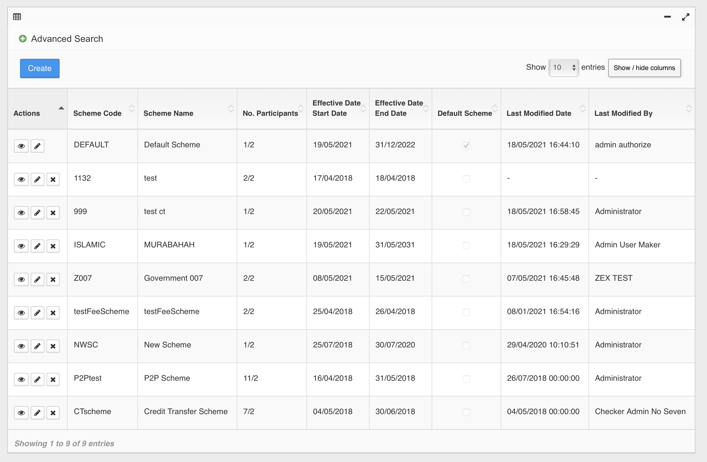
Bank A
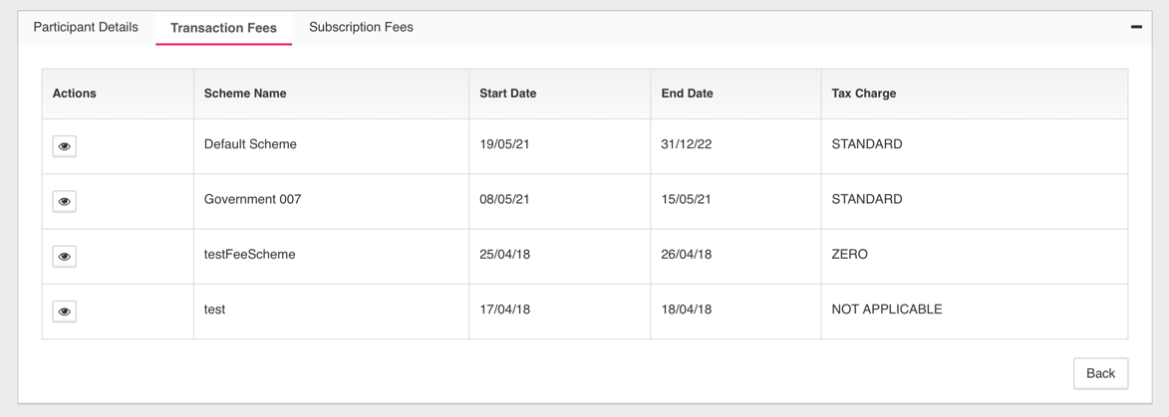

Bank B
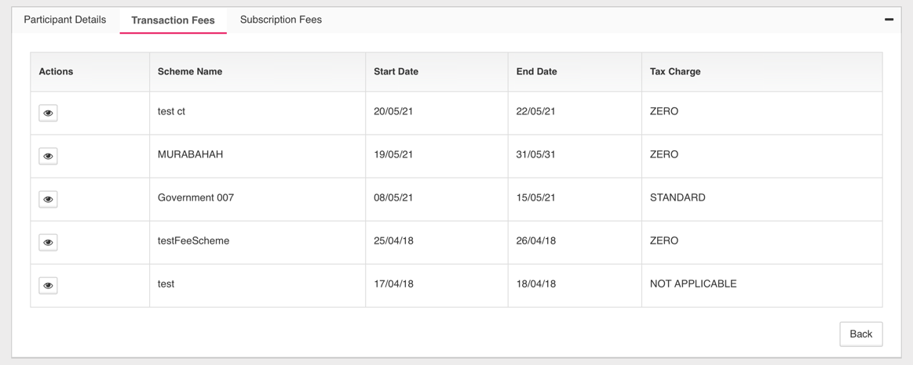

Scheme with highlighted in RED, tied with Bank A & Bank B.
Issue 1:
System throw Error after delete the. Scheme
Expected Result:
System will throw an error message, this scheme unable to delete due to ………



Issue 2:
The rest of the Scheme not highlighted in RED are unable to delete. System throw error as above as well.
Expected Result:
Able to delete any scheme if not tied with any bank.

