- To rename Participant Profile to Participant Maintenance
- To replace Participant ID with value = BNKAMYKL
- To standardise Description value.
- To rename Category Name to Activity Name
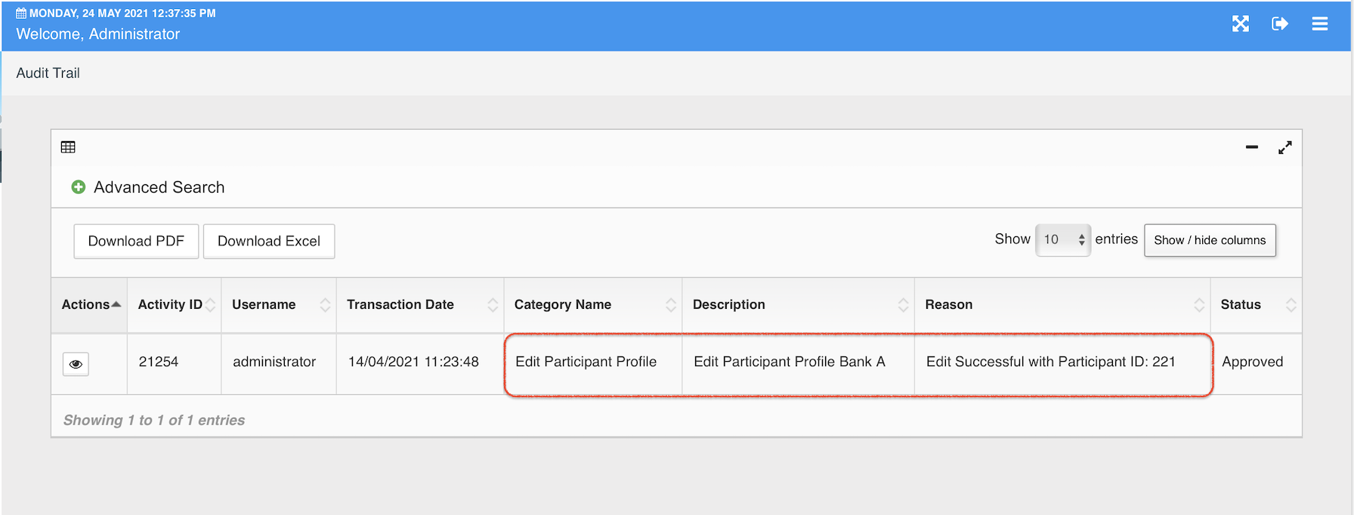
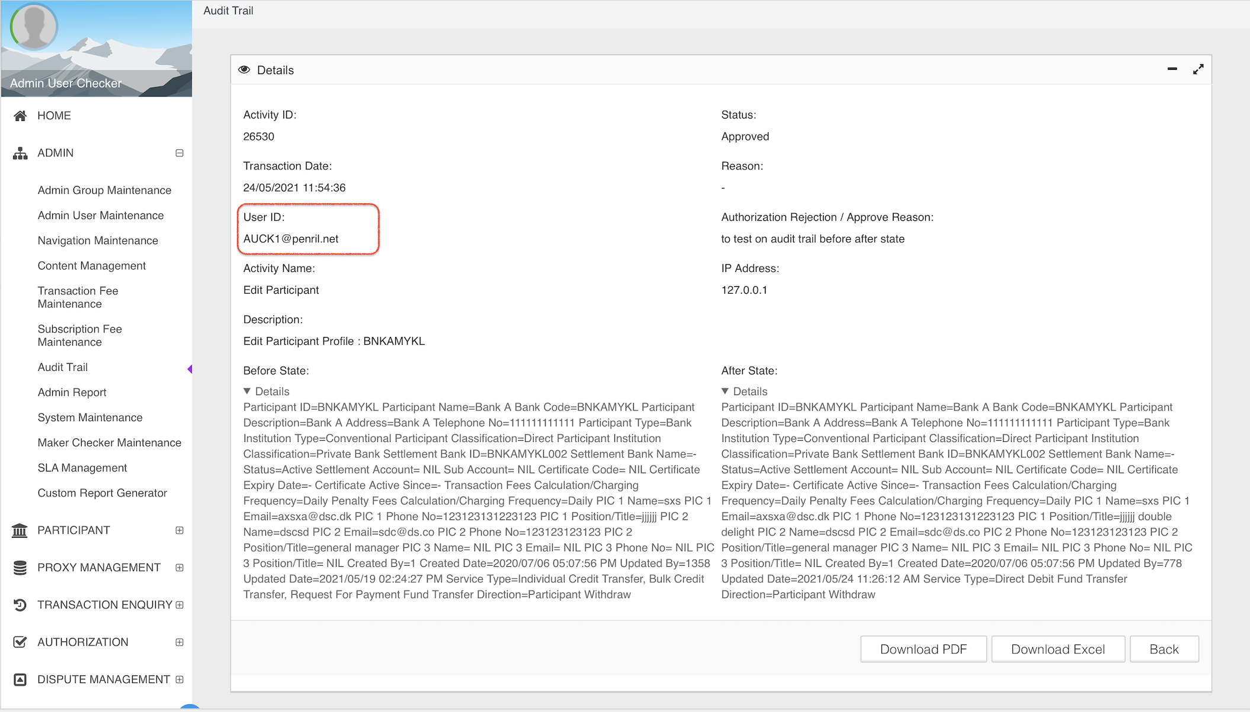
- Authorize Reason display null. Sorry salah highlight kt reason pulak
- To remove HTML code at Before State & After state value.

