### 11741 -  Transaction status in IBAM File Processing not tally with CDB Transmittal Report

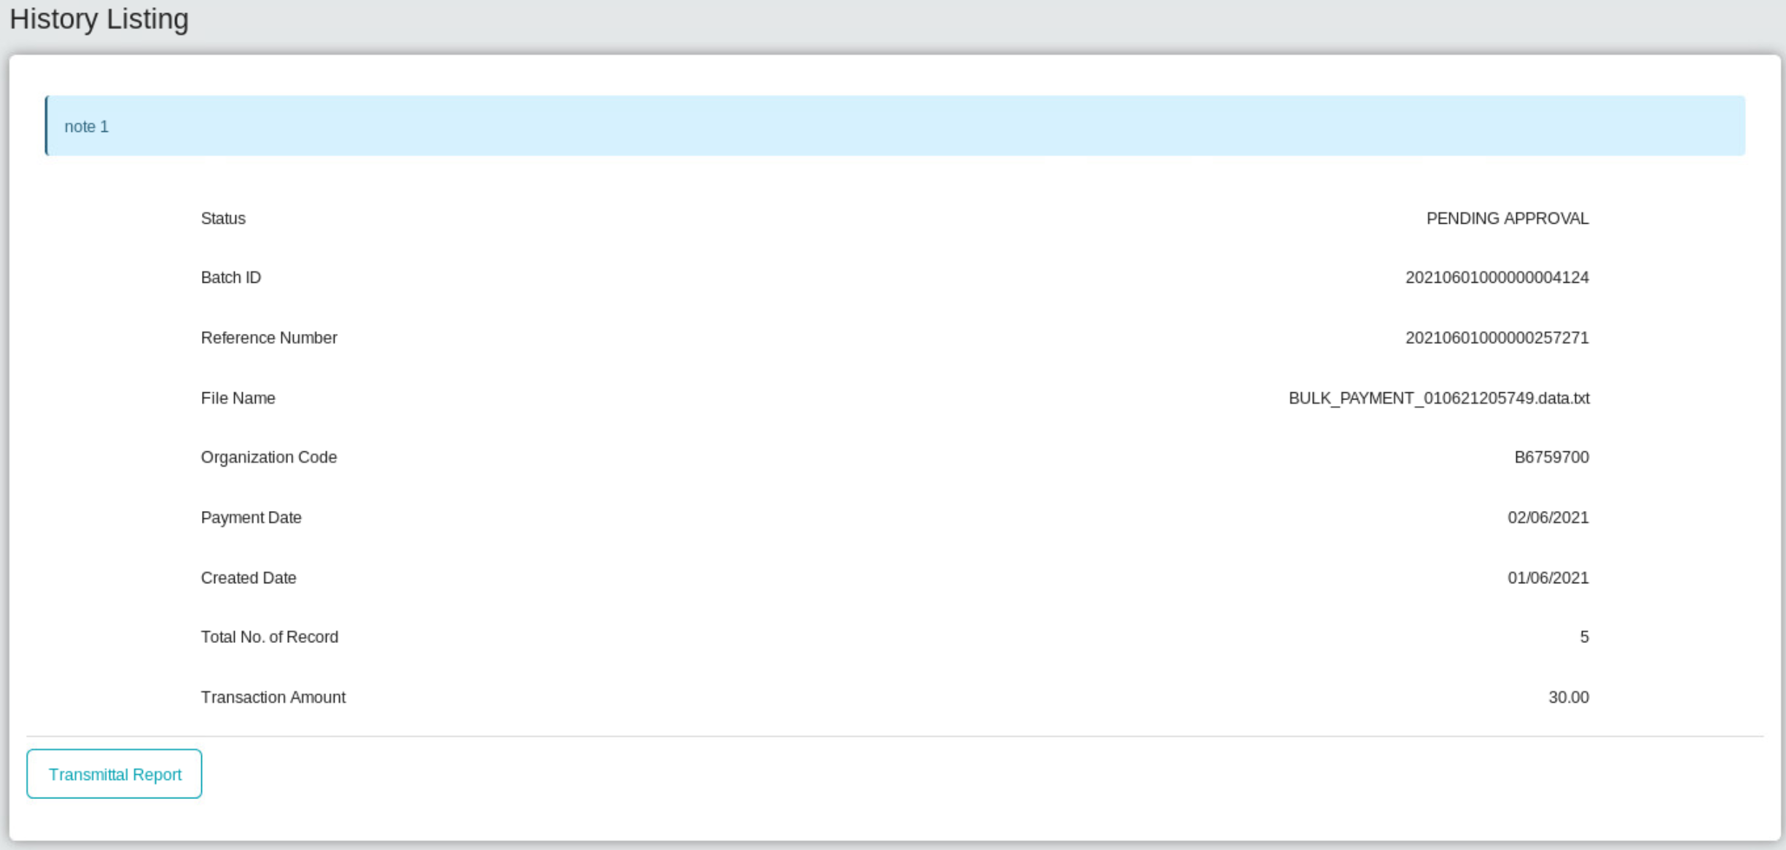

Transmittal cdb

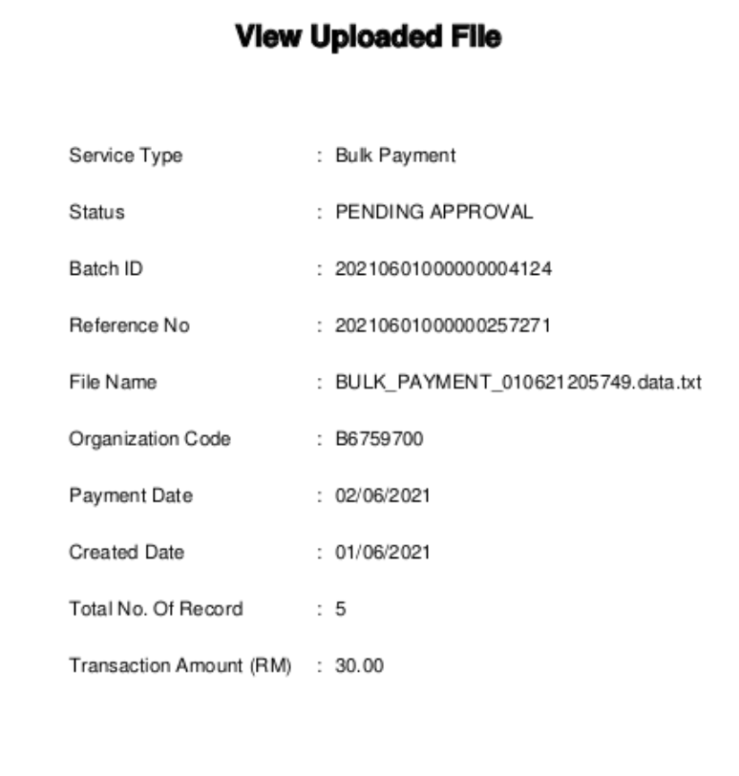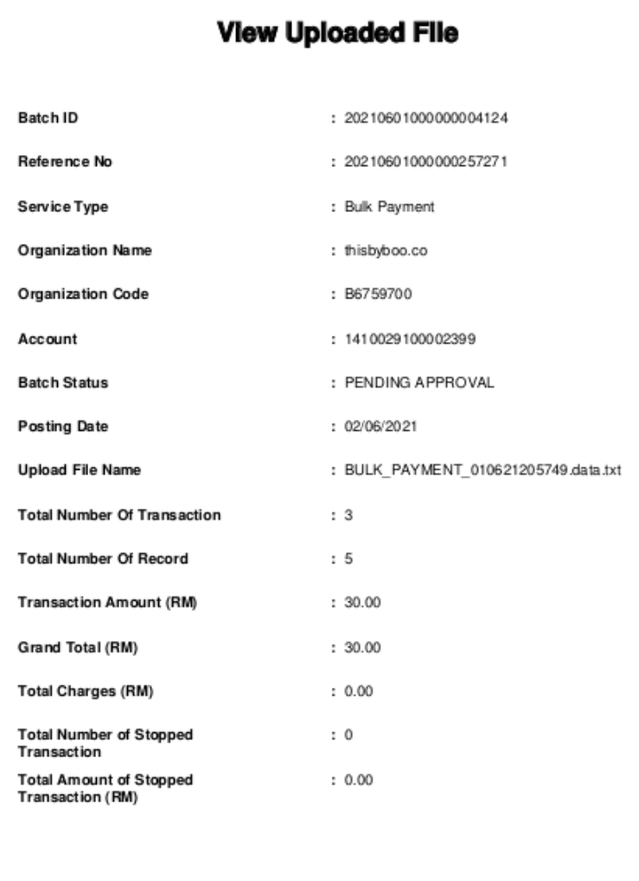

CDB and IBAM transmittal

* Wrong status display at Bulk Payment > Transaction History , File Processing and both transmittal report.

System display : Pending Approval.

* Refer IBAM > BSNeBiz Transaction Enquiry , System display status : Successful

Approval Matric for bulk payment :

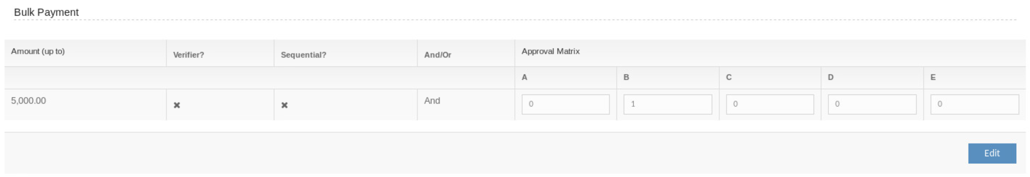

File enquiry/file processing

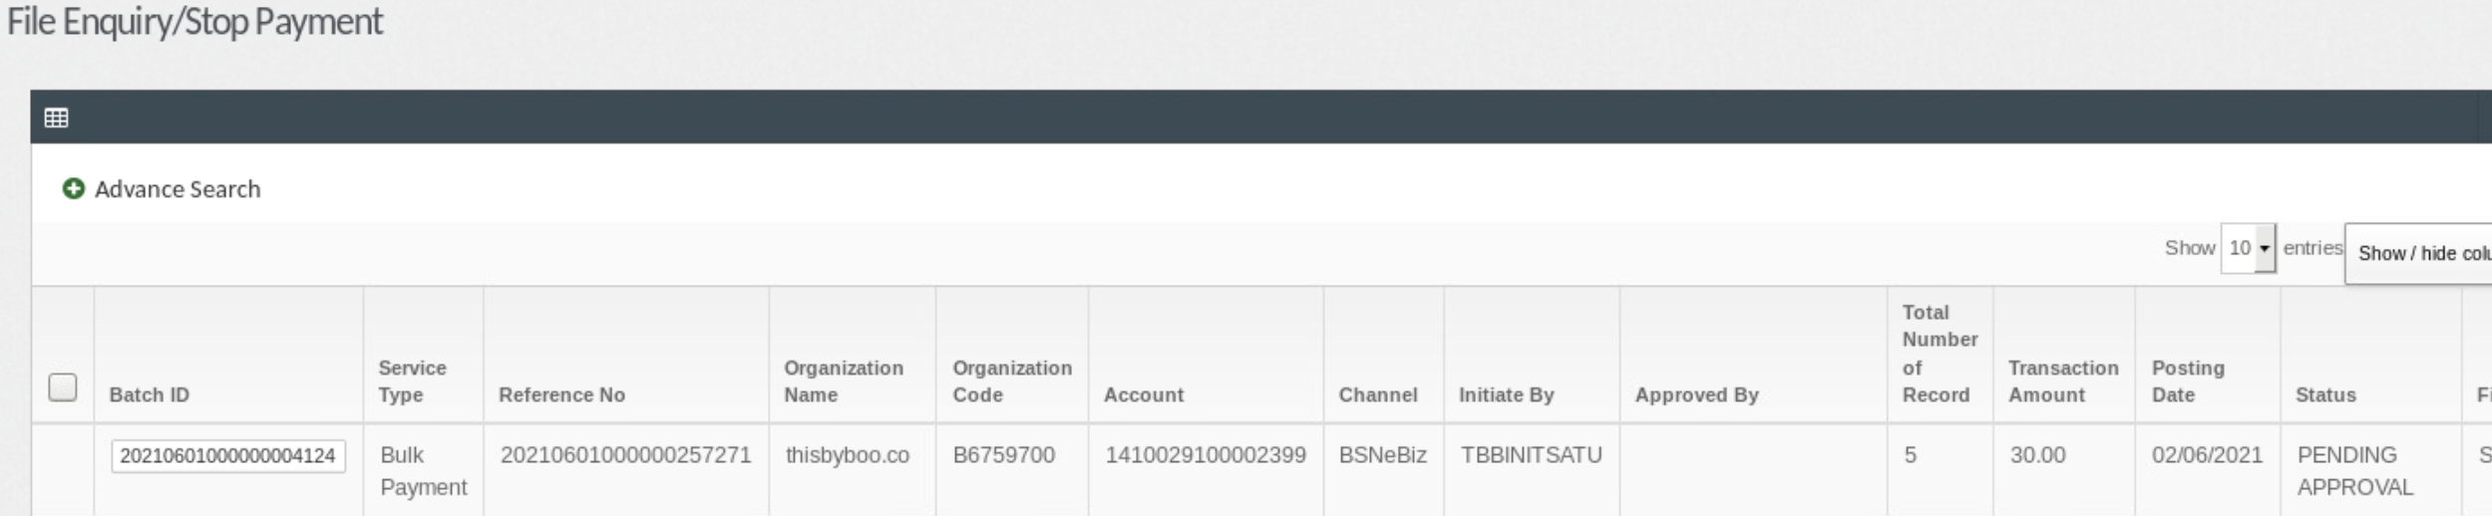

History Listing

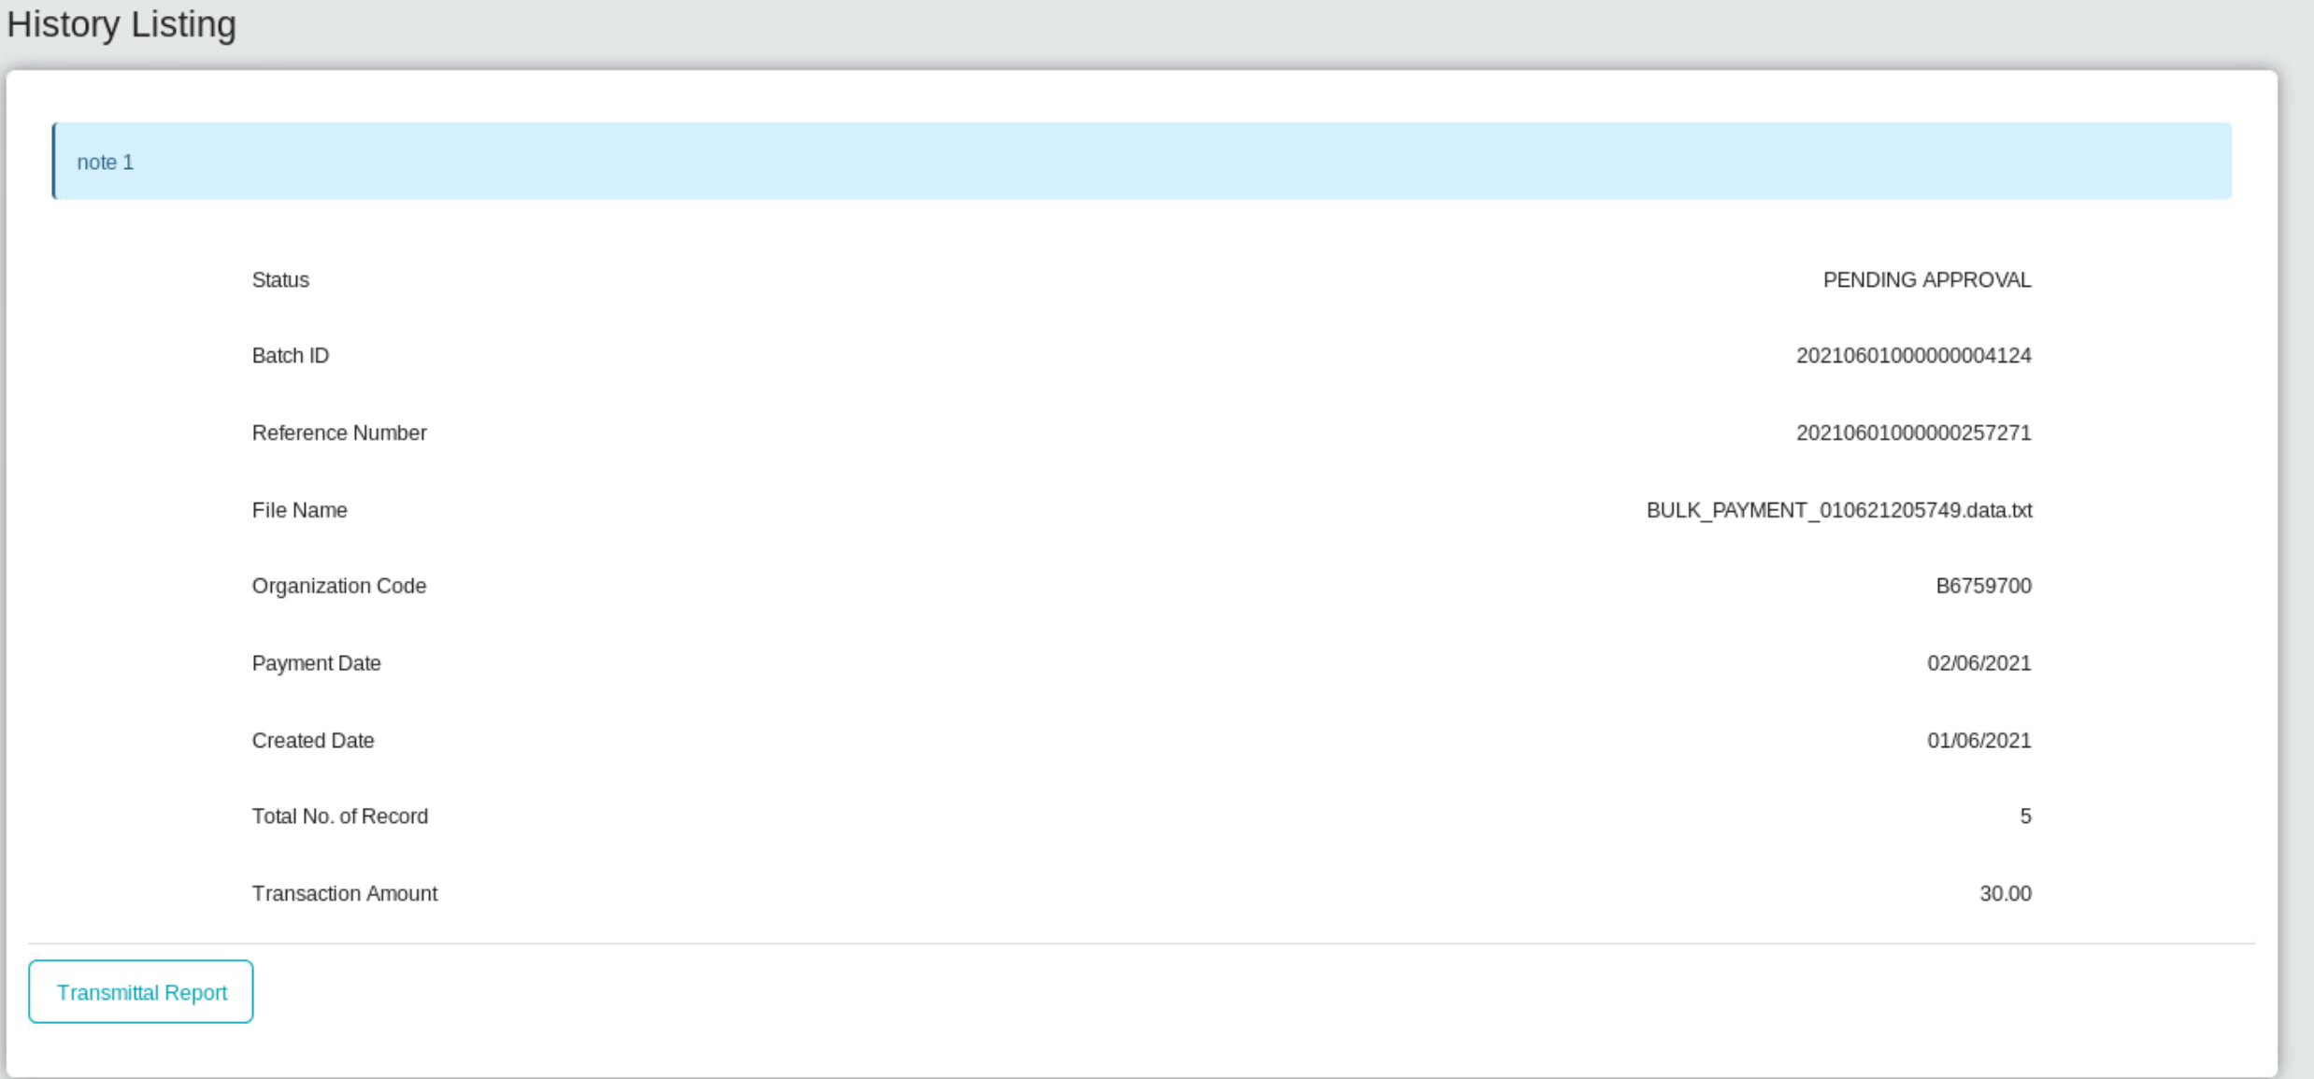

Transaction Enquiry

