Auto sweeping

Select and delete all

1. At CDB, initiator select all and delete all existing sweeping transaction. (Got 2 item in the list)
2. At authorization screen, system only display one item.
3. After approved the request, access to Initiator screen.

**Result :**

System only delete one item.

**Expected**

System display all selected item and delete all selected item.

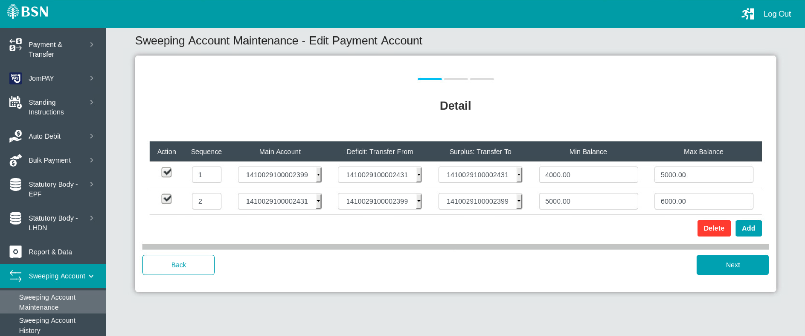

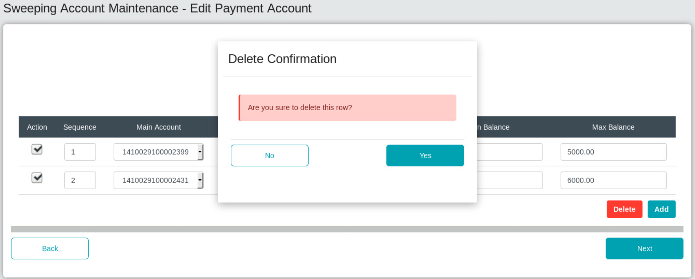

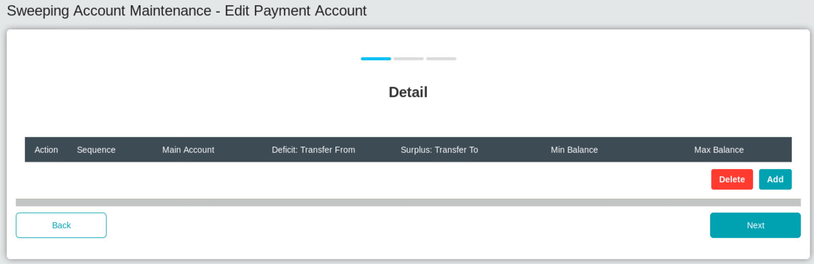

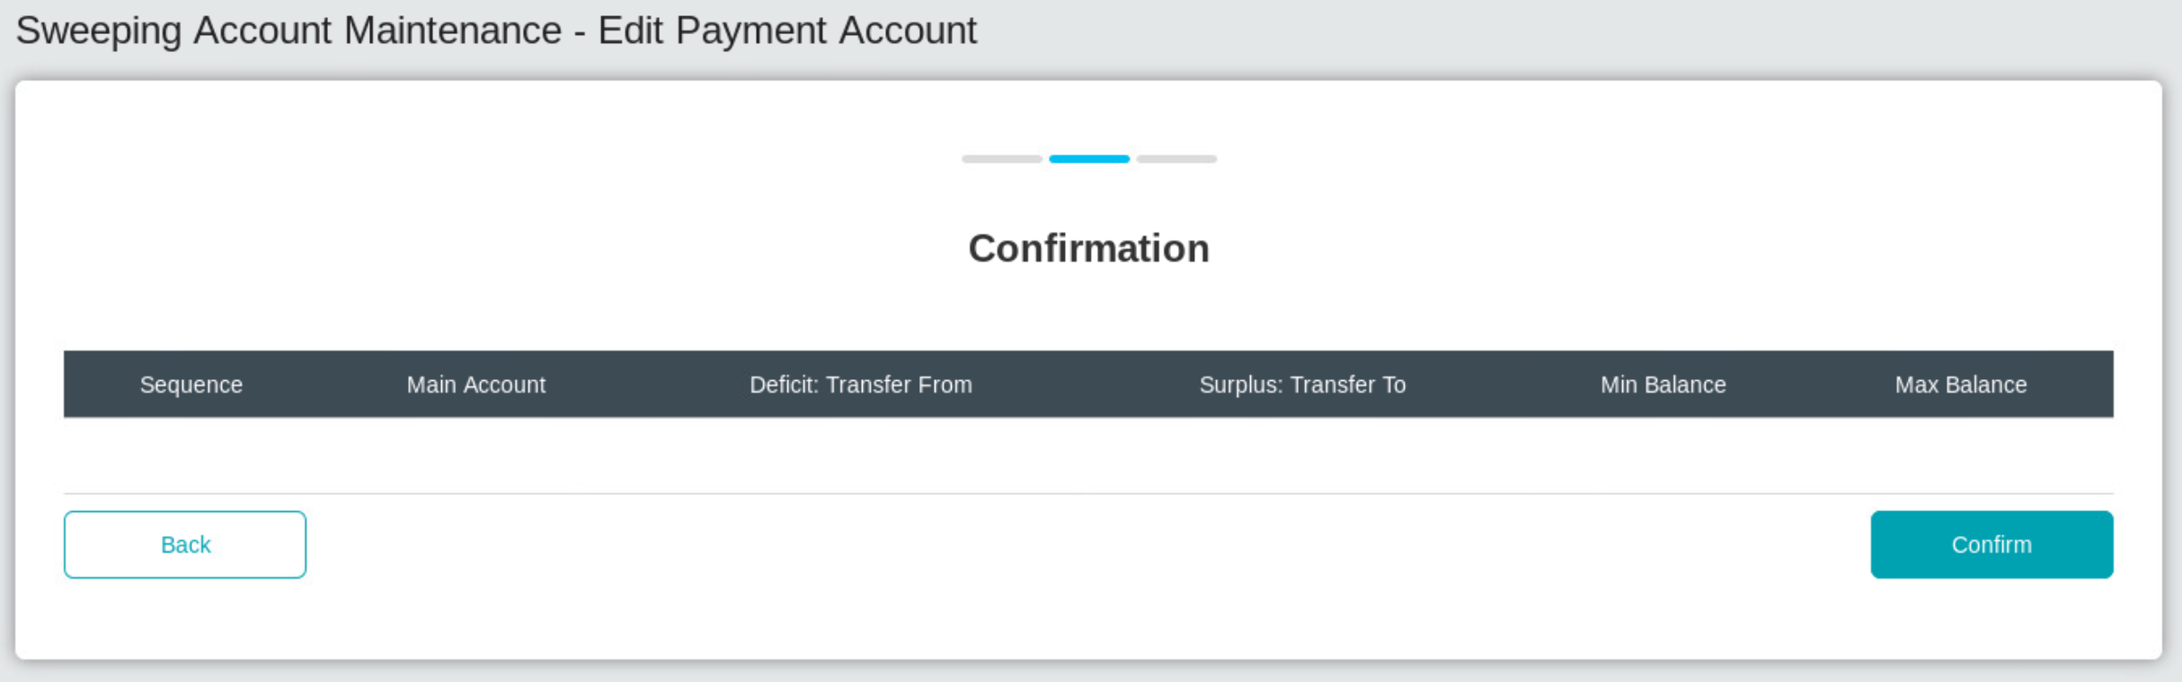

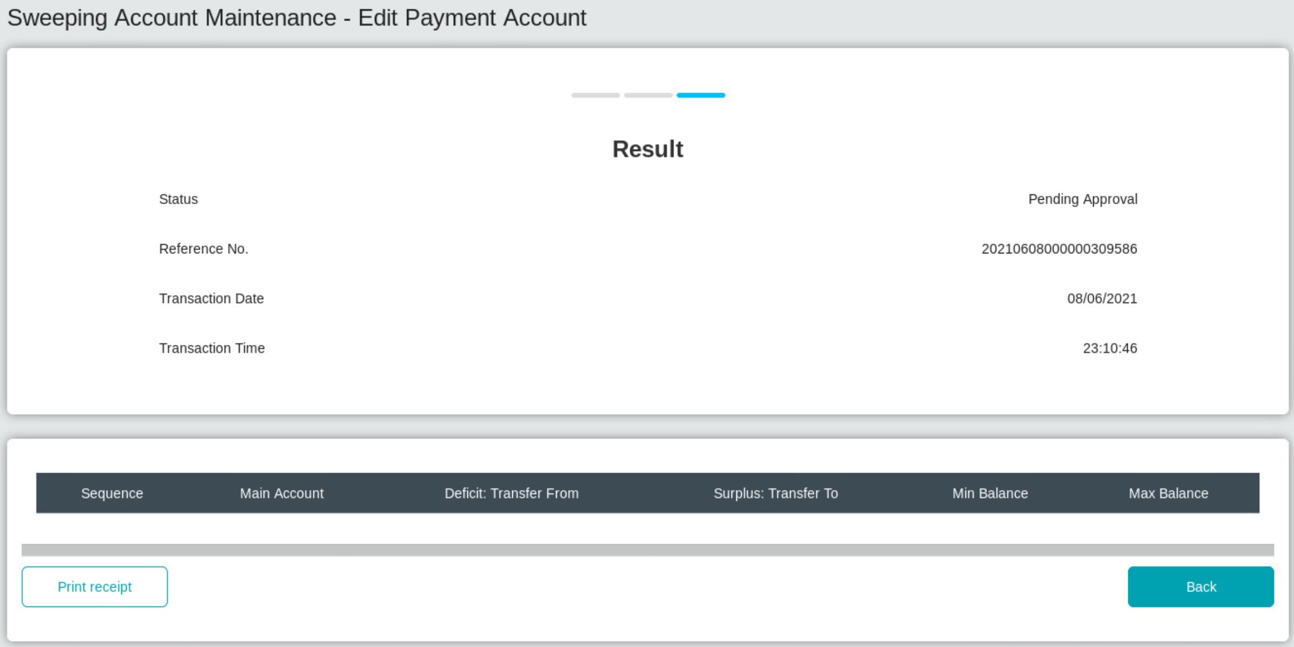

Authorization screen

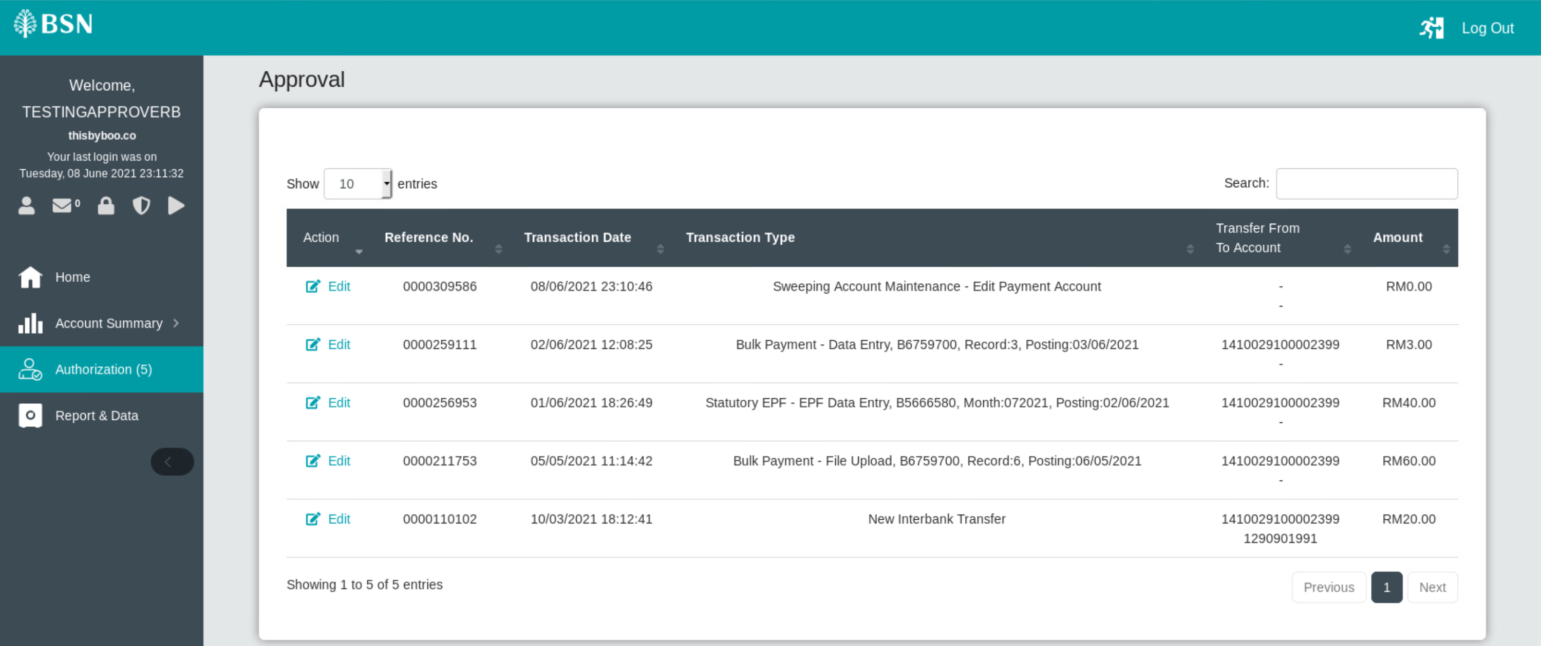

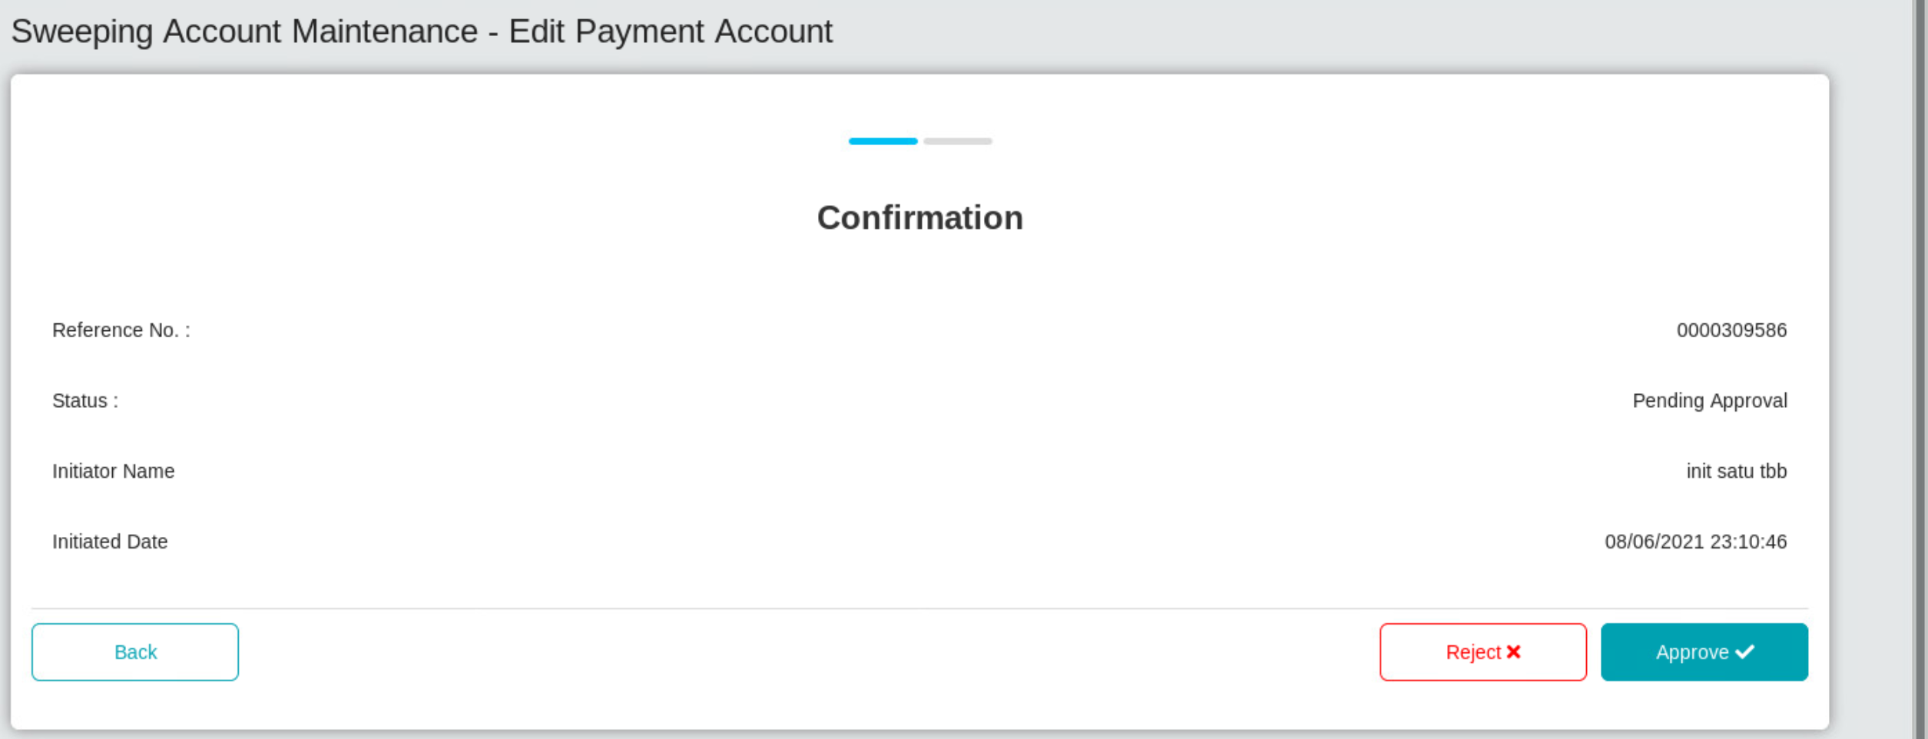

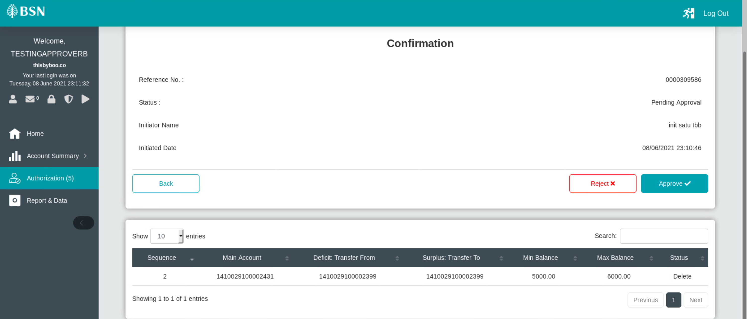

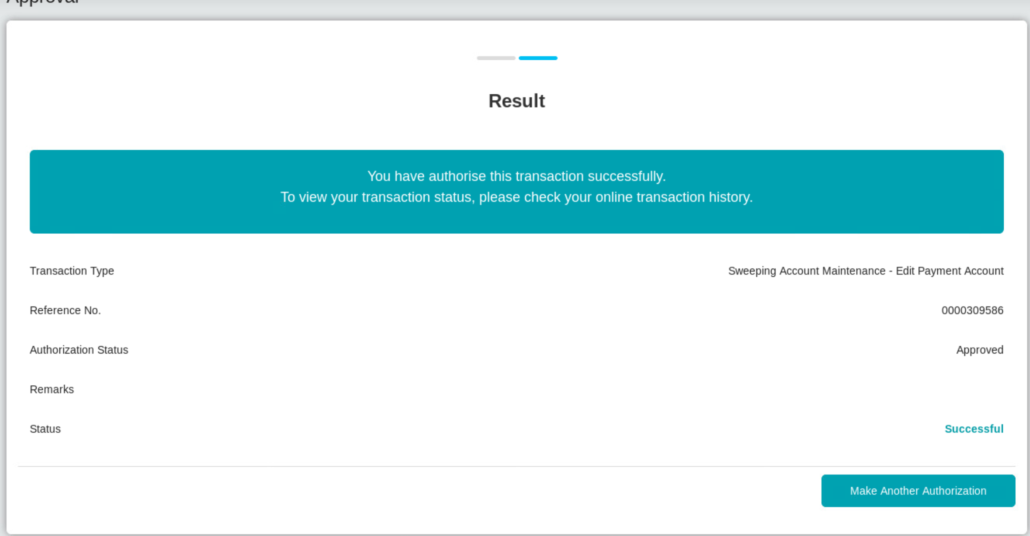

Back to initiator screen

