Auto sweeping - Failed following the sequence no

Acc Sum

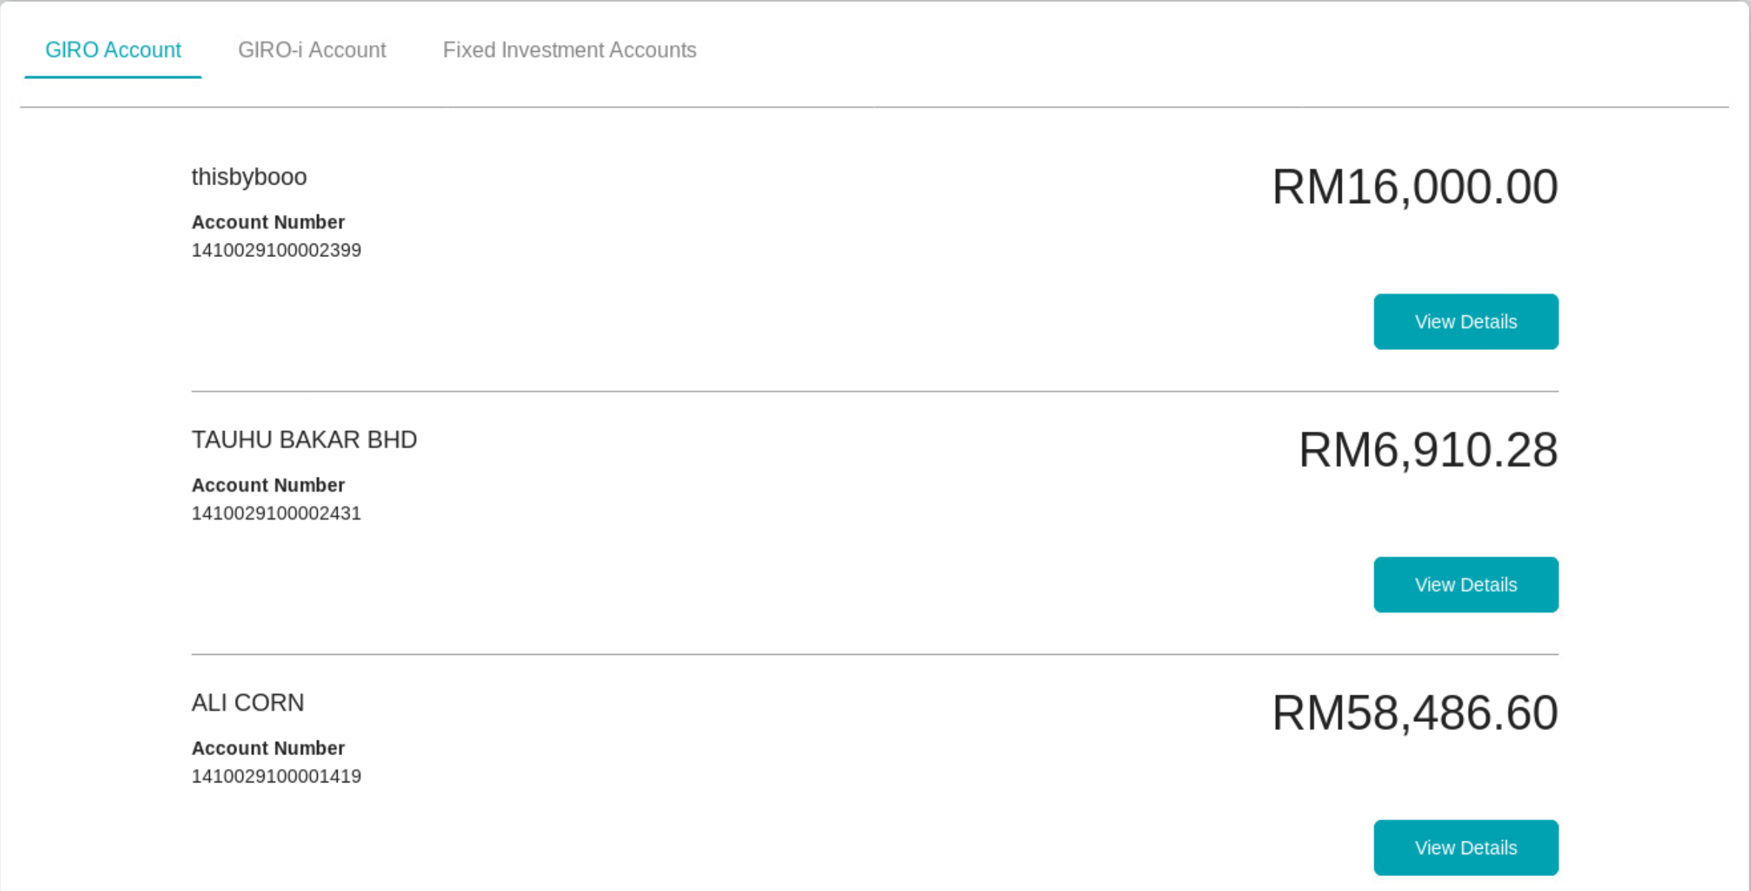

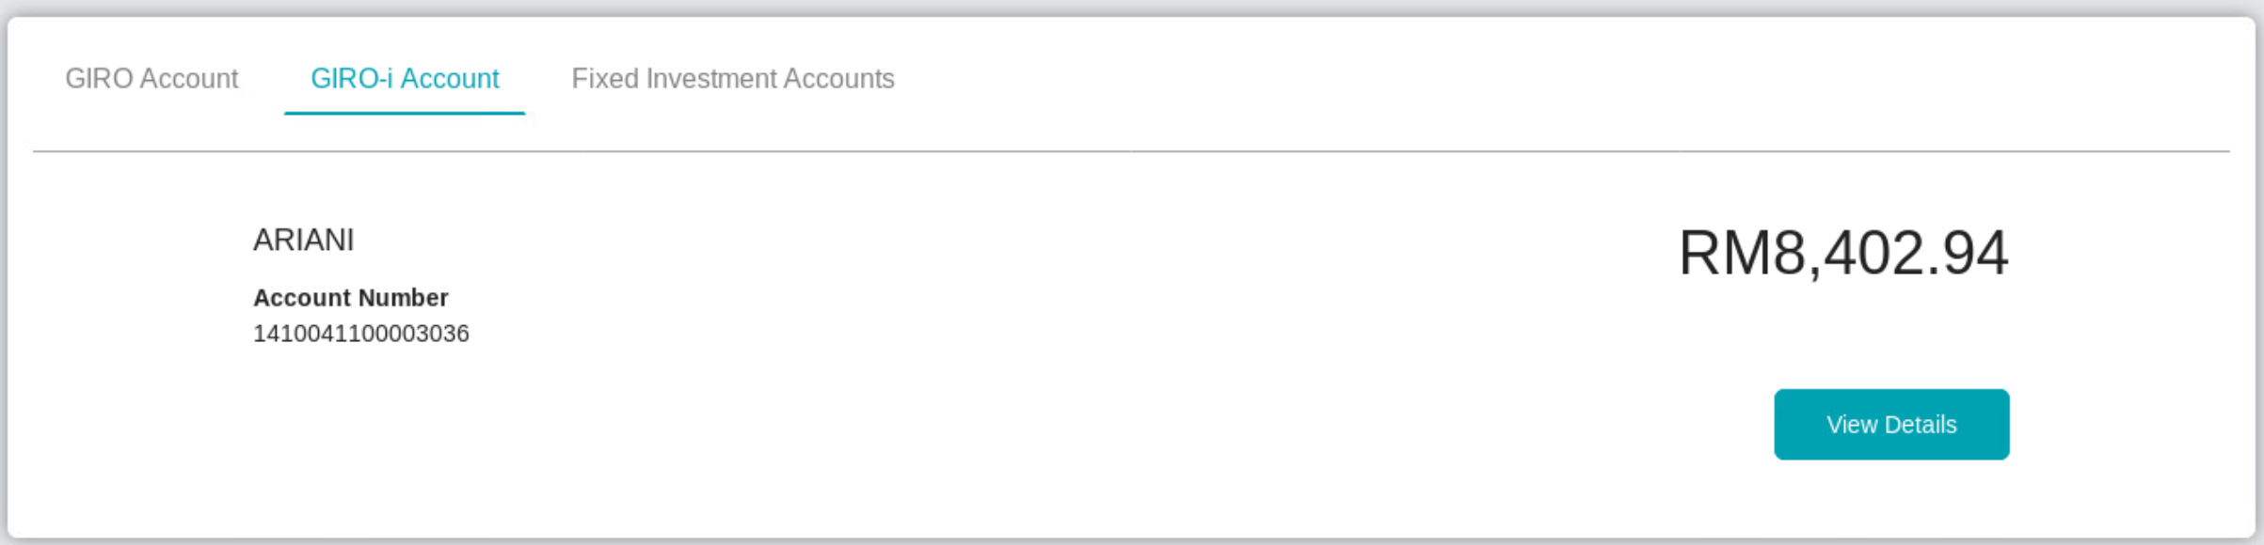

Sequence Set

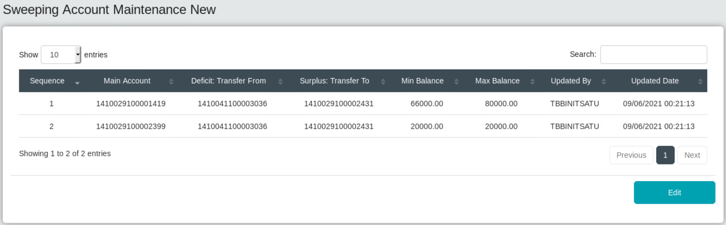

Expected :

Ali Corn : 66000

Ariani : 889.54

Thisbyboo : Failed due to insufficient balance

Result :

System deducted for thisbyboo first, not following the sequences

