**IT Organisation Chart – 20 Jan 2021**

OLD CHART IN DESKMATE

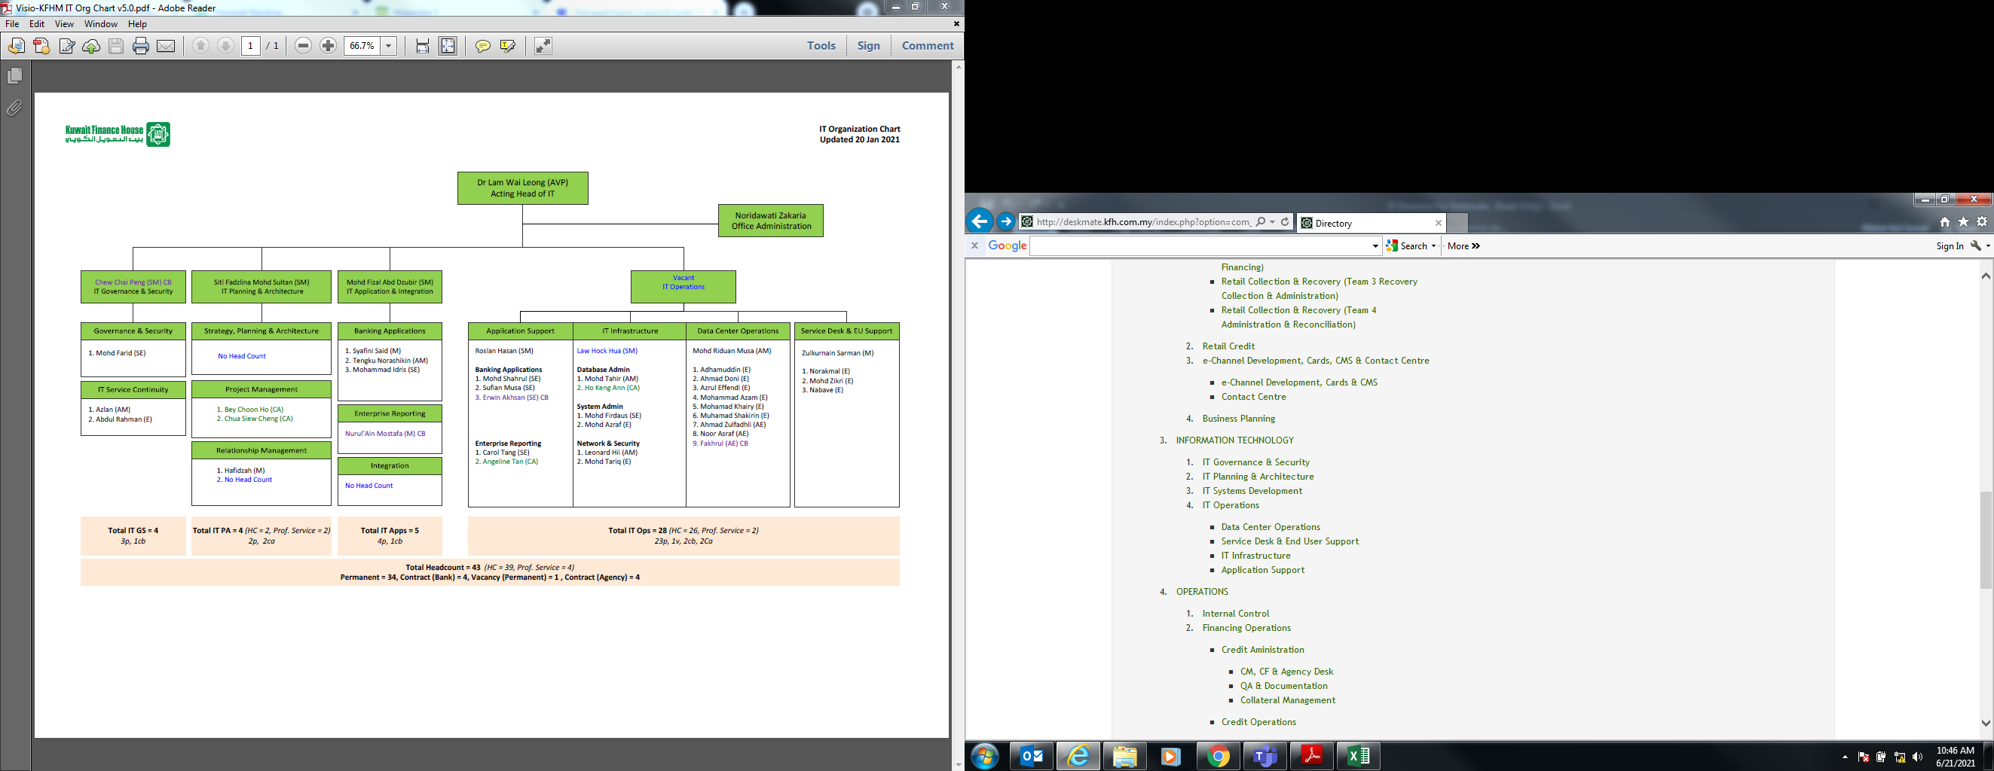

NEW CHART

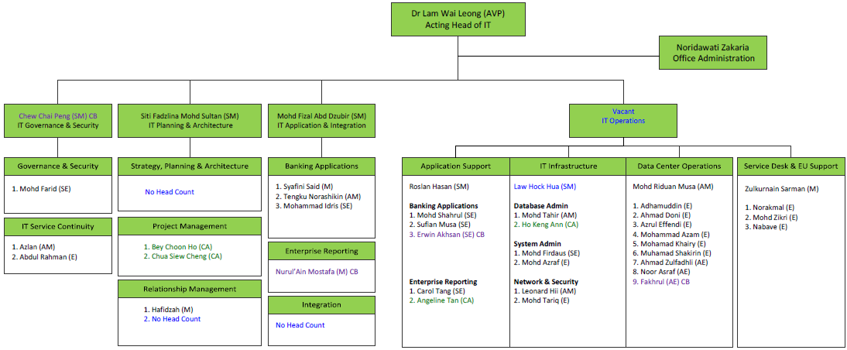

1. To add the following staff under IT Governance & Security



Simon Chew Chai Peng (Staff ID: 20-1803)

Head, Governance & Security / Senior Manager

03-21680121

[chew.chai.peng@kfh.com.my](mailto:chew.chai.peng@kfh.com.my)

1. To add two sub-units under IT Governance & Security
2. Governance & Security

To add the following staff under the new unit:

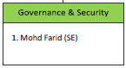

1. IT Service Continuity

To add the following staff under the new unit:

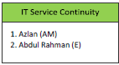

1. To add three sub-units under IT Planning & Architecture

Head, IT Planning & Architecture / Senior Manager

1. Strategy, Planning & Architecture – No Head Count
2. Project Management

To add the following staff under the new unit:

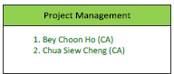

Bey Choon Ho

Project Manager

03-21680142

bey.choon.ho@kfh.com.my

Chua Siew Cheng

Project Manager

03-21680145

[chua.siew.cheng@kfh.com.my](mailto:chua.siew.cheng@kfh.com.my)

1. Relationship Management

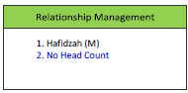

1. To rename IT Systems Development to IT Application & Integration

Head, IT Application & Integration / Senior Manager

1. To add three new units under IT Application & Integration
2. Banking Applications

To add the following staff under the new unit:

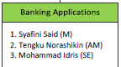

To update staff designation:

1. Norashikin – from Senior Executive to Assistant Manager
2. Idris – from Executive to Senor Executive
3. Enterprise Reporting

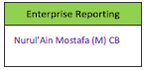

Nurul'Ain Mostafa (Staff ID: 20-1797)

Manager

03-21680118

[nurul.ain@kfh.com.my](mailto:nurul.ain@kfh.com.my)

1. Integration – No Head Count
2. IT Operations
3. IT Infrastructure - to add three new units
4. Database Admin



Eugene Hoe Keng Ann

Database Administrator

03-21680105

[hoe.keng.ann@kfh.com.my](mailto:hoe.keng.ann@kfh.com.my)

1. System Admin



1. Network & Security



1. Data Centre Operations - To add the following staff:

Muhammad Fakhrulizzuan Harun (19-1770)

Associate Executive

03-21682585 / 2586

fakhrulizzuan.harun@kfh.com.my

1. Service Desk & End User Support - To remove Zulkurnain (resigned)
2. To add two new units under Application Support



1. Banking Application



Erwin Akhsan (Staff ID: 20-1810)

Senior Executive

03-21680106

[erwin.akhsan@kfh.com.my](mailto:erwin.akhsan@kfh.com.my)

1. Enterprise Reporting



Angeline Tan Yunn Fei

Enterprise Reporting

03-21680136

angeline.tan@kfh.com.my

1. To upload all staff new photo, saved in \\10.20.8.132\share doc\Azli CCD\Deskmate 2021 - Staff Photo\NEW-100x100\IT