CR#DO210018 – BIB – Direct Debit / Direct Credit

# Objective

1. Configure direct debit and direct credit approval time range based on company.
2. Enhance BIB to support approver will approve direct debit or direct credit follow configuration setup in company profile.
3. Validate direct debit and direct credit amount field in detail must be greater than 0 when upload direct debit and direct credit file.
4. Validate the fields in footer is match with the detail records.

# Database

1. Add new columns DD_DC_START_TIME AND DD_DC_END_TIME in BIB_COMPANY table.

# IBAM

1. Add Direct Debit/Credit Approval Start Time (HHmm) and Direct Debit/Credit Approval End Time (HHmm) in create company module.

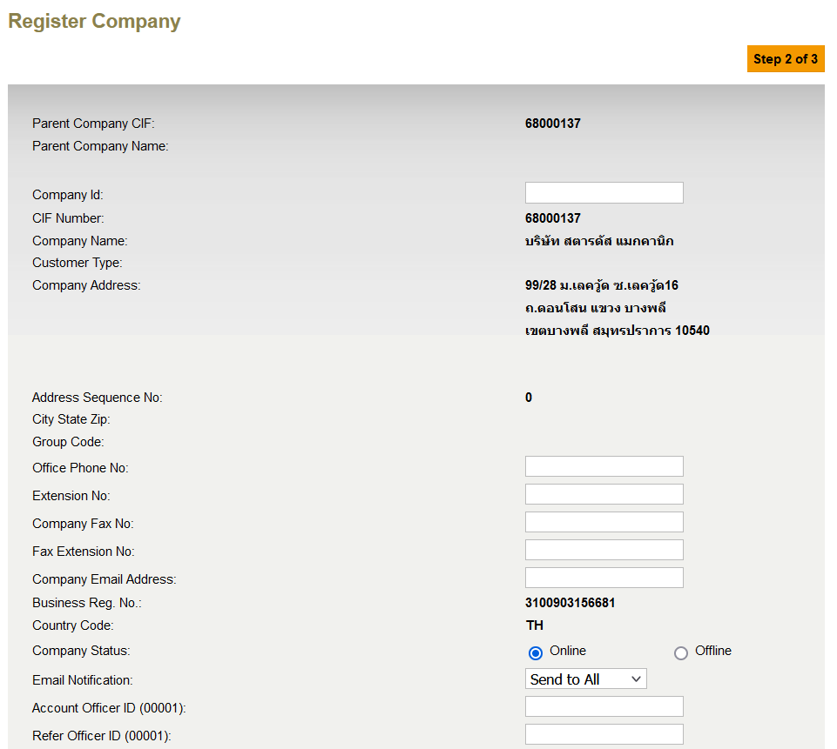

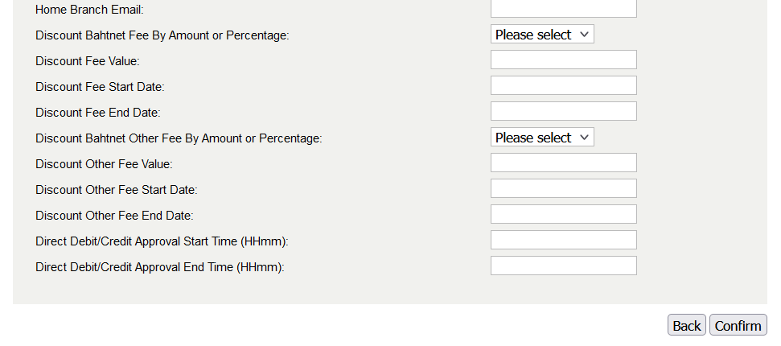

1. Add Direct Debit/Credit Approval Start Time (HHmm) and Direct Debit/Credit Approval End Time (HHmm) in edit company module.

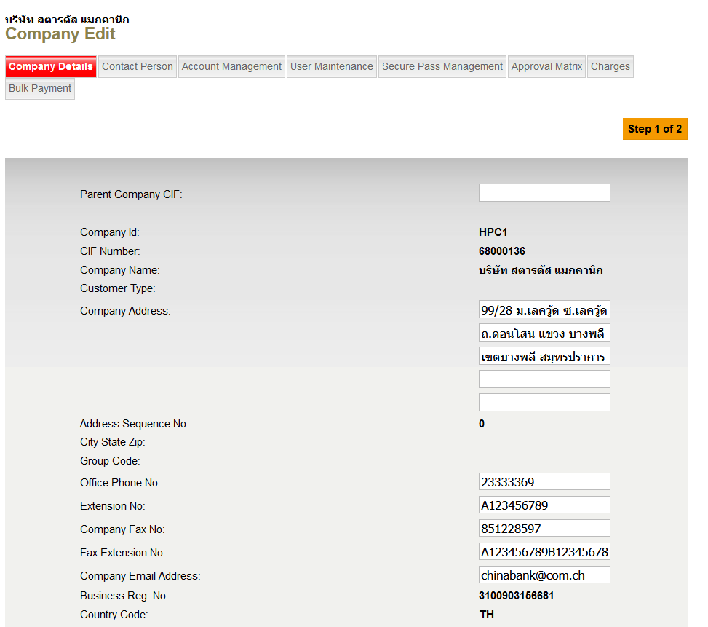

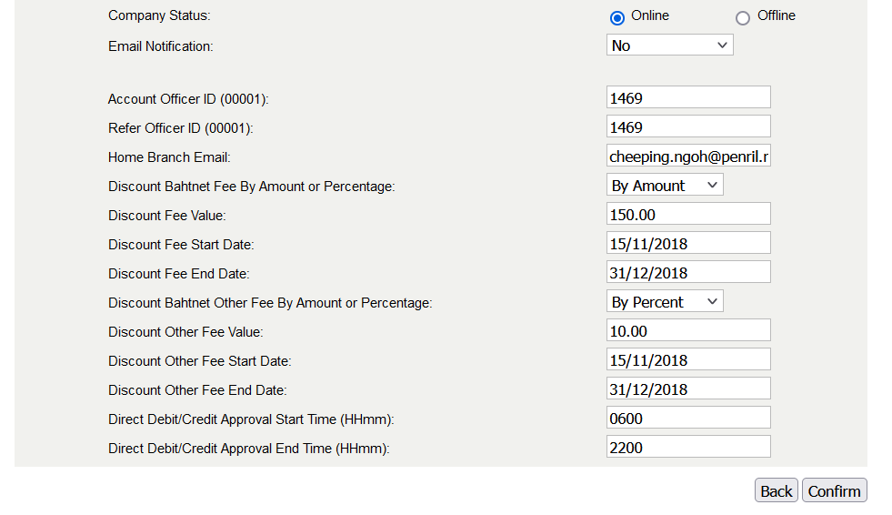

# BIB

1. When approver access to authorization module, check current time is within configured direct debit/credit start time and end time setup in company profile for service info direct debit (BULKUPLOADDEBIT) and direct credit (BULKUPLOADCREDIT).
2. Only will show direct debit and direct credit transaction that is within the configured direct/credit start time and end time setup in company profile.
3. Validate direct debit and direct credit amount field in detail must be greater than 0 when upload file. Show error message when amount is 0.

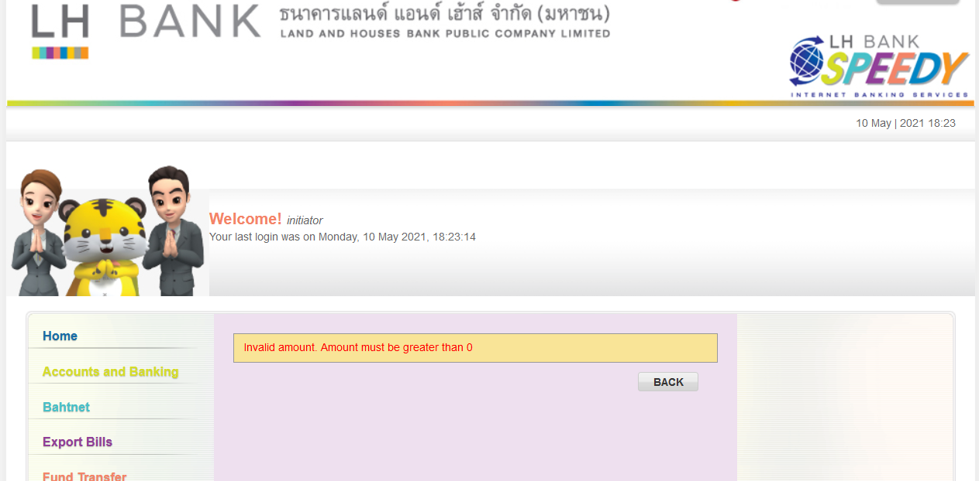

1. Validate direct debit and direct credit for field “total number of debits”, “total number of credits”, “total credit amount”, and “total debit amount” in footer must be equal to the total number of records in details when upload file. Show error message when the total number of records and total amount in footer is not match with the details.

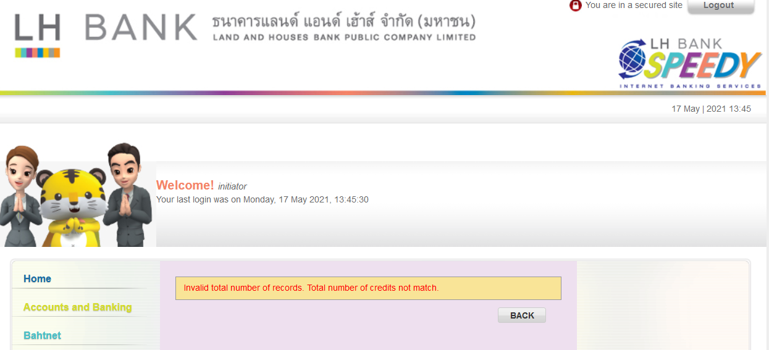

|  |  |
| --- | --- |
| Effort(man-days) | 8 |
| AMC | Applicable |
| Affected Area | BIB |